Load Test Report

## Load Details

stack: S4

stack_url: https://mercury.uptycs.net/

sprint: 138

build: 138005

load_type: AWS_multicustomer

load_duration_in_hrs: 12 hrs

load_start_time_ist: 2023-08-24 00:33

load_end_time_ist: 2023-08-24 12:33

## Disk Usages

### KAFKA disk space usage

|  |  |  |  |  |
| --- | --- | --- | --- | --- |
| Node | KAFKA total space configured(TB) | KAFKA disk used % before load | KAFKA disk used % after load | KAFKA used space during load (GB) |
| s4c1pn1v | 3.6 | 1.0 | 3.0 | 73.73 |
| s4c1pn2v | 3.6 | 1.0 | 3.0 | 73.73 |
| s4c1pn3v | 3.6 | 1.0 | 3.0 | 73.73 |
| s4c1pn4v | 3.6 | 1.0 | 3.0 | 73.73 |
| s4c1pn5v | 3.6 | 1.0 | 3.0 | 73.73 |
| s4c1pn6v | 3.6 | 1.0 | 3.0 | 73.73 |
| s4c2pn1v | 3.6 | 1.0 | 3.0 | 73.73 |
| s4c2pn2v | 3.6 | 1.0 | 3.0 | 73.73 |
| s4c2pn3v | 3.6 | 1.0 | 3.0 | 73.73 |
| s4c2pn4v | 3.6 | 1.0 | 3.0 | 73.73 |
| s4c2pn5v | 0.37 | 1.0 | 25.0 | 89.95 |
| s4c2pn6v | 3.6 | 1.0 | 3.0 | 73.73 |

### HDFS disk space usage

|  |  |  |  |  |
| --- | --- | --- | --- | --- |
| Node | HDFS total space configured(TB) | HDFS disk used % before load | HDFS disk used % after load | HDFS used space during load (GB) |
| s4c1dn6 | 11.78 | 29.59 | 29.82 | 27.39 |
| s4c1dn4 | 11.78 | 28.99 | 29.22 | 26.79 |
| s4c1dn3 | 11.81 | 29.06 | 29.26 | 23.67 |
| s4c1dn5 | 11.78 | 28.16 | 28.37 | 24.95 |
| s4c2dn4 | 11.78 | 26.67 | 26.88 | 26.03 |
| s4c2dn2 | 11.78 | 26.65 | 26.88 | 26.96 |
| s4c2dn6 | 11.78 | 26.26 | 26.49 | 27.33 |
| s4c2dn5 | 11.78 | 26.19 | 26.39 | 23.85 |
| s4c2dn3 | 11.78 | 25.98 | 26.21 | 27.36 |
| s4c1dn2 | 11.81 | 26.11 | 26.32 | 25.88 |
| s4c2dn1 | 11.78 | 25.28 | 25.48 | 24.01 |
| s4c1dn1 | 11.81 | 24.68 | 24.87 | 22.43 |

### PG disk space usage

|  |  |  |
| --- | --- | --- |
| partition | master configdb node | standby configdb node |
| /pg | 14G | 23G |
| /data | 51G | 63G |

### Kafka topics

|  |
| --- |
| 138005 |
| Summary : New topics found |
| New Topics : __consumer_offsets __debezium-heartbeat.cdc __debezium-heartbeat.statedb agentghquery agentkubequery agentlesslog agentlesslogdecorator agentoktaquery agentosquery alert alert_replay api asset-capability assetgroup1 audit auto-exception az_events_blob bulk_replay cdc.public.alerts cdc.public.asset_cloud_infos cdc.public.asset_tags cdc.public.assets cdc.public.cloud_accounts cdc.public.customer_database cdc.public.customers cdc.public.incidents cdc.public.object_groups cdc.public.user_object_groups cdc.public.users cloudconnectorsink cloudqueryVuln cloudqueryevents cloudqueryinventory cloudtrail_objects compliance compliance_summary containers cqazevents cqcloudtrail cqcloudtrail_data_sink cqcloudtrail_ro_sink debezium_configs debezium_offsets debezium_statedb_configs debezium_statedb_offsets debezium_statedb_status_storage debezium_status_storage decorators detection ephermalresources epsink event event_cloud event_replay gcp_cloudlog_objects managedavtables notifications op osquery_cli_tags prestoquerylogs querypack realtimequery registryevent reportschedule1 scan_summary sidequerydecorator slackuser1 state statedb.public.containers_current statedb.public.kubernetes_nodes_current statedb.public.kubernetes_pods_containers_current statedb.public.kubernetes_pods_current statedb.public.vulnerabilities_scanned_images tag1 threat_indicators unified_dashboard uptycs-cloud-remediation vulnerabilities vulntickets |
| Old Topics : |

## Charts

### Memory consumed by effectivepermissions

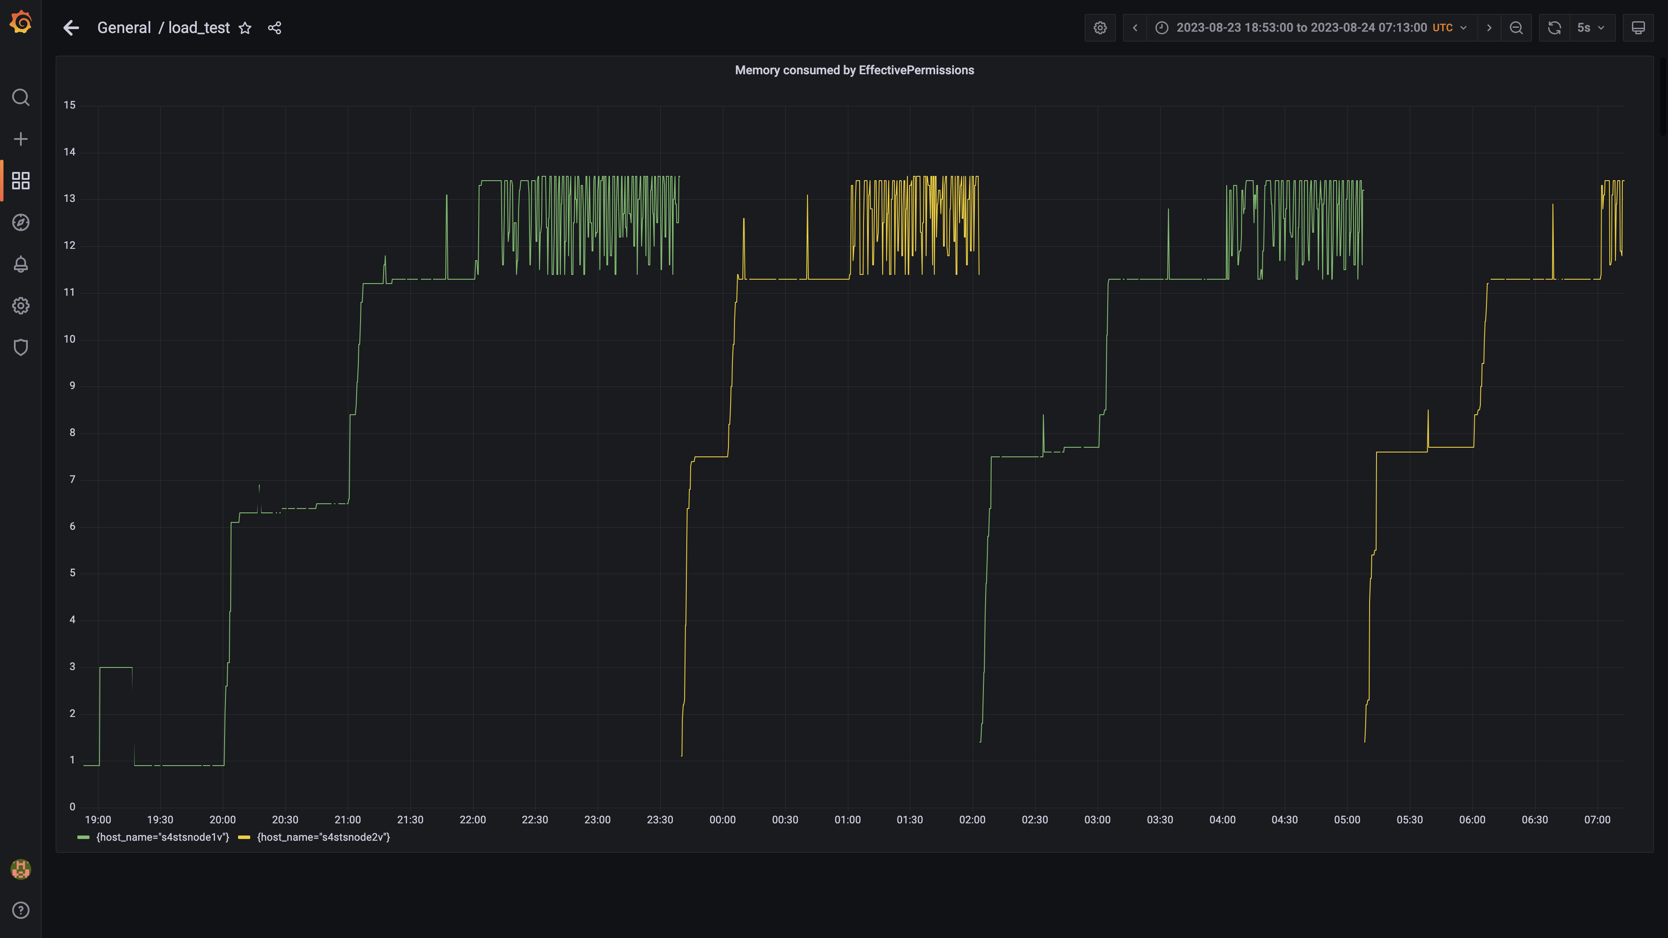

### Memory consumed by stsdetection

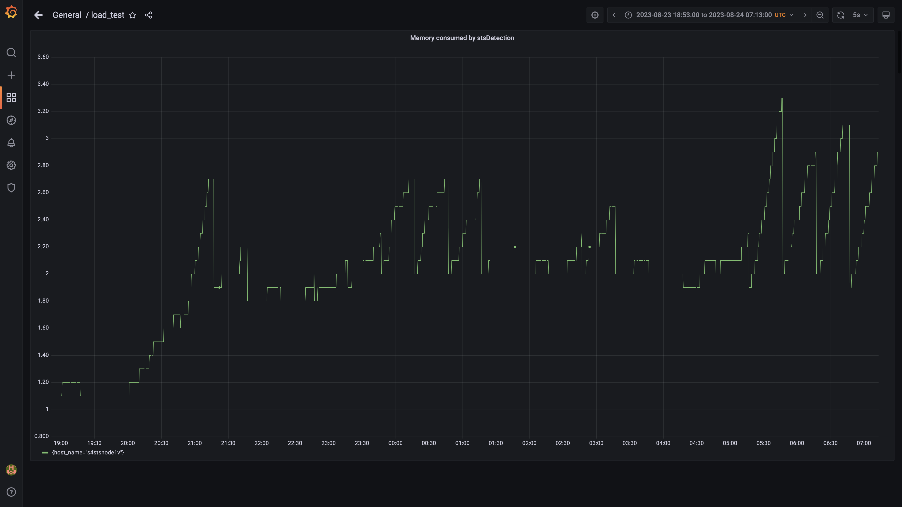

### Memory consumed by memgraphdb

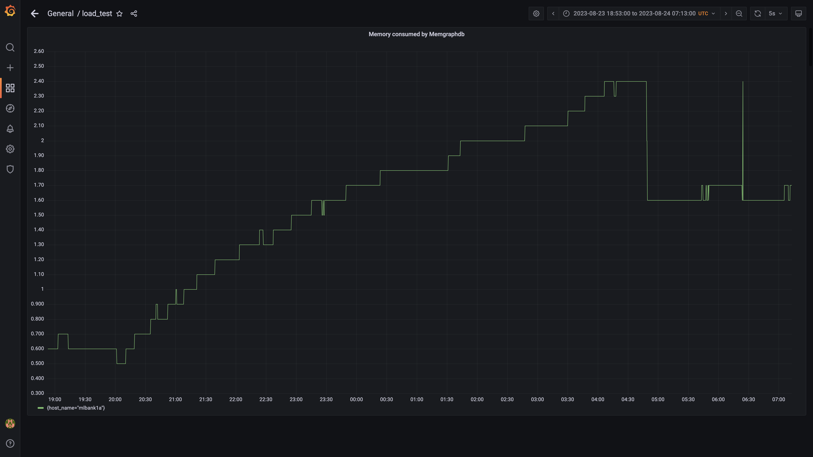

### Panel 44 not loaded in given time

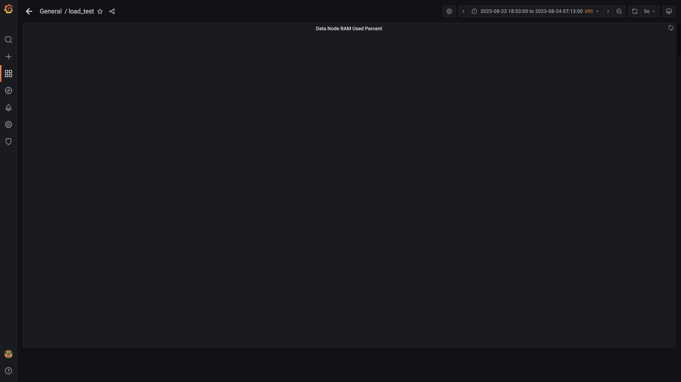

### Process node ram used percent

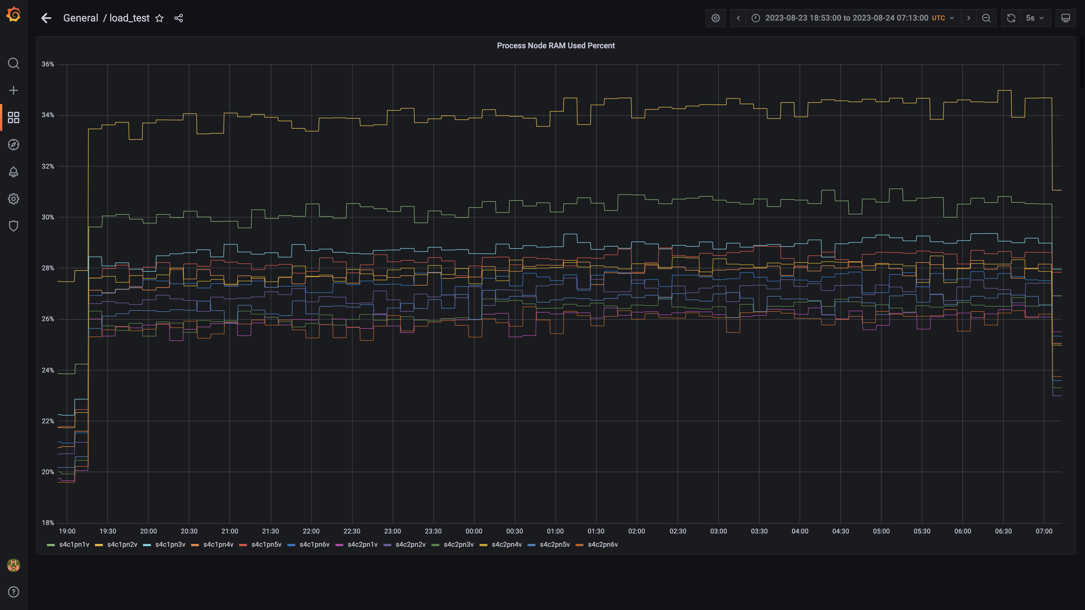

### Sts app memory%

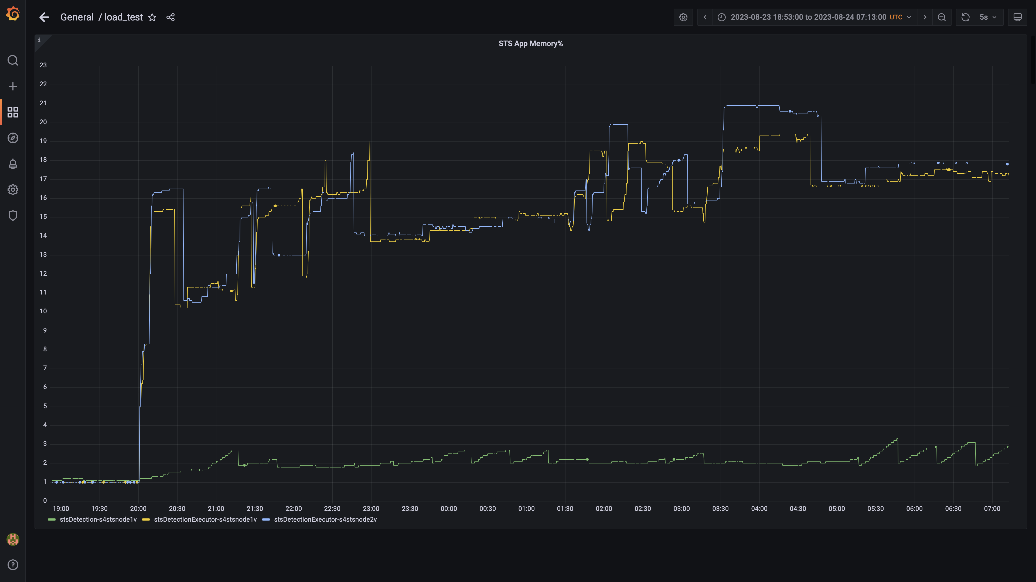

### Postgres node ram used percentage

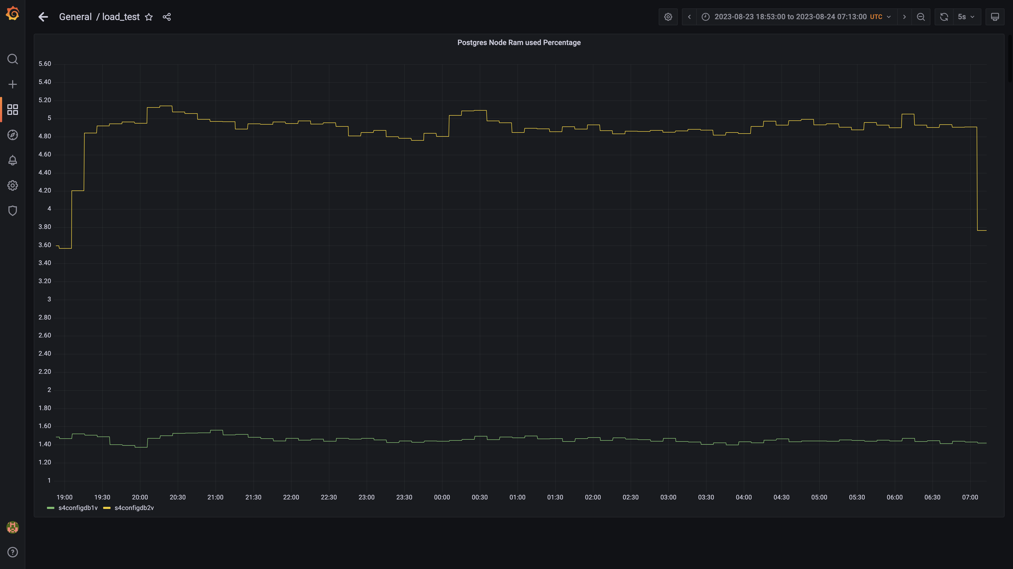

### Memory consumed by cloudqueryconsumer

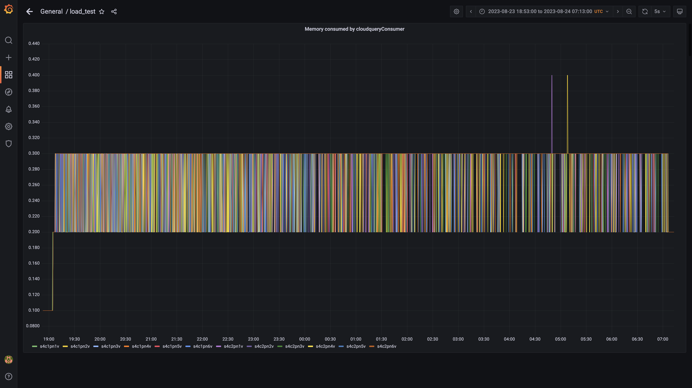

### Memory consumed by clouddetectionconsumer

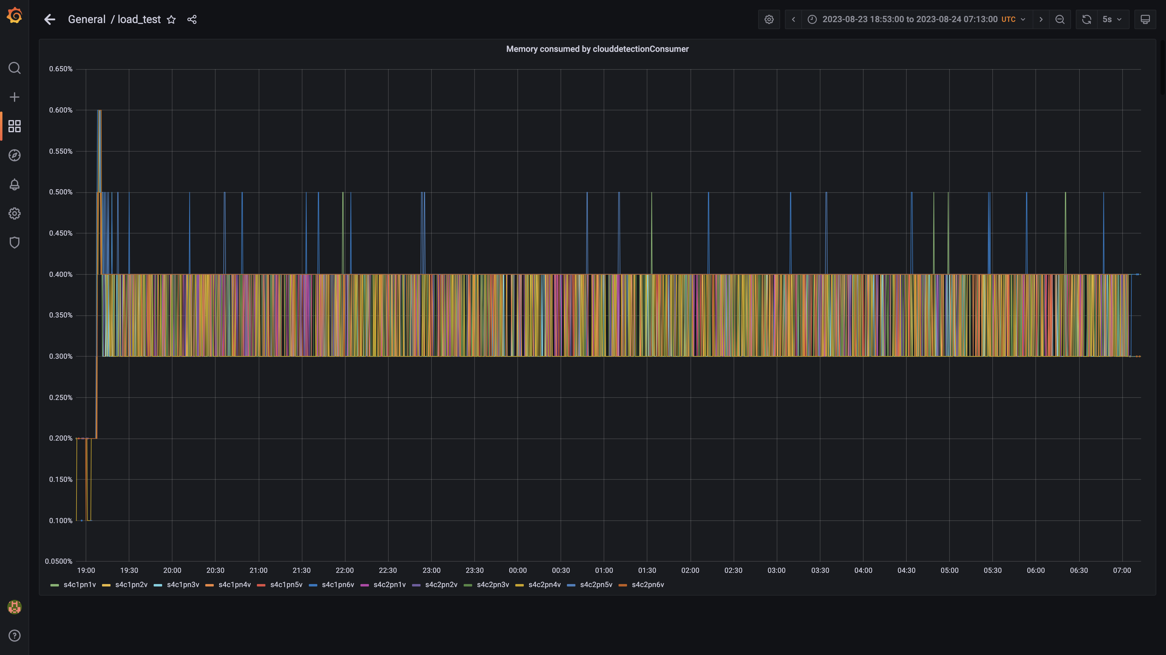

### Statedb memory used percent

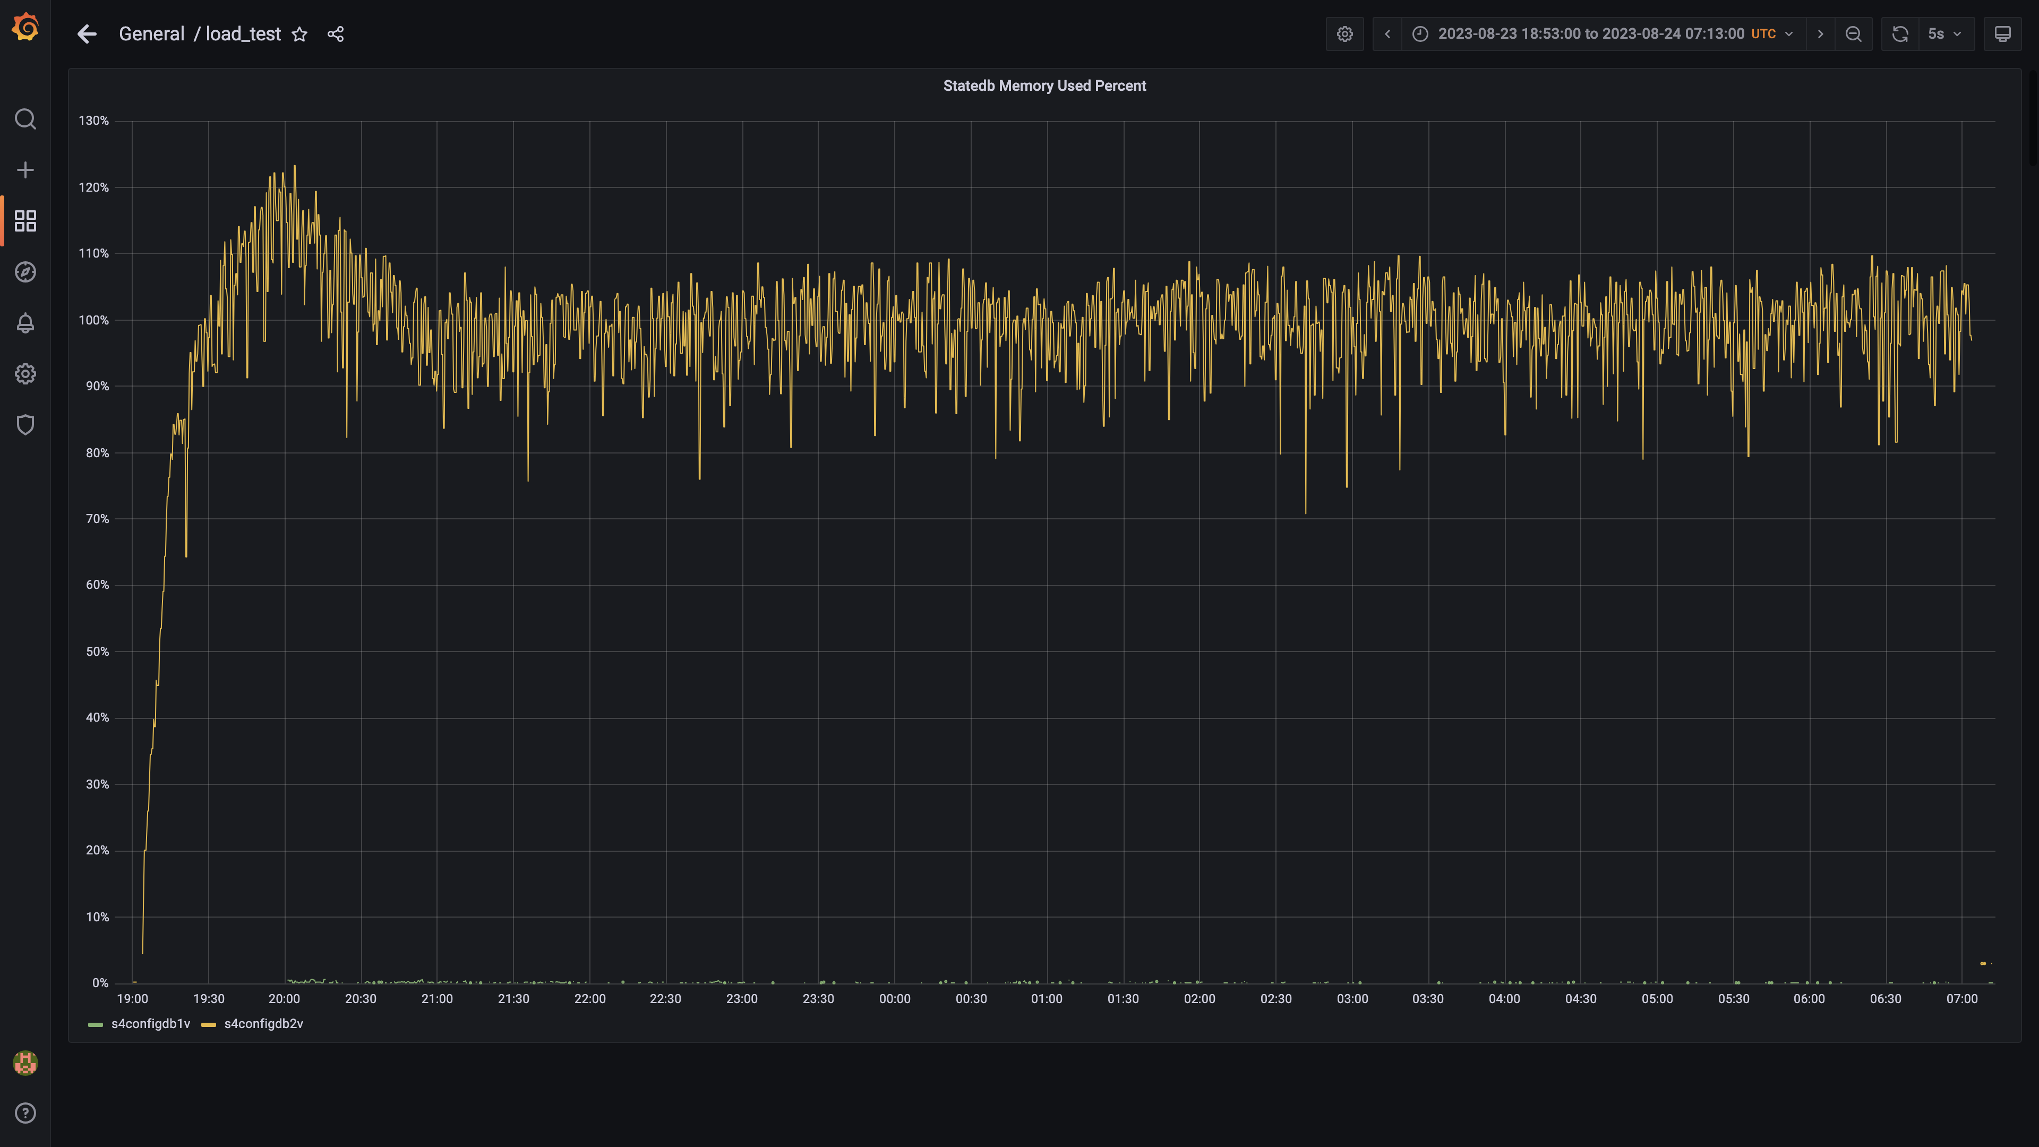

### Memory consumed by cloudconnectoringestion

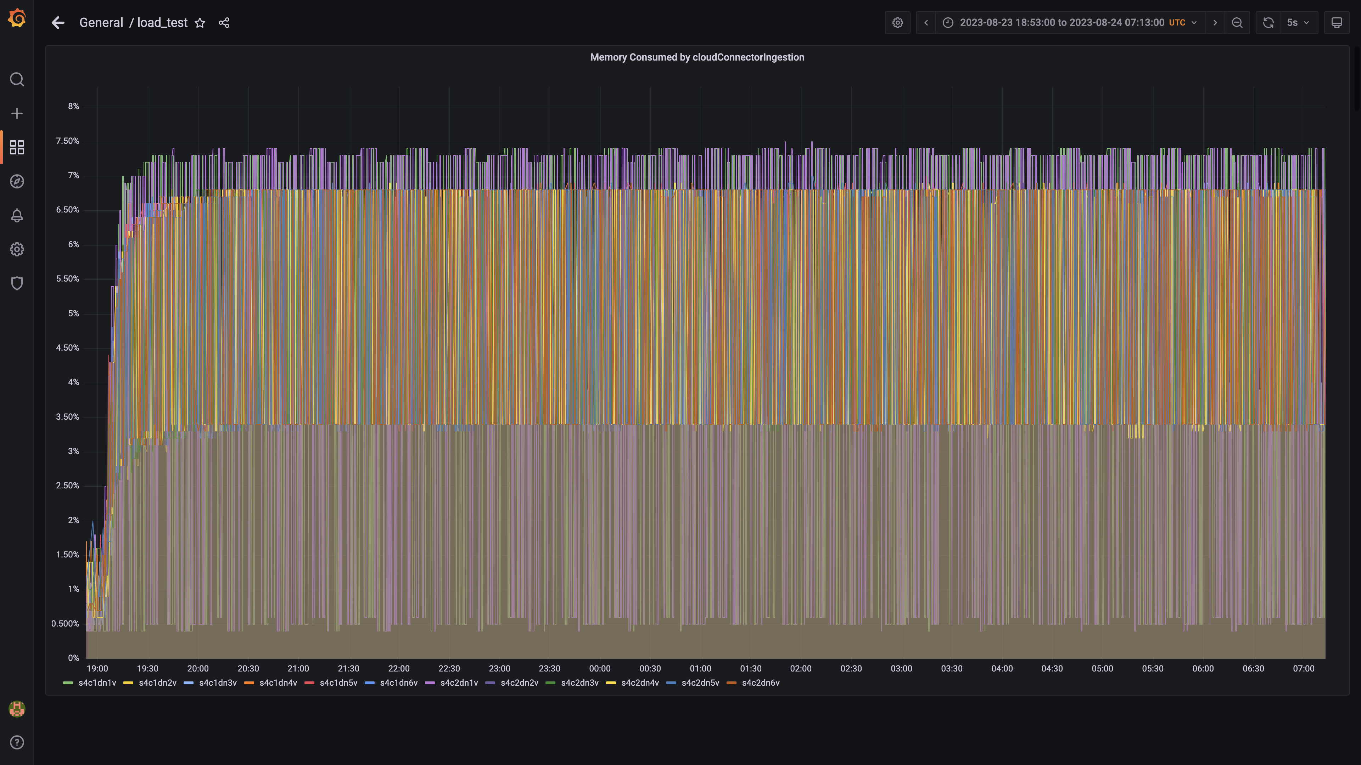

### Memory consumed by tls

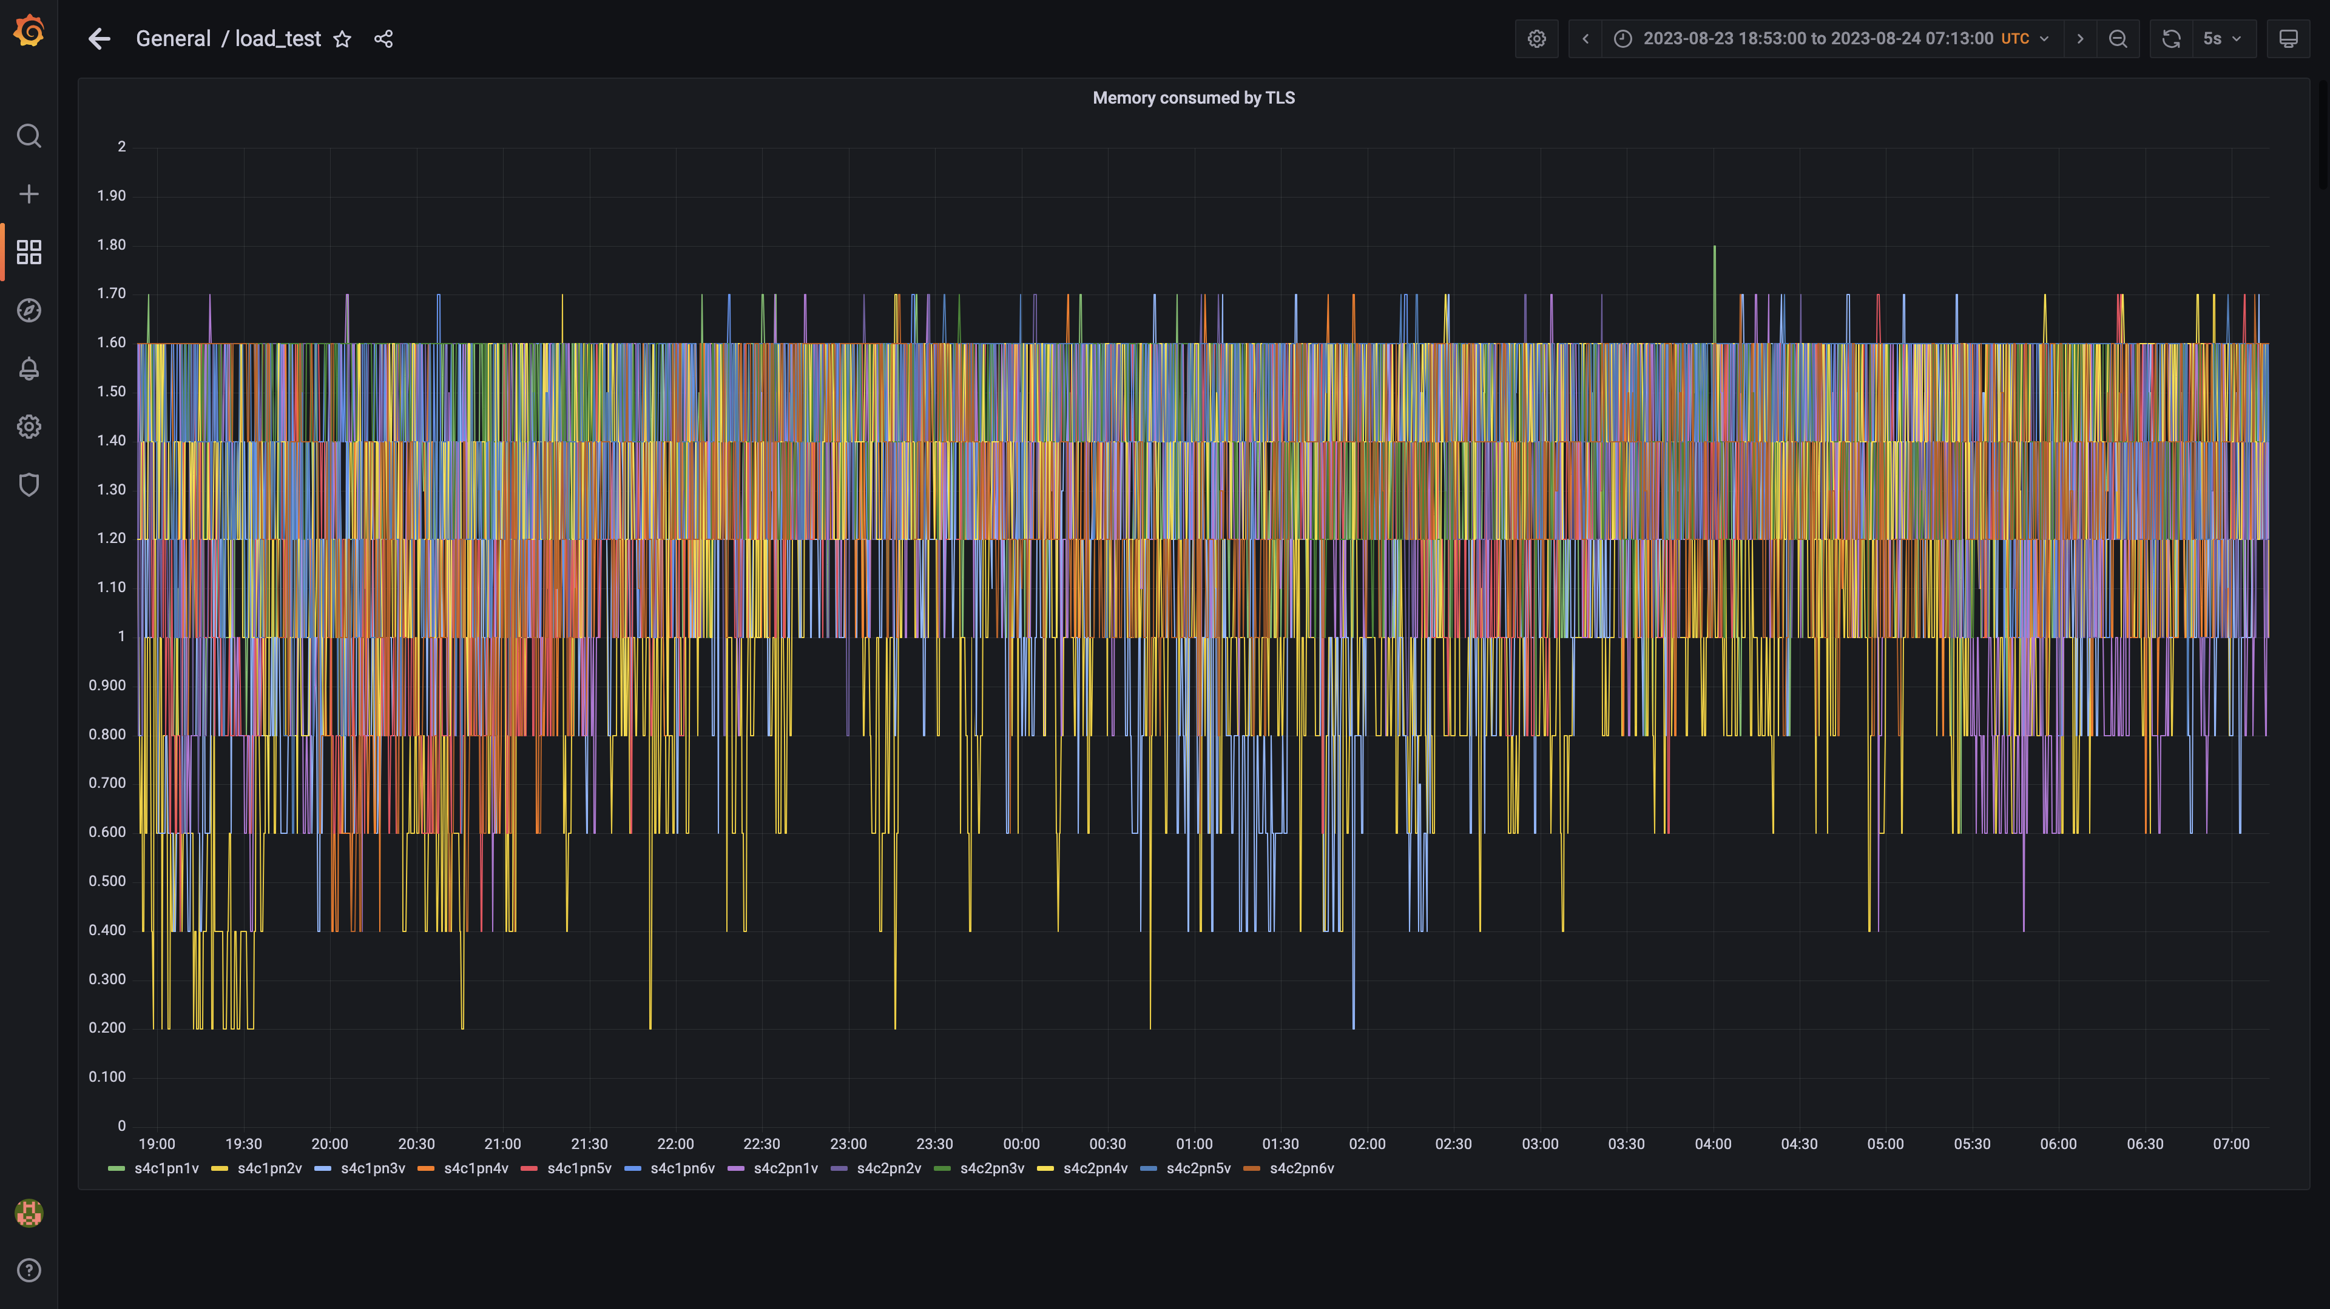

### Configdb memory used percent

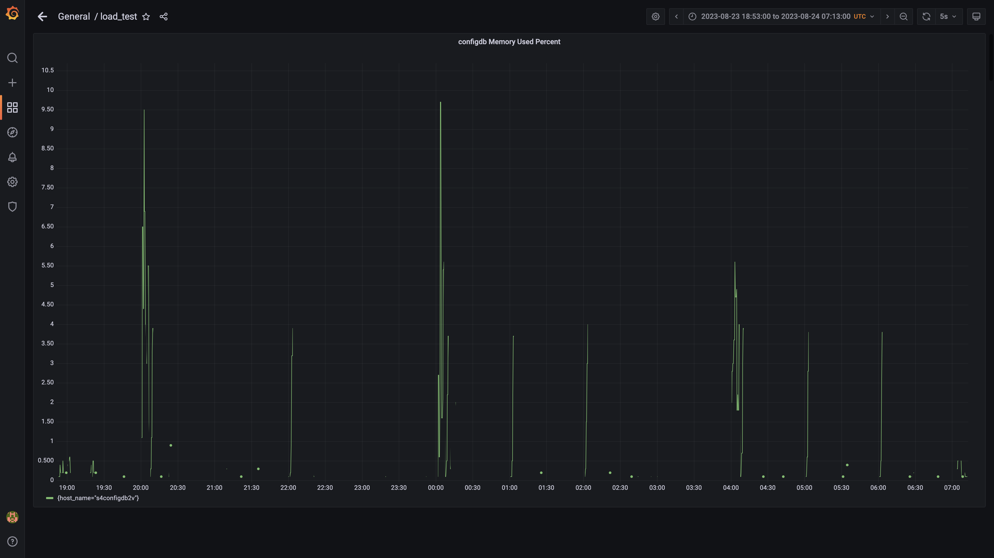

### Kafka memory used percentage

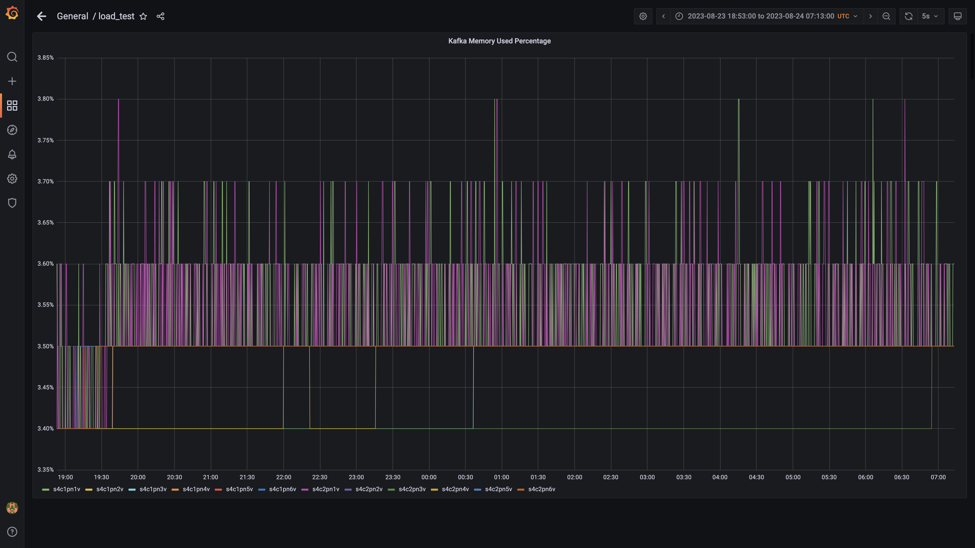

### Memory consumed by data archival

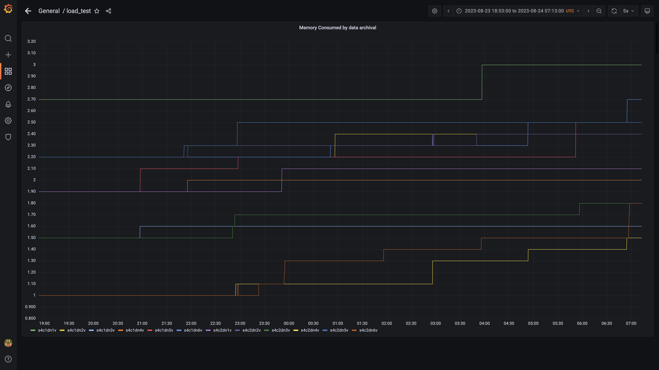

### Memory consumed by osqueryingestion

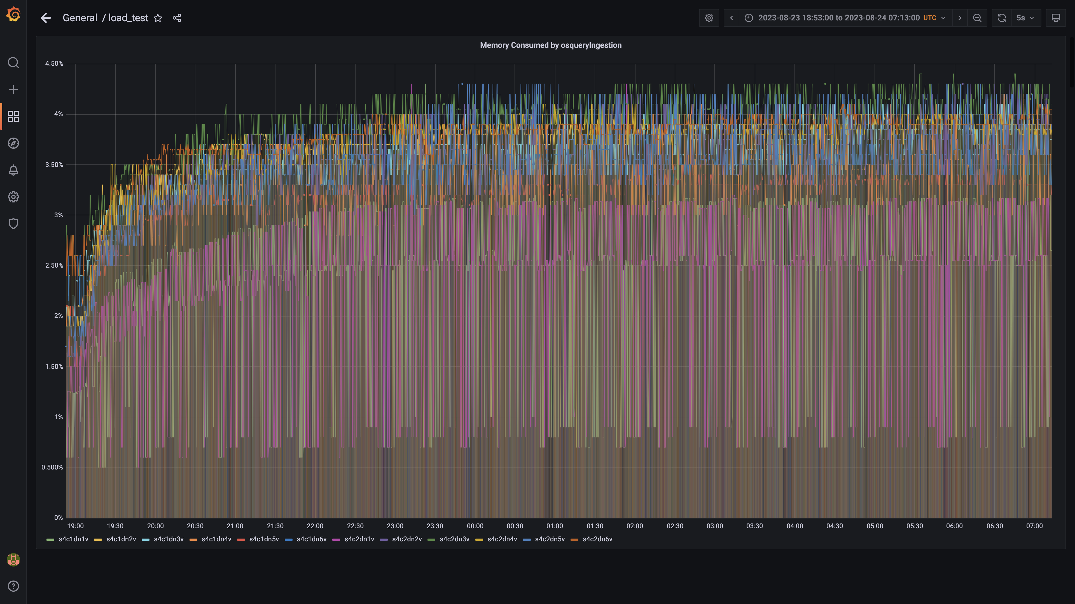

### Memory consumed by logger:

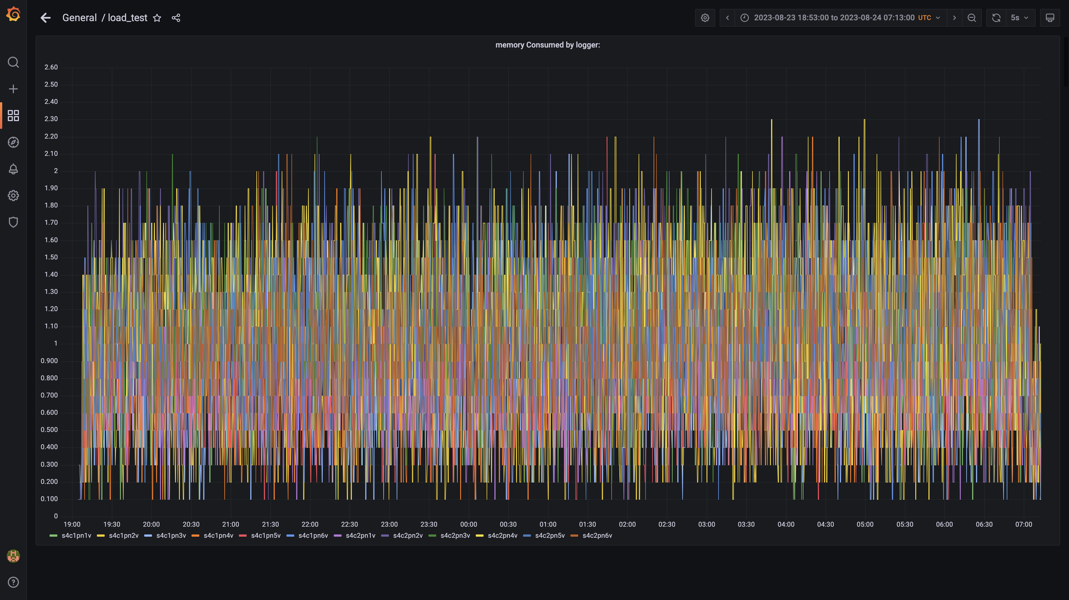

### Memory consumed by trino

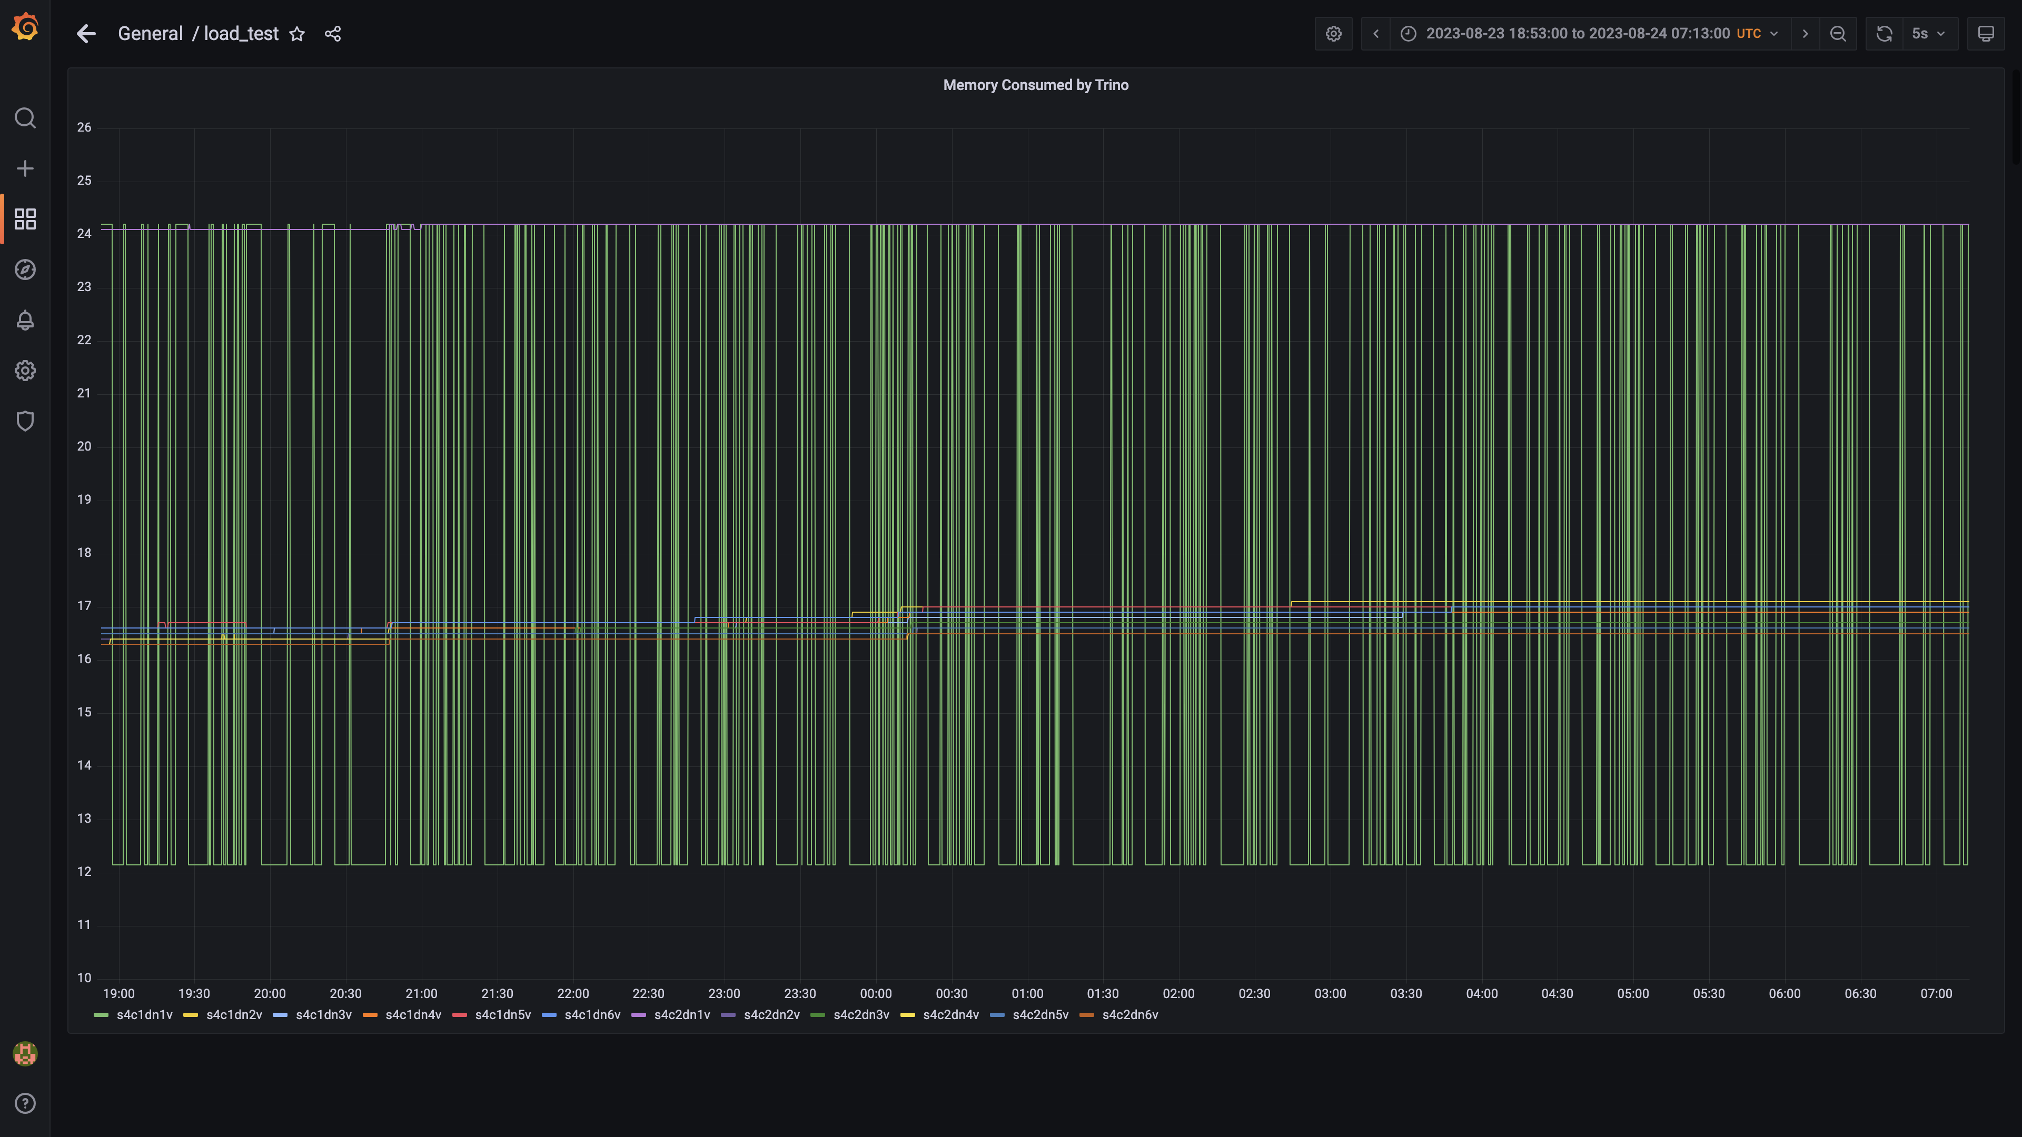

### Debezium memory usage

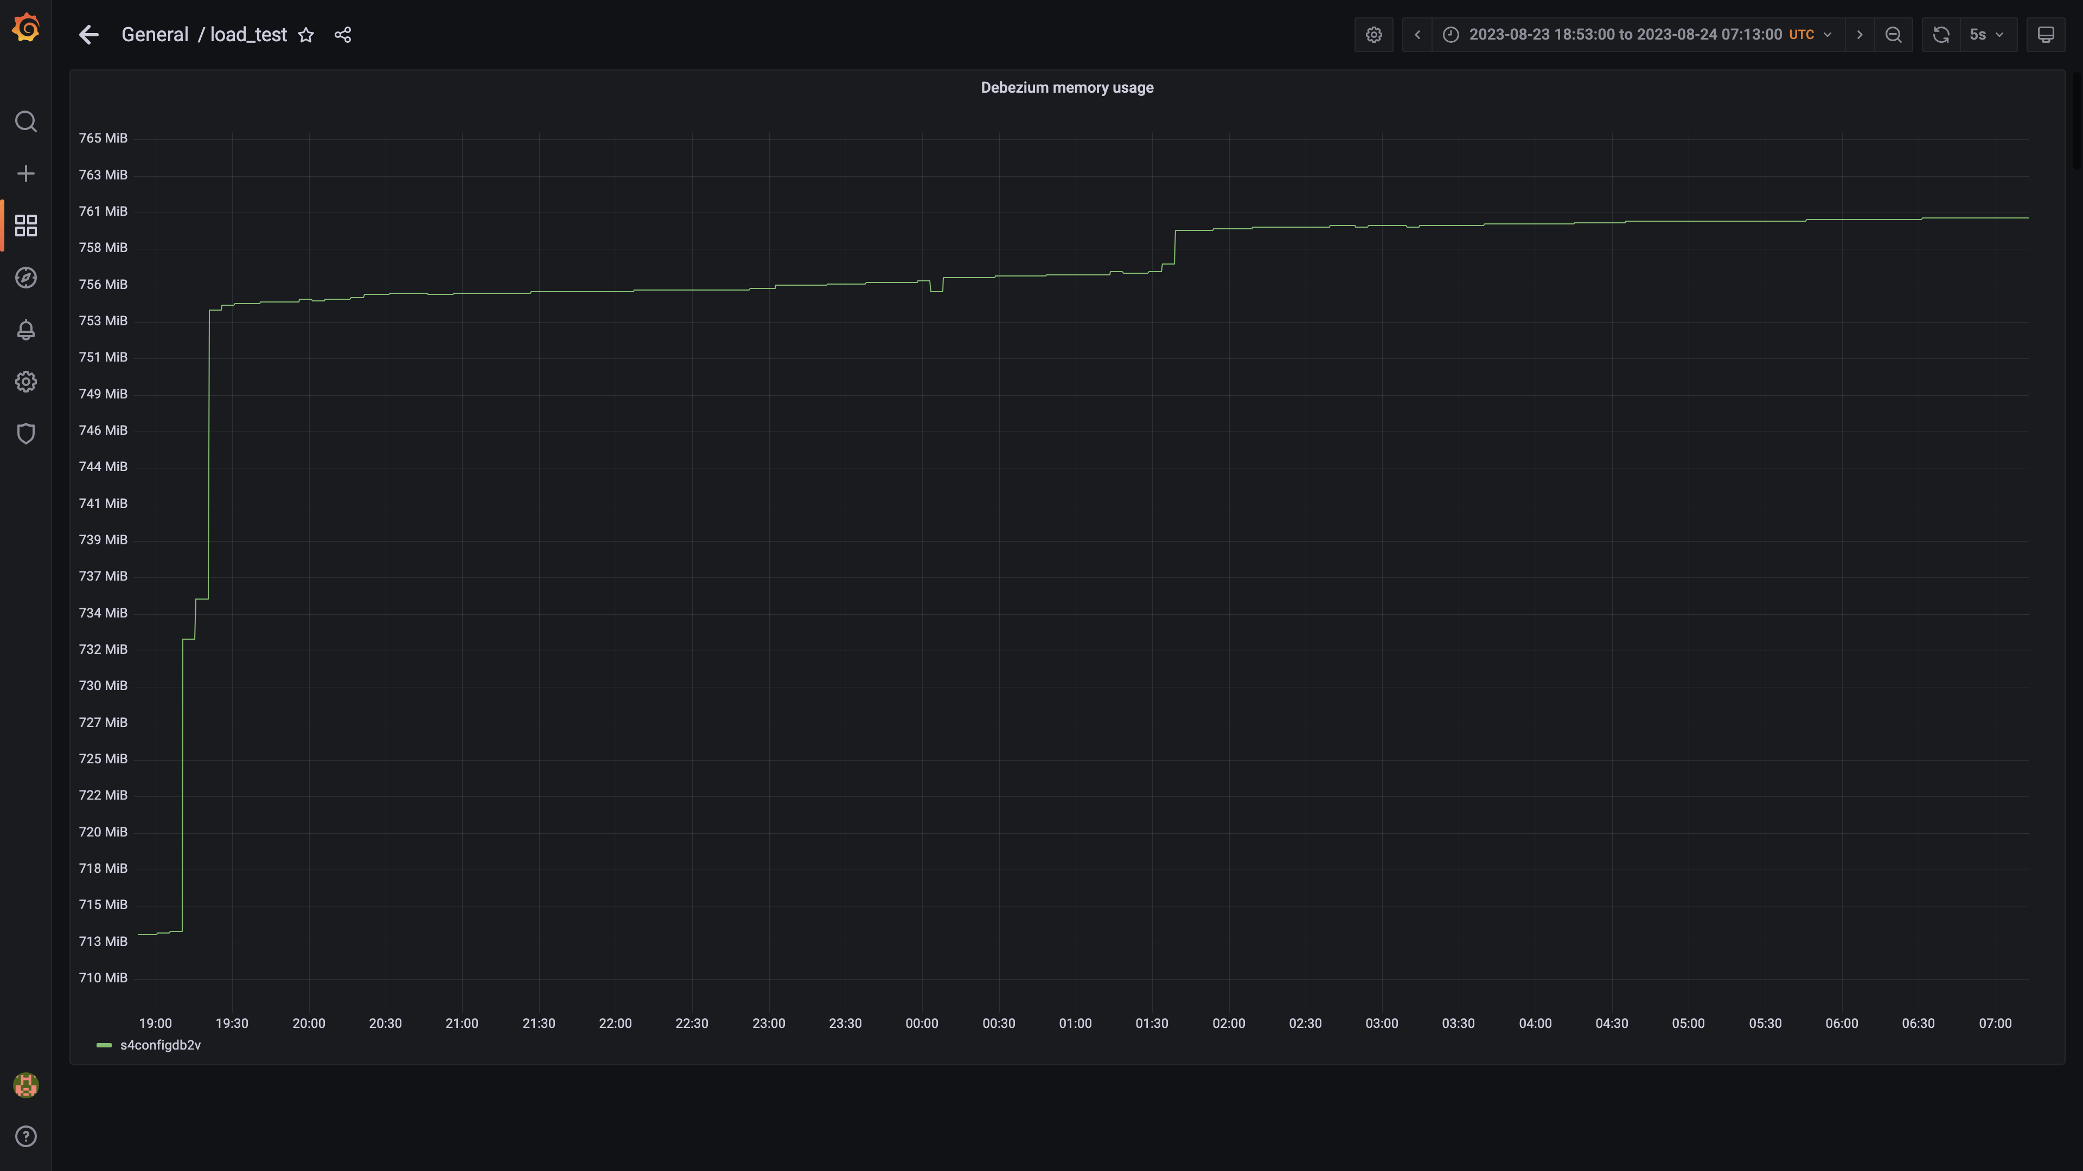

### Memory consumed by orc-compaction:

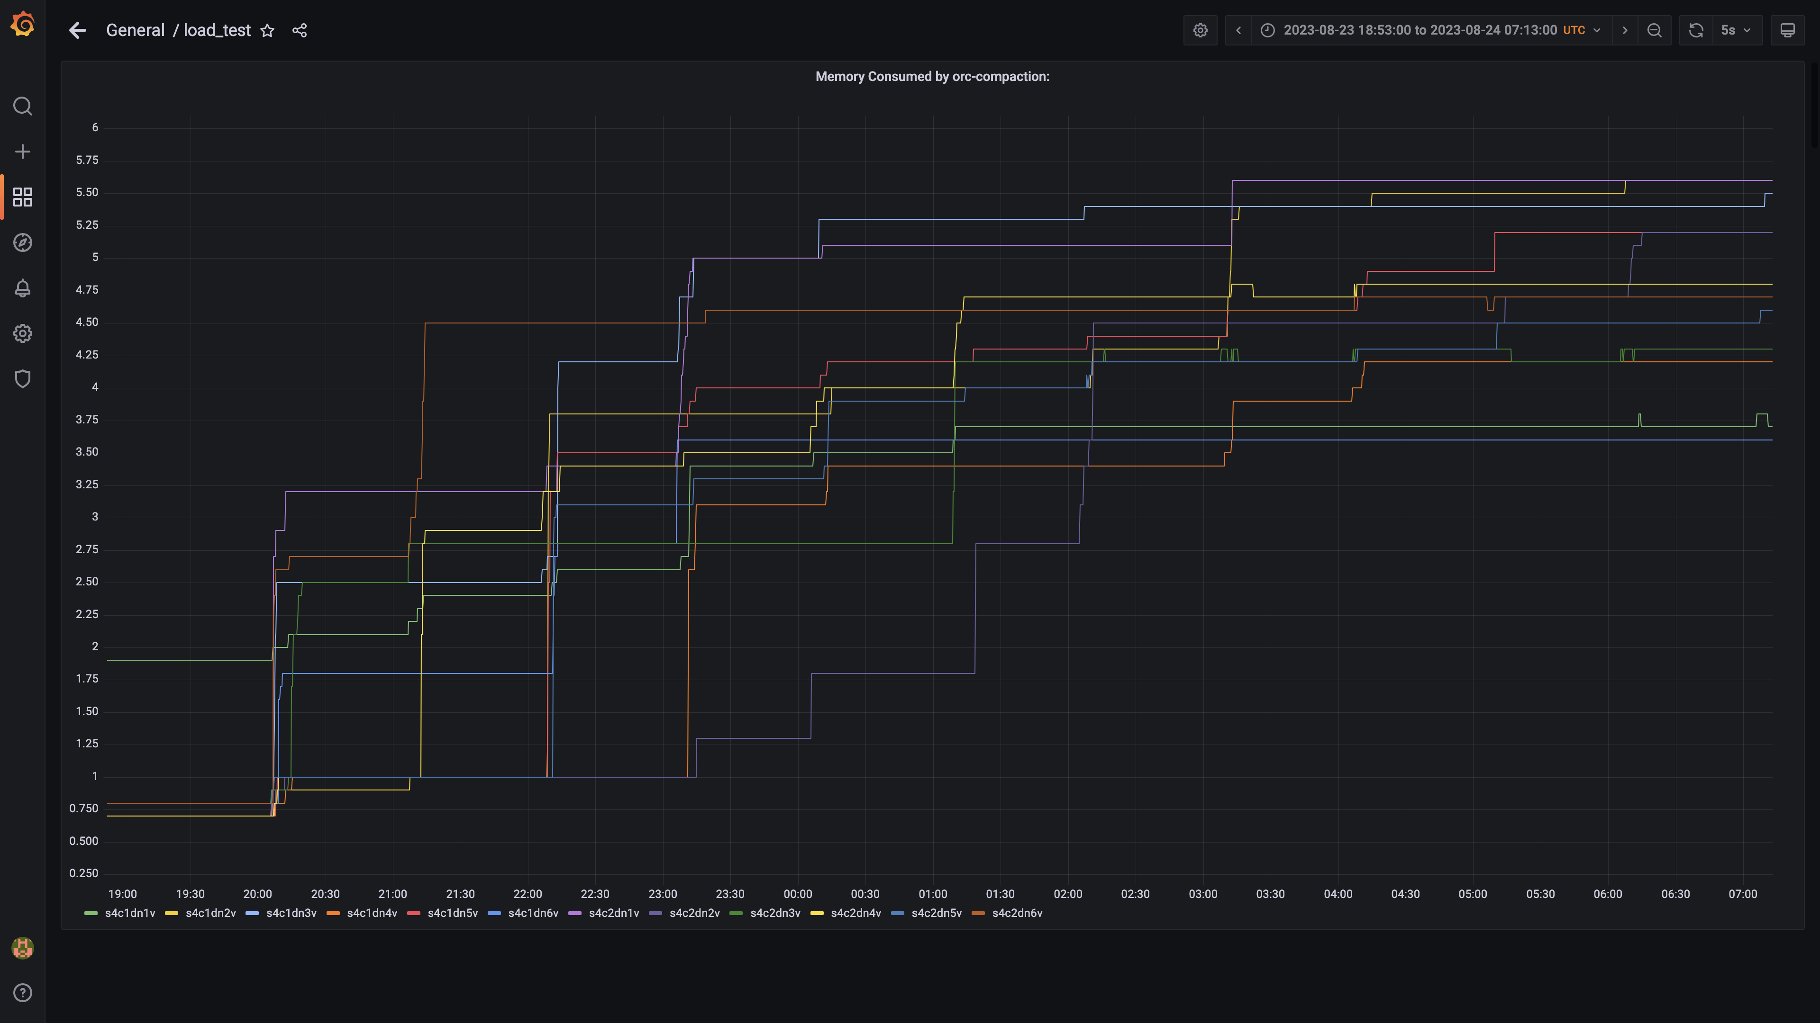

### Memory consumed by spark-worker

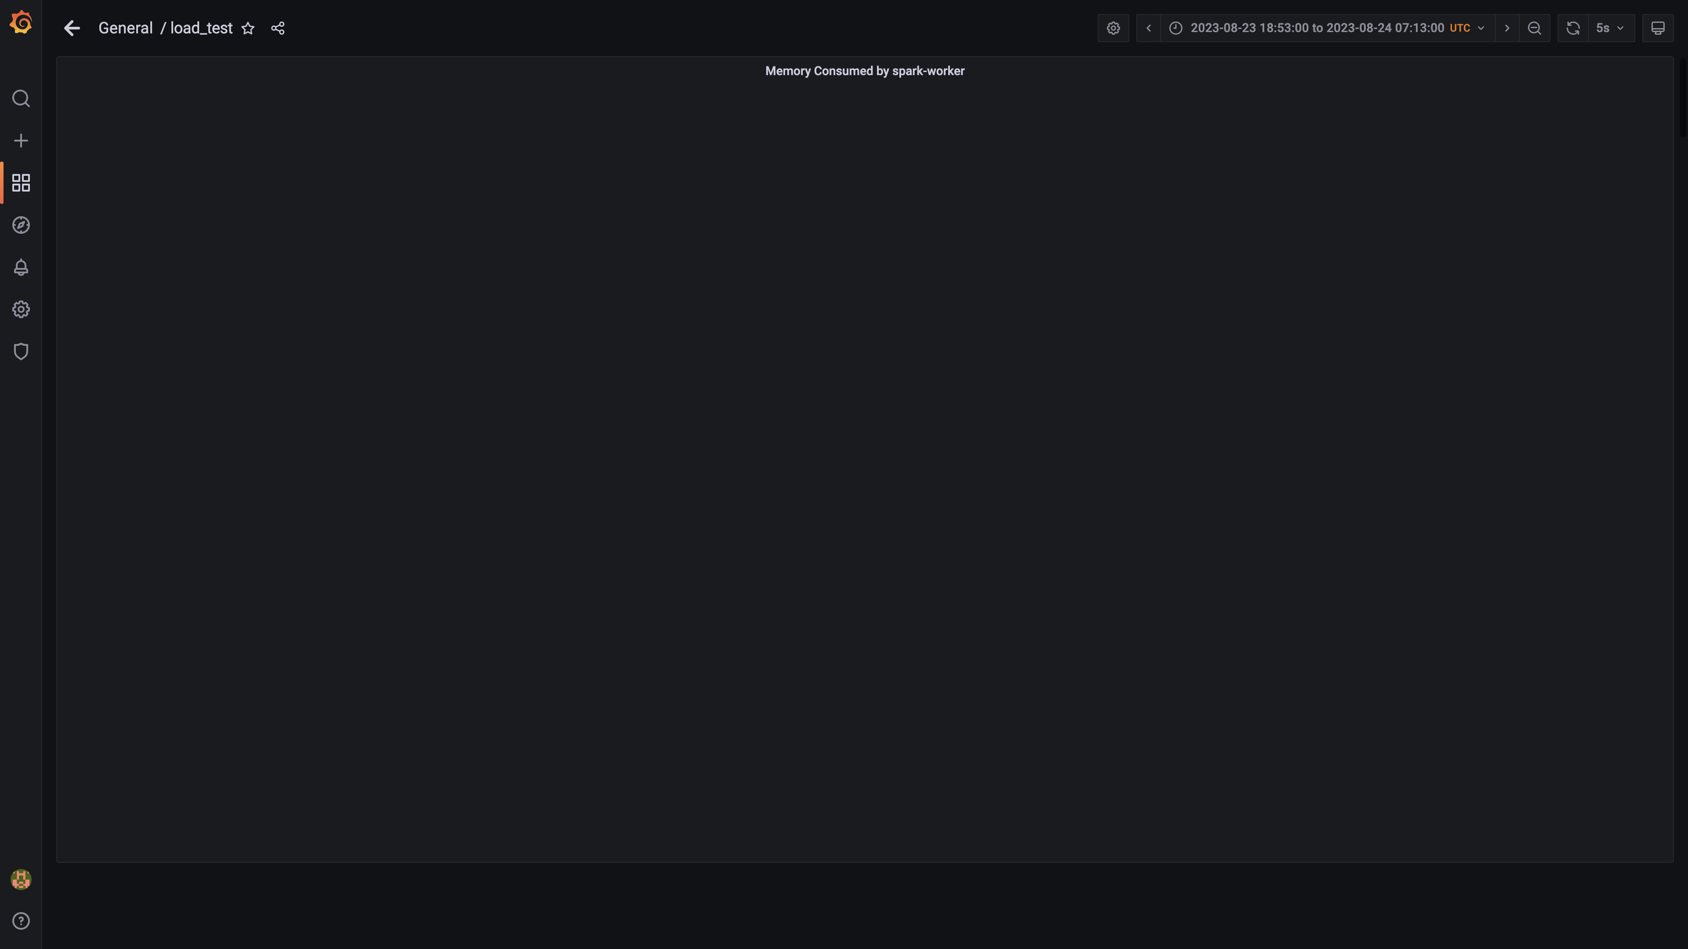

### Memory consumed by ruleengine

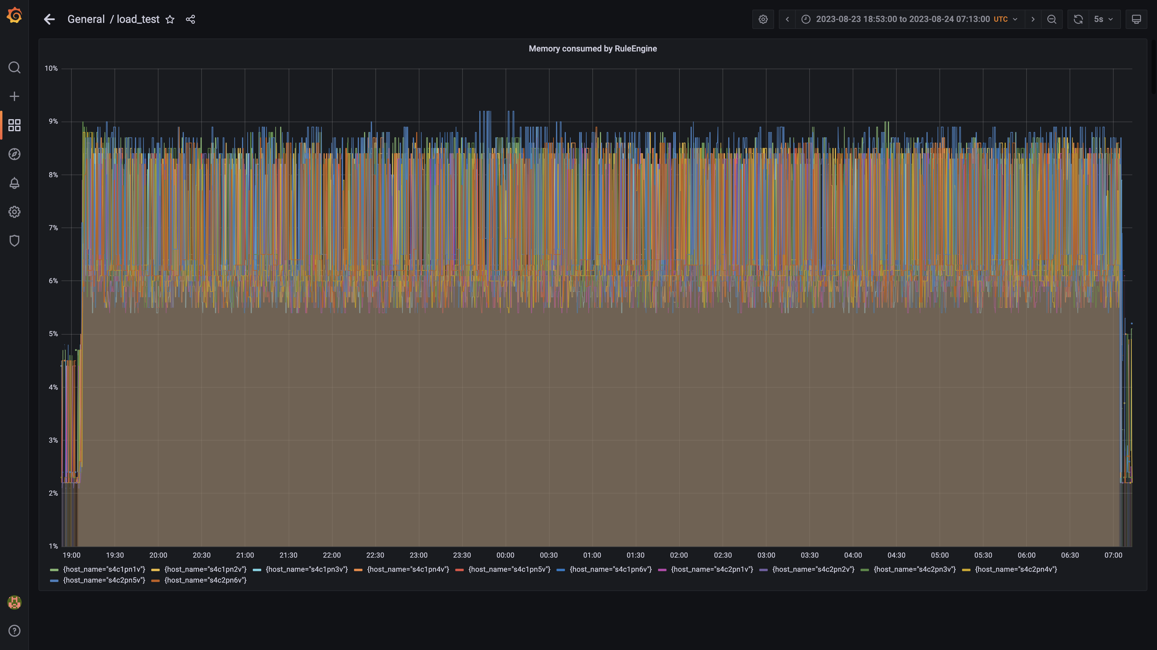

### Memory used by airflow

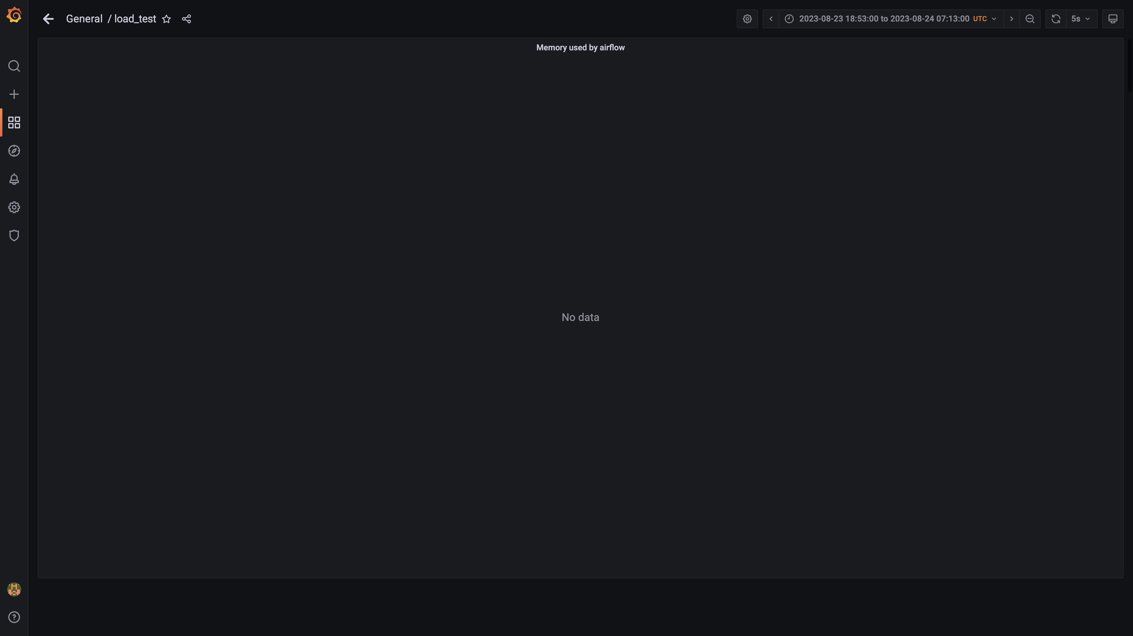

### Memory consumed by redis server

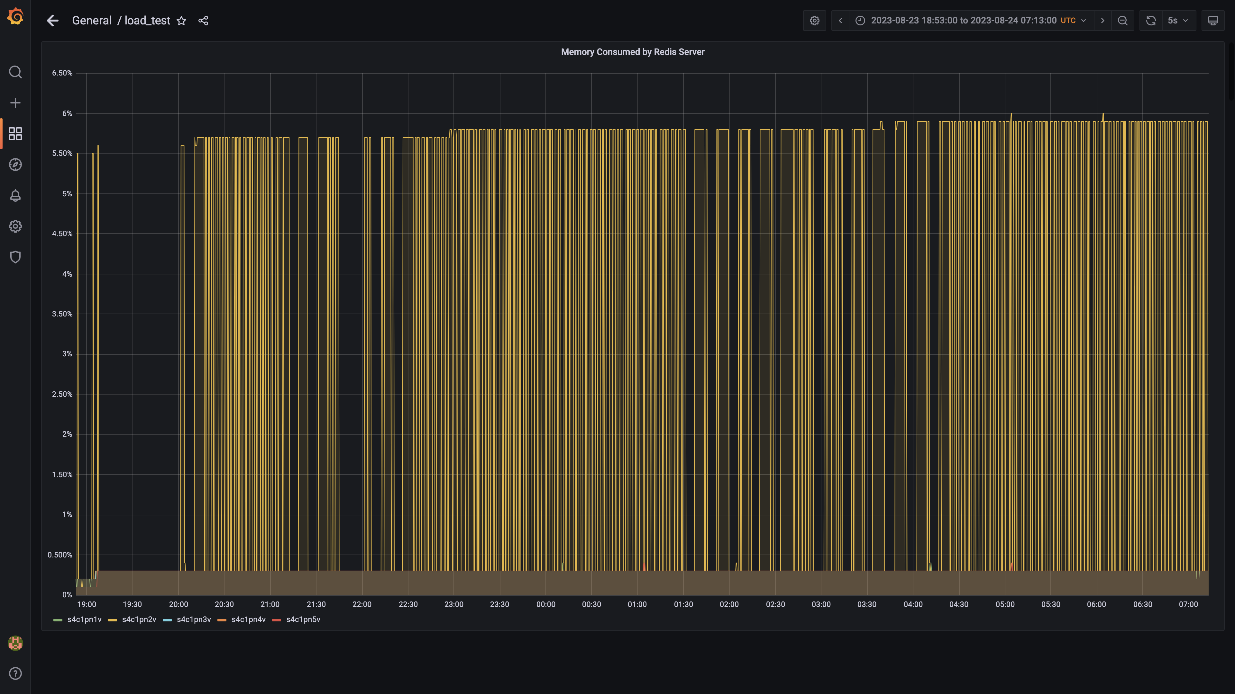

### Memory consumed by spark-master

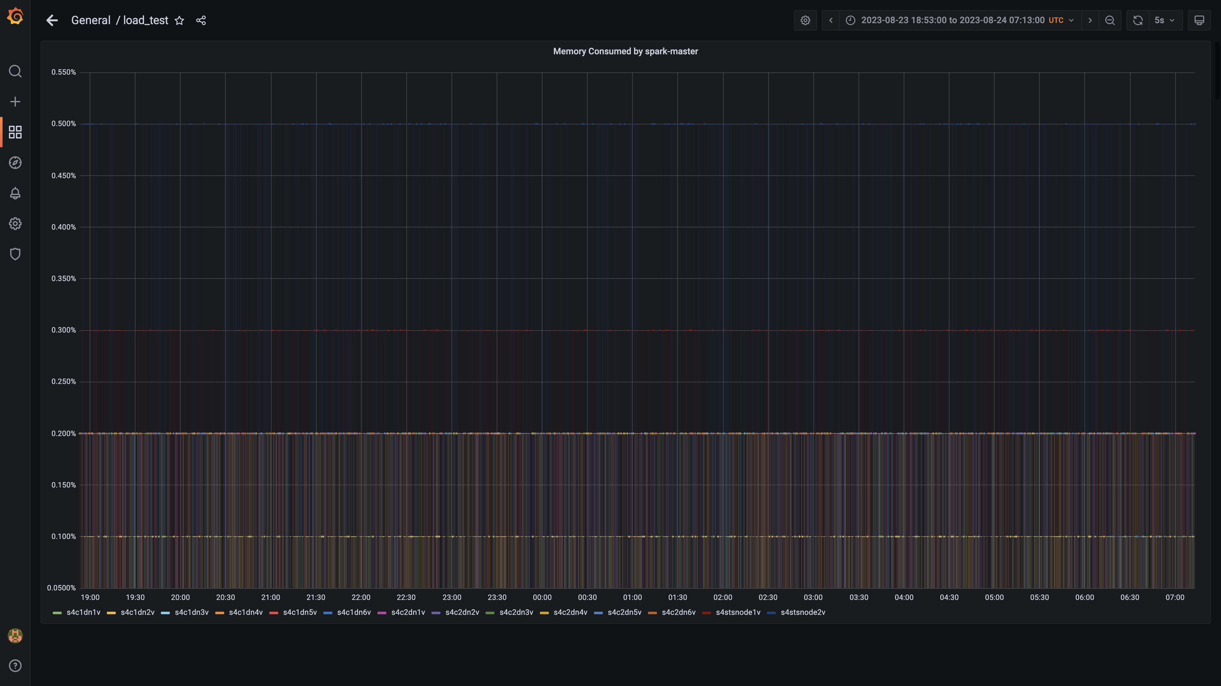

### Cpu consumed by memgraphdb

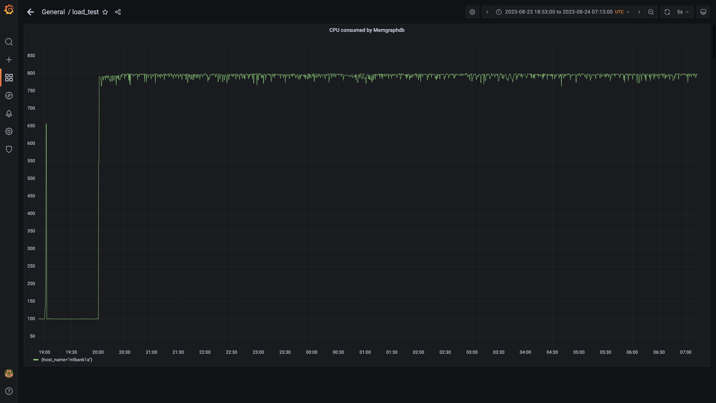

### Cpu consumed by effective permissions

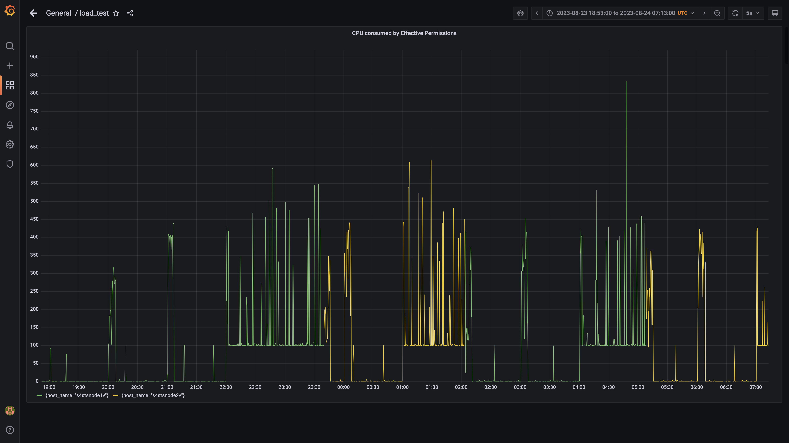

### Cpu consumed by stsdetection

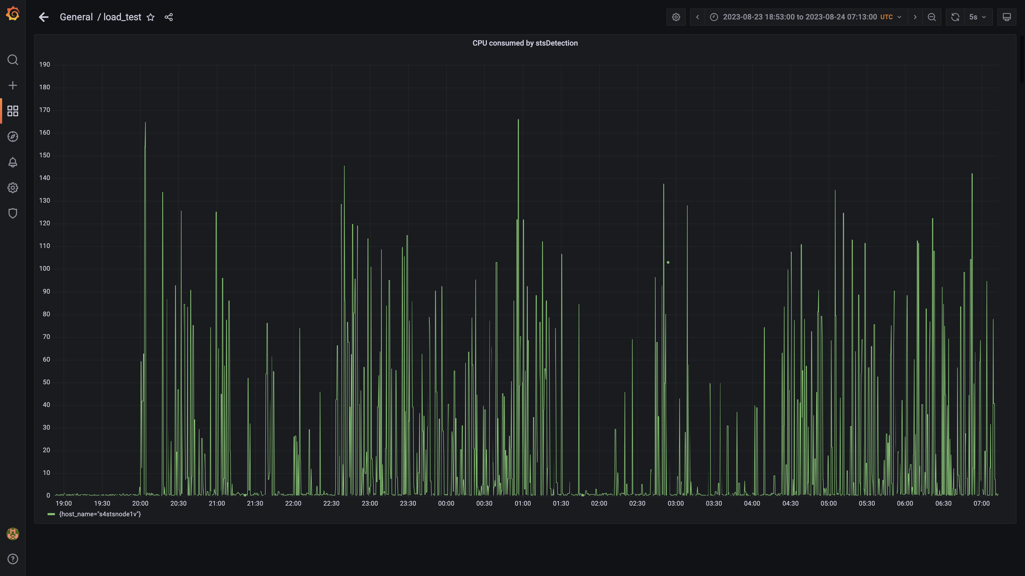

### Data node cpu busy percent

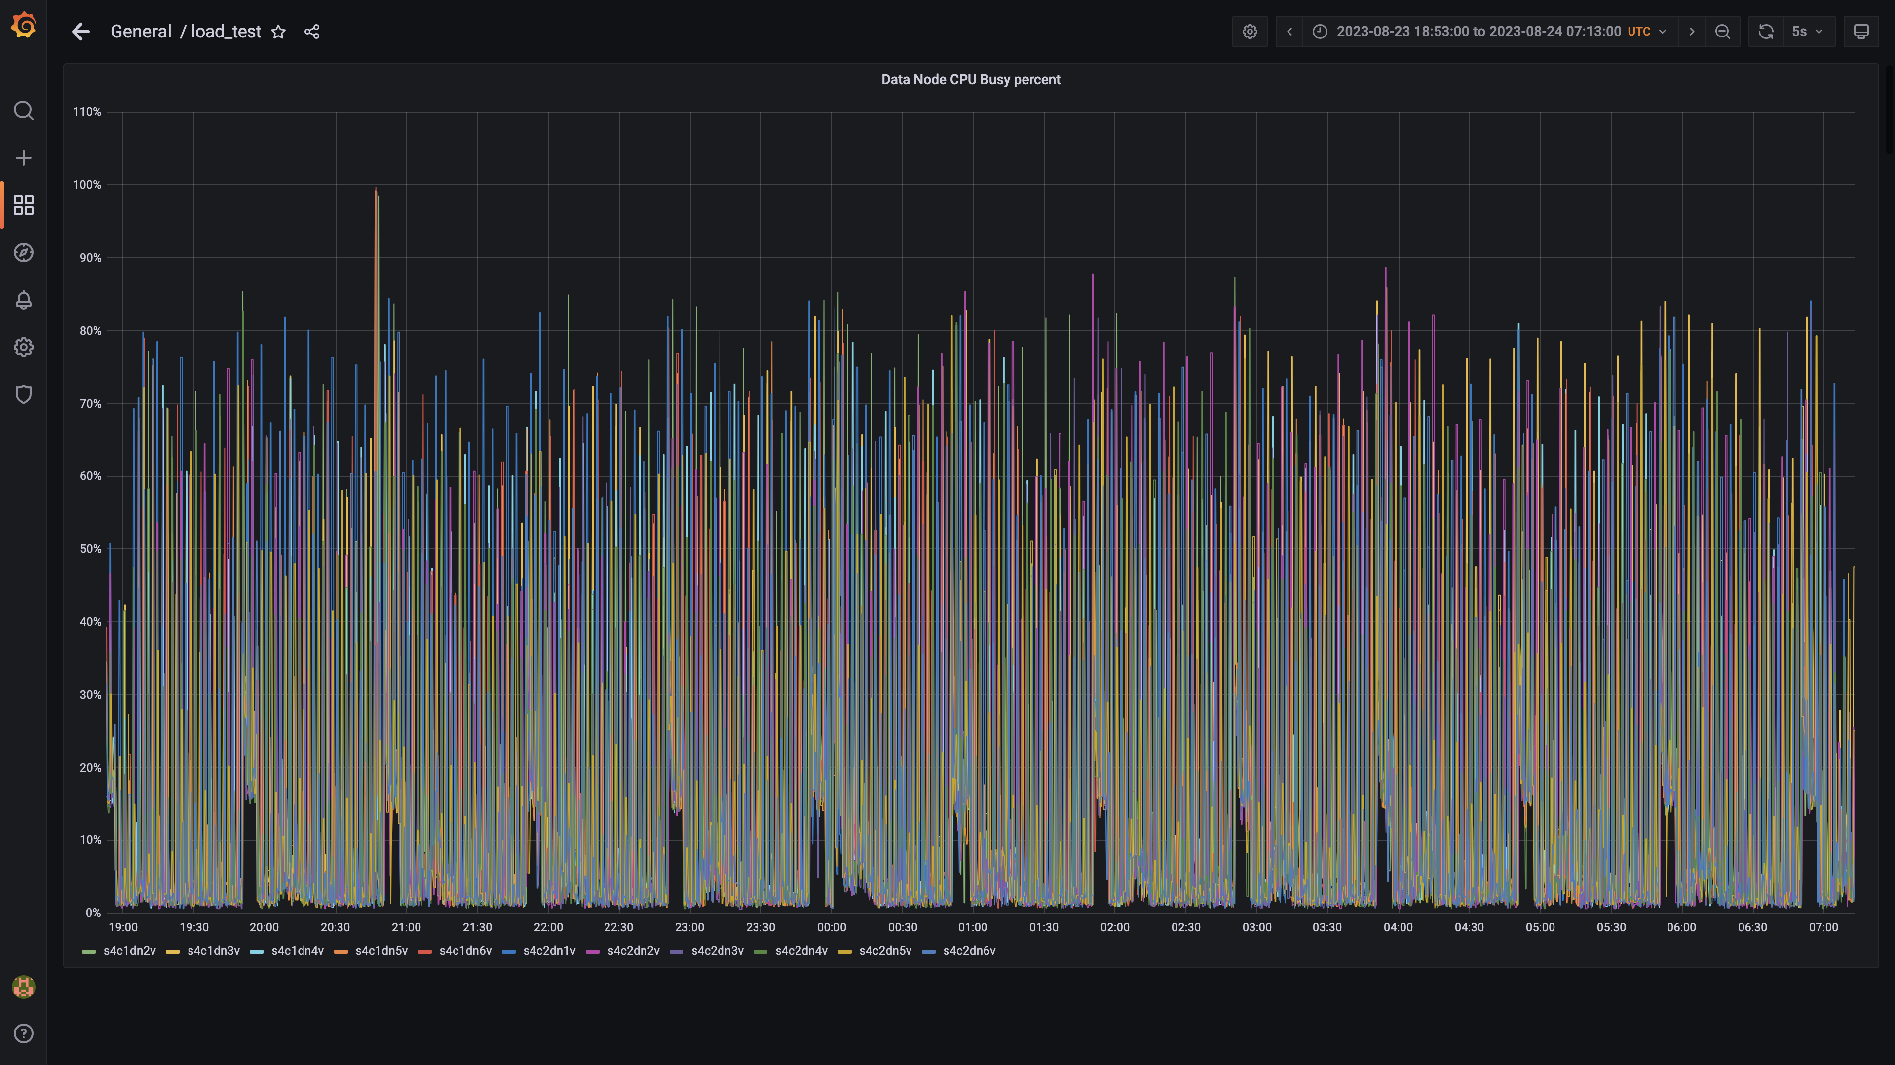

### Process node cpu busy percent

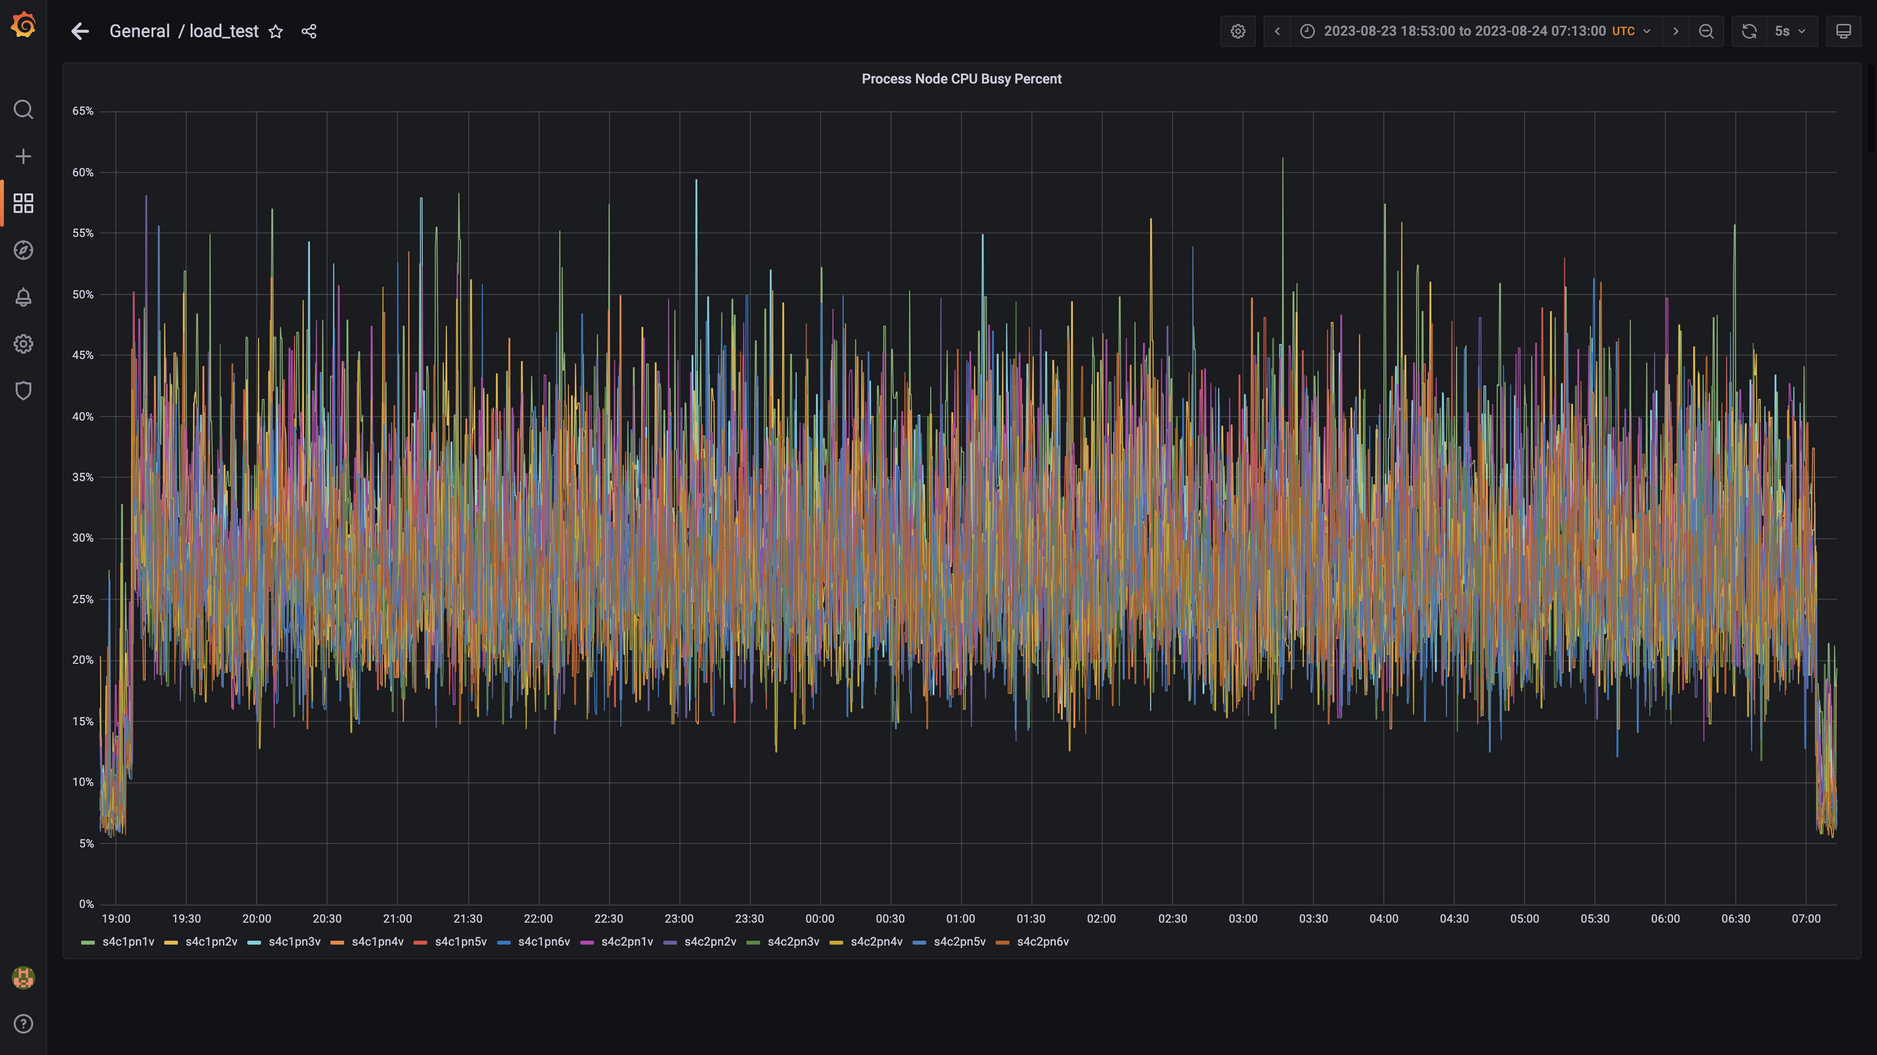

### Sts app cpu%

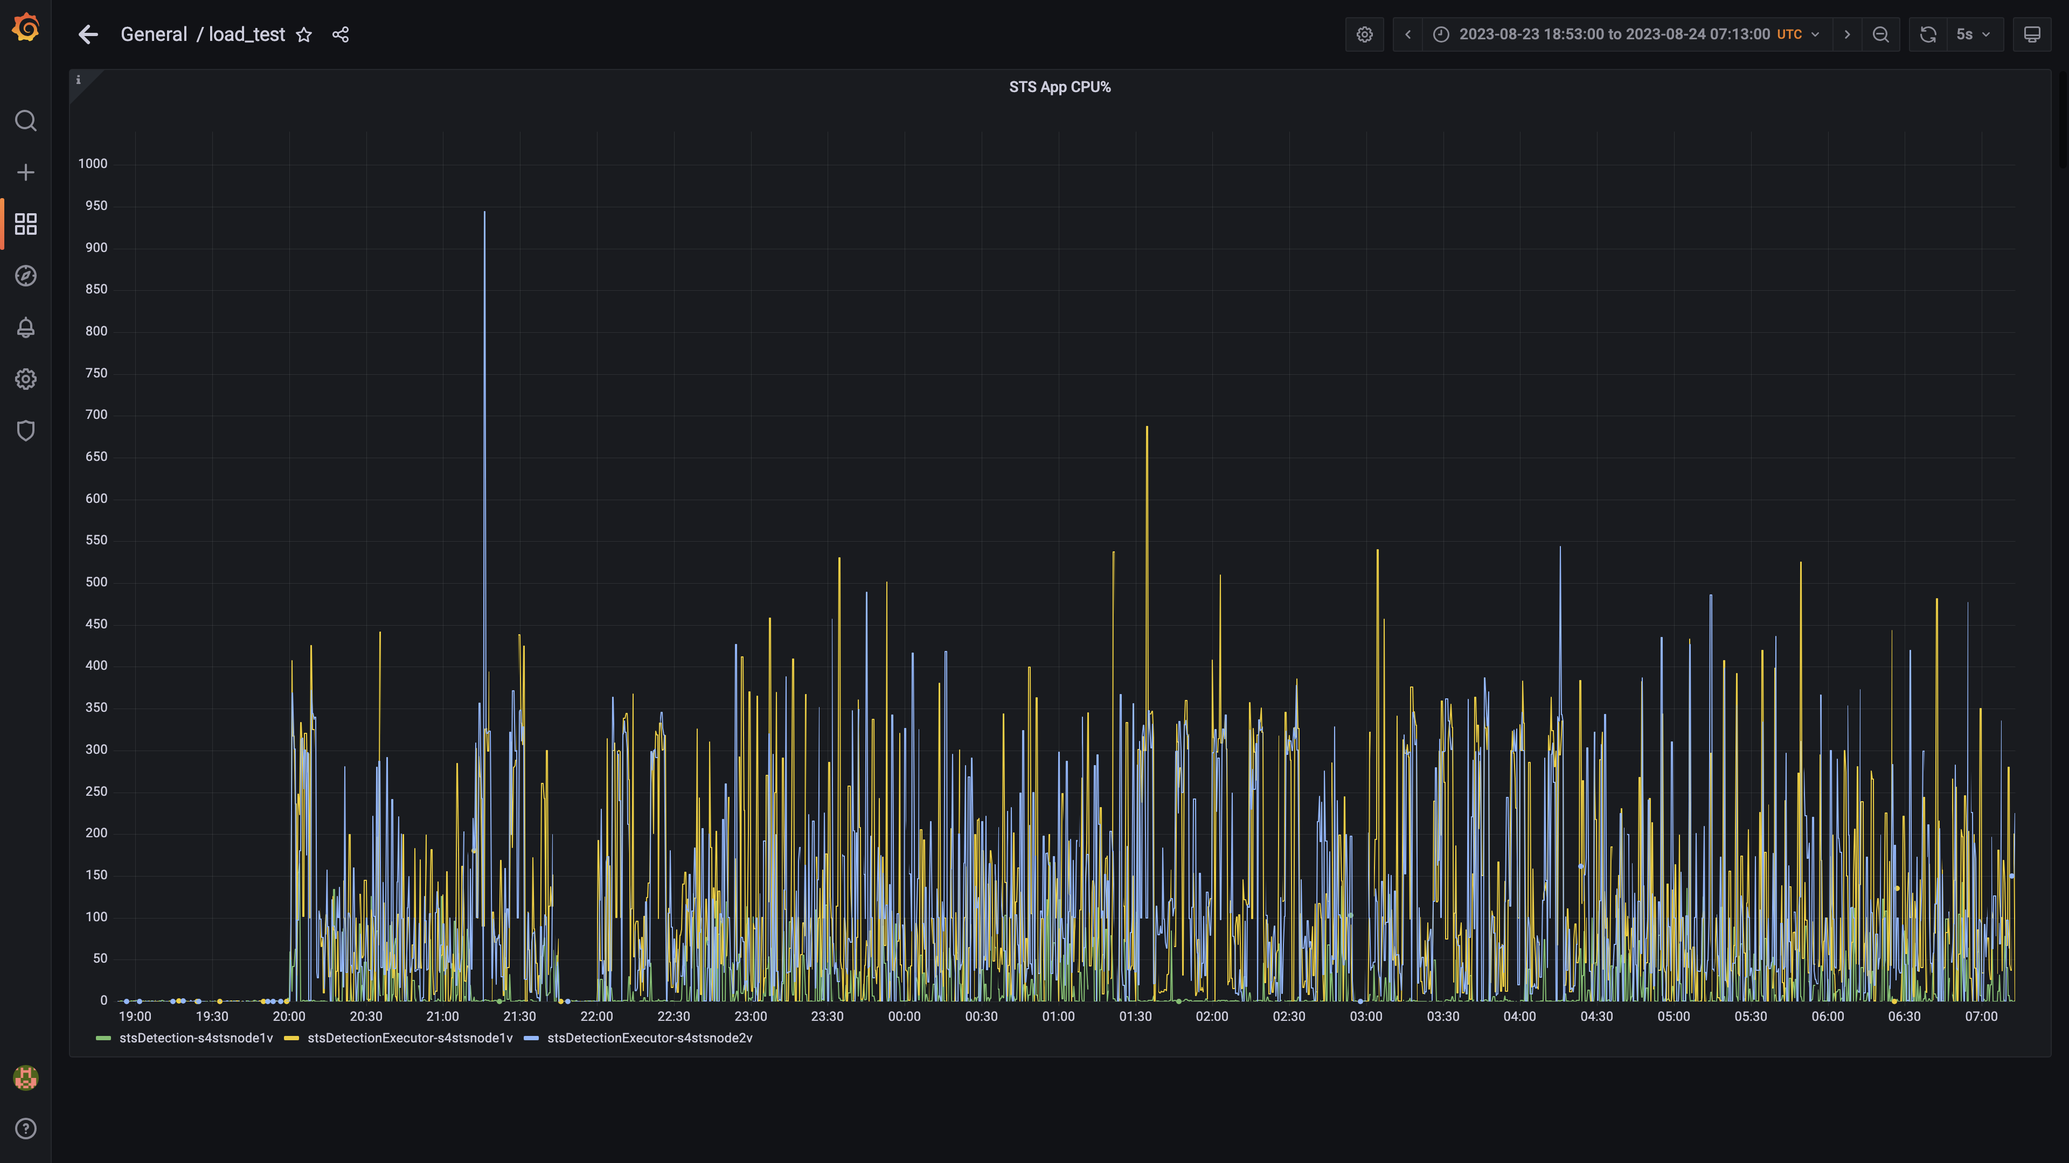

### Postgres node cpu busy percent

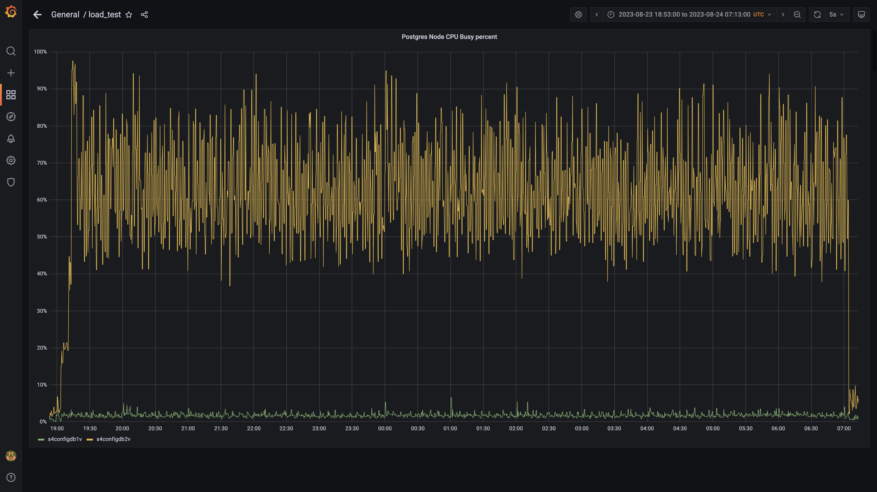

### Cpu consumed by cloudqueryconsumer

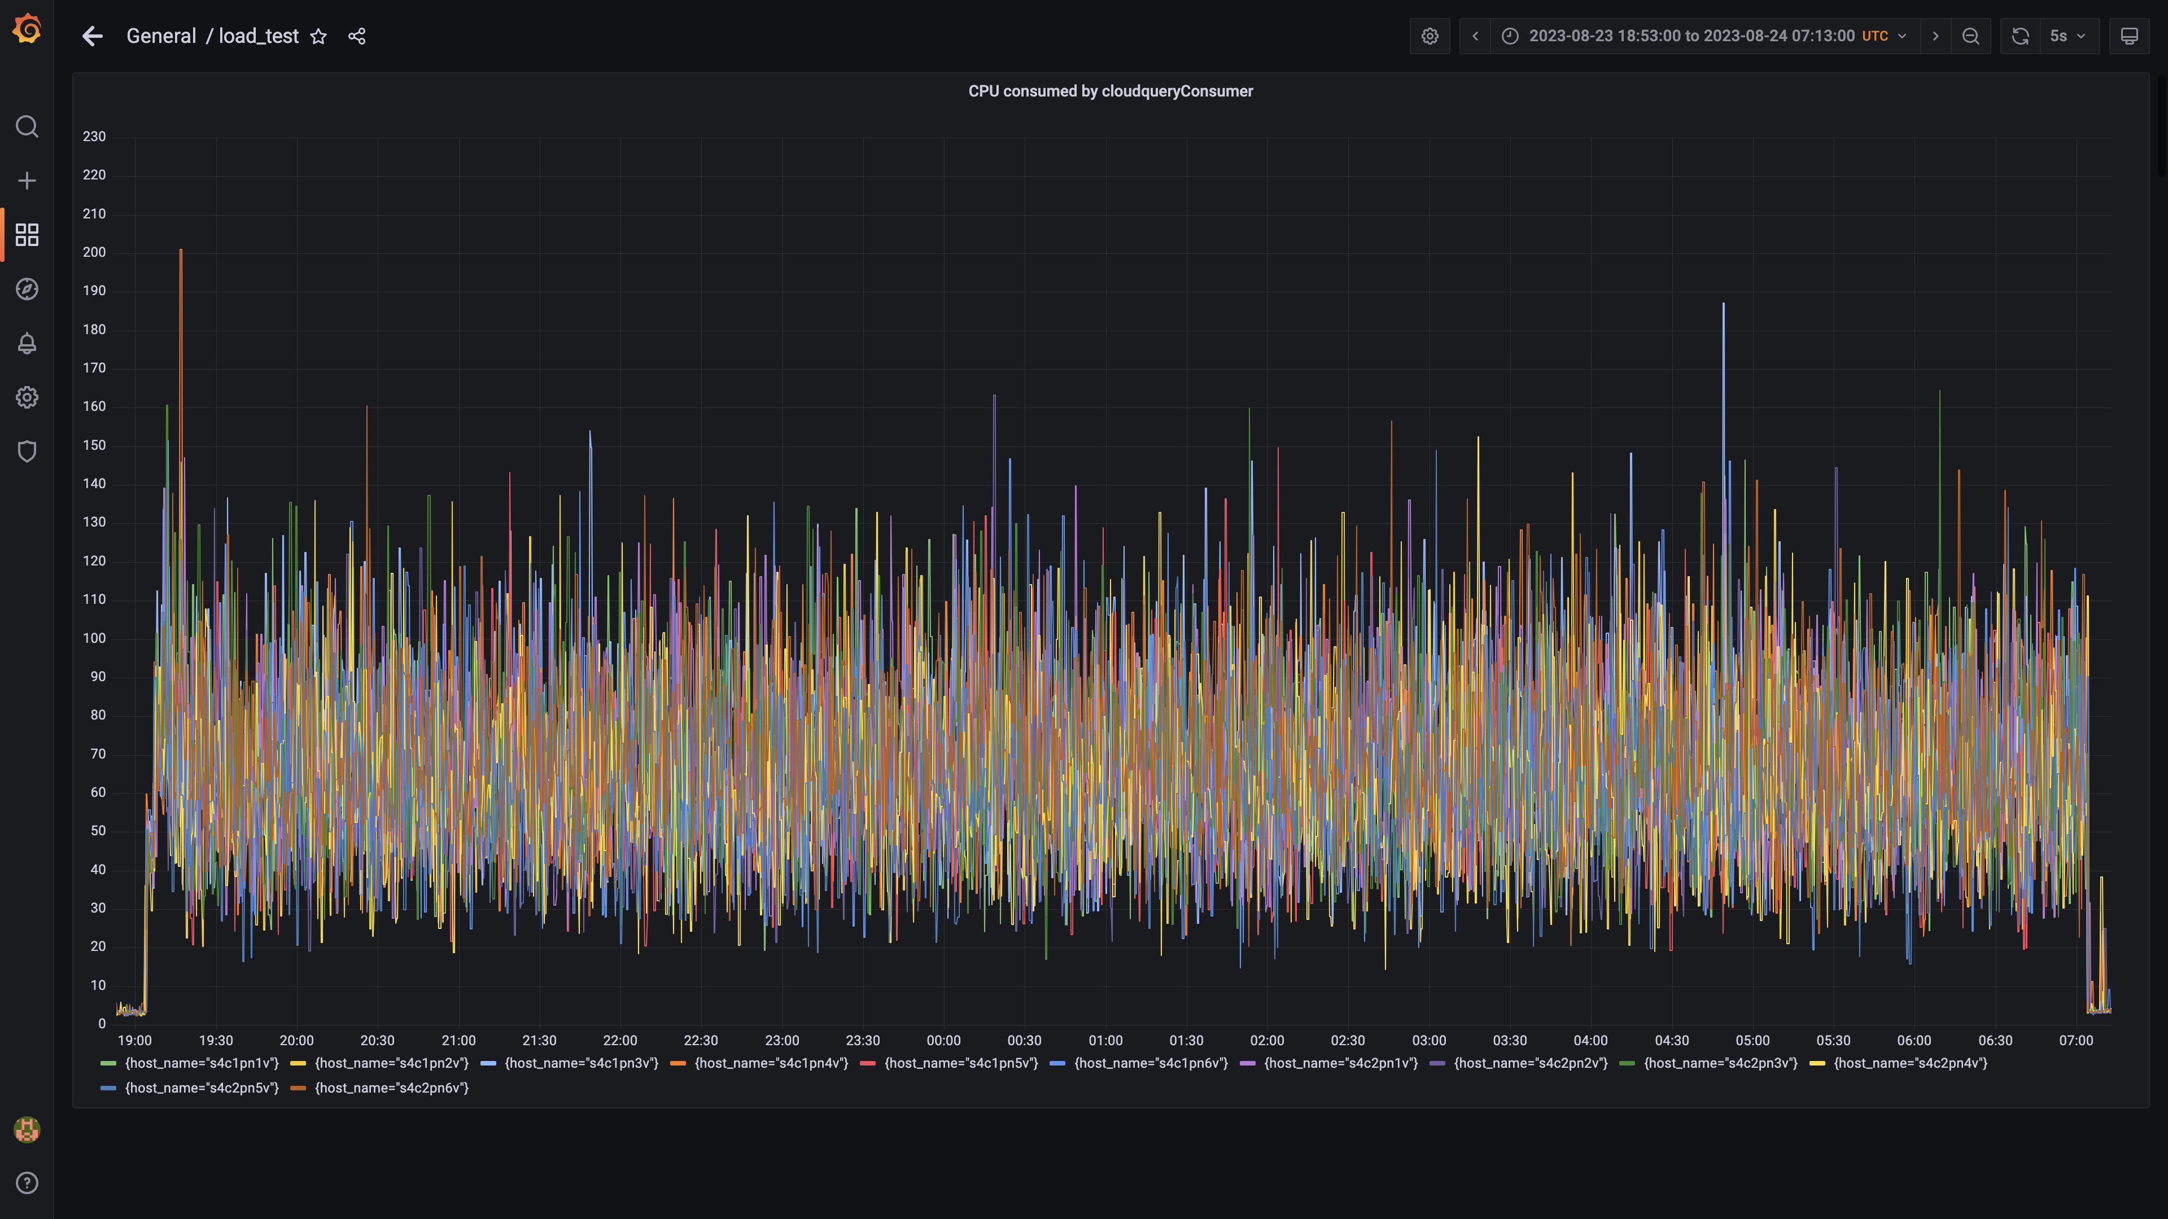

### Cpu consumed by clouddetectionconsumer

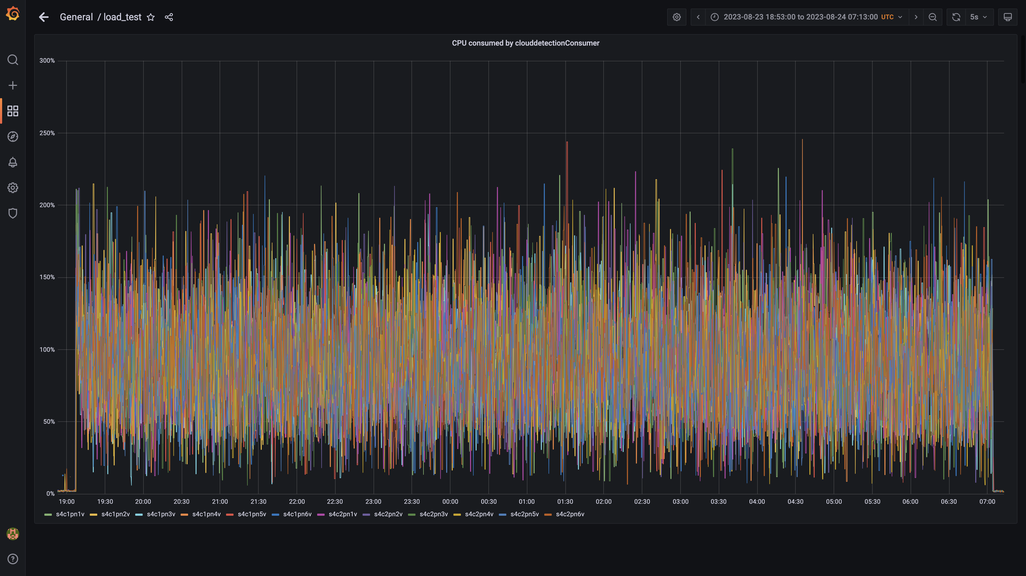

### Statedb cpu used percent

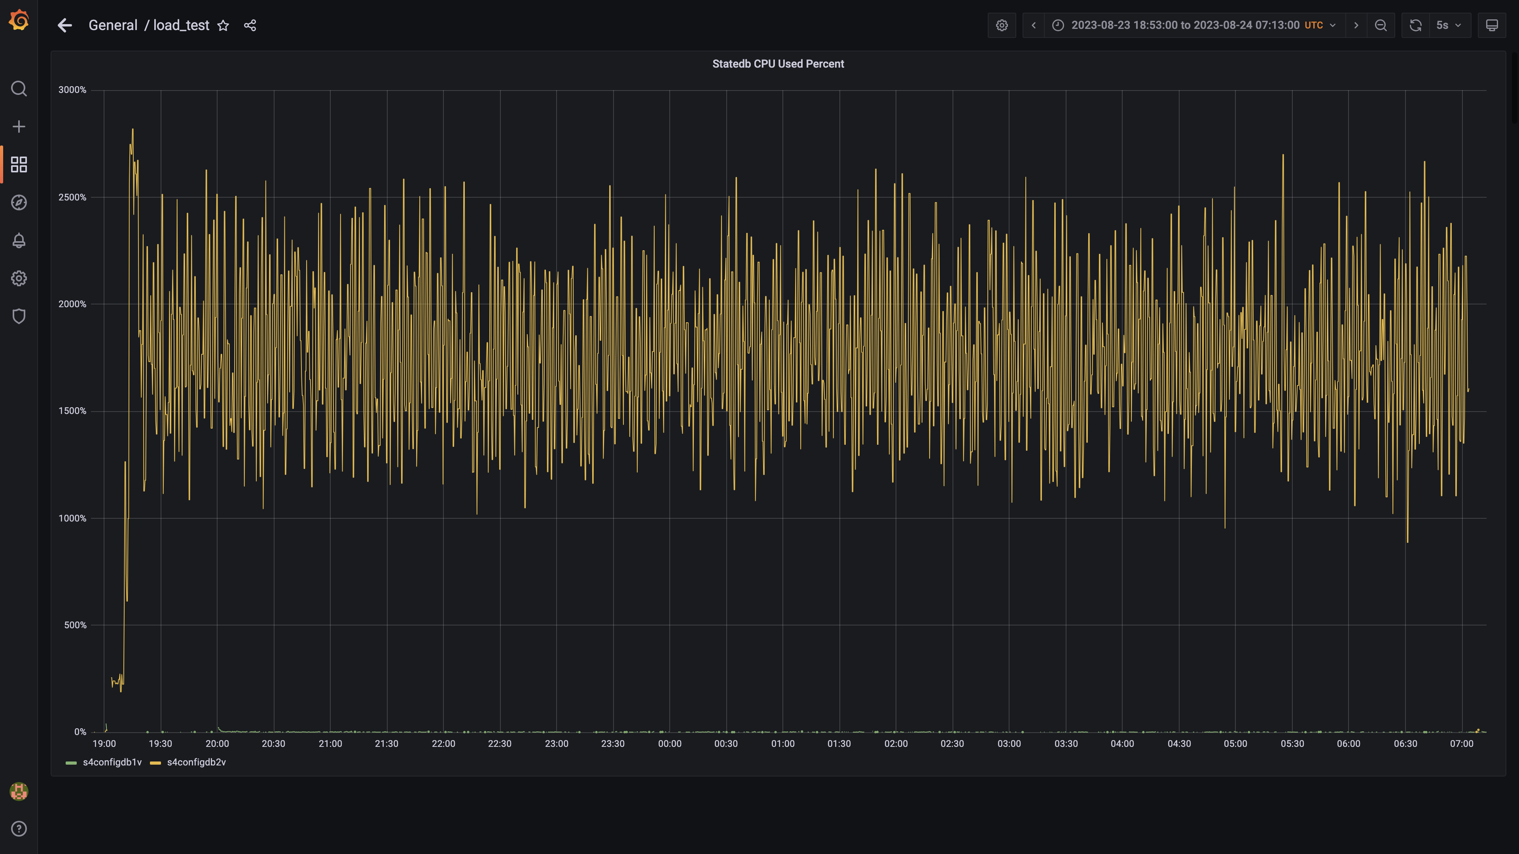

### Cpu consumed by cloudconnectoringestion

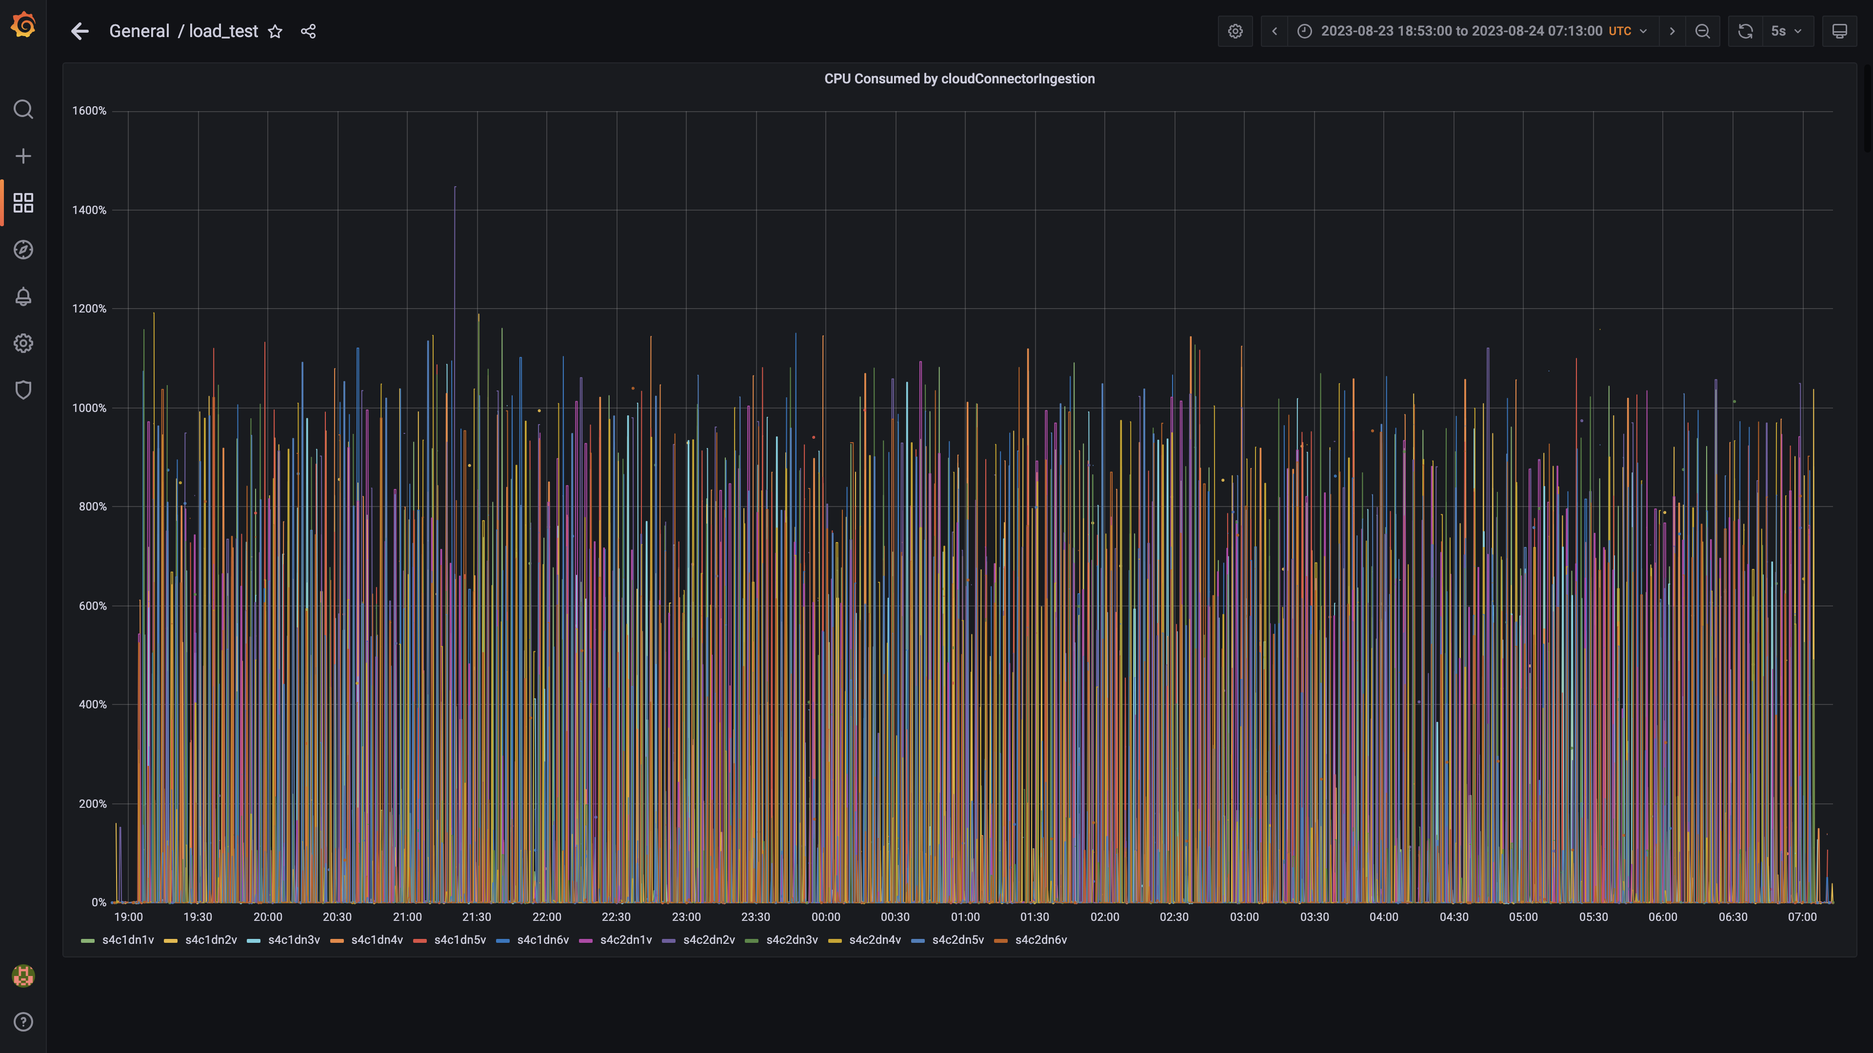

### Cpu consumed by tls

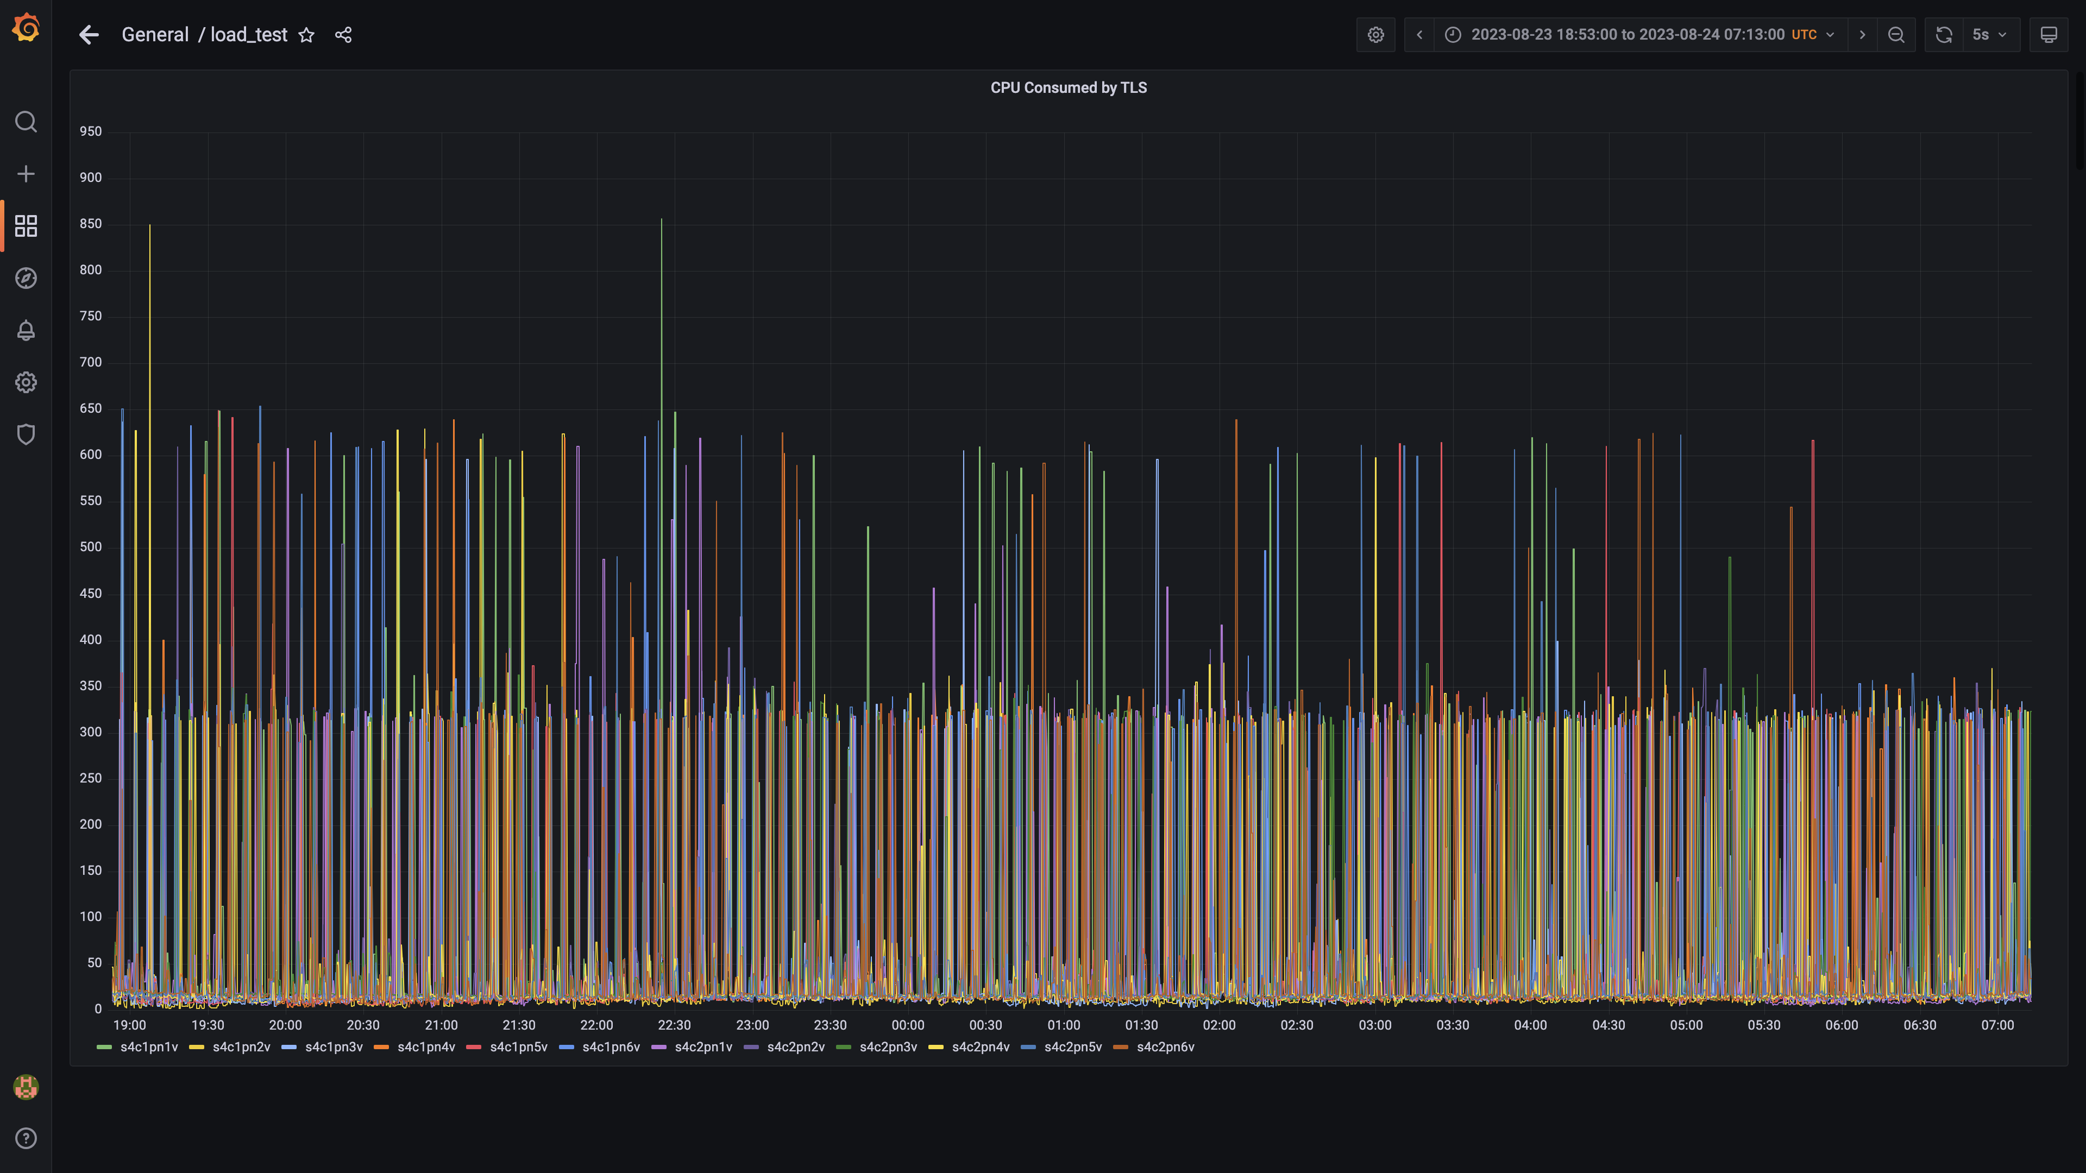

### Postgres-configdb cpu used percentage

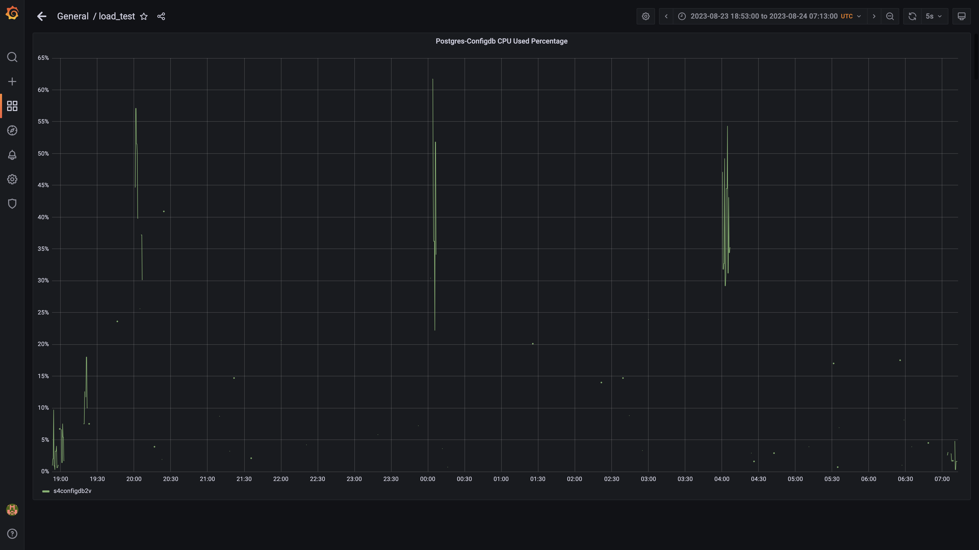

### Kafka cpu used percentage

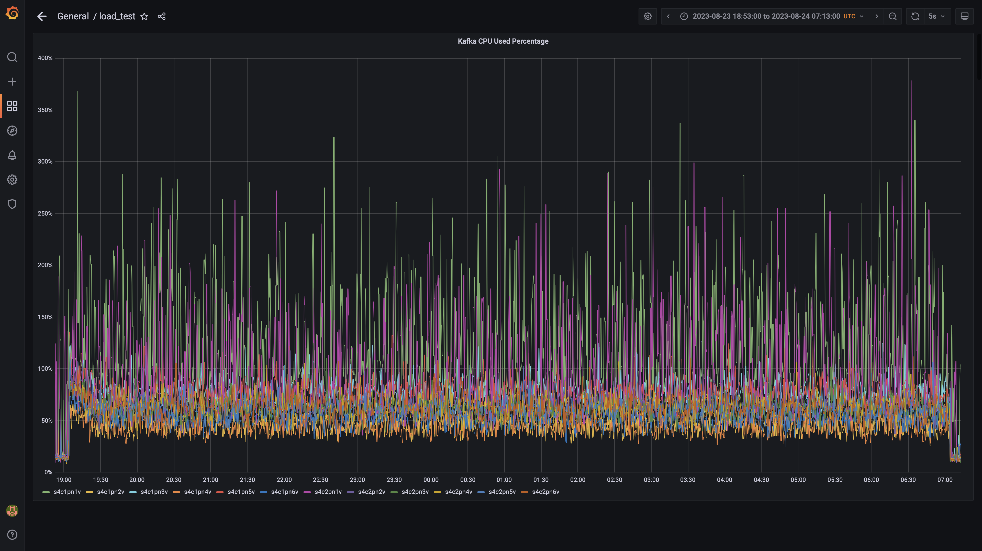

### Cpu used by data-archival

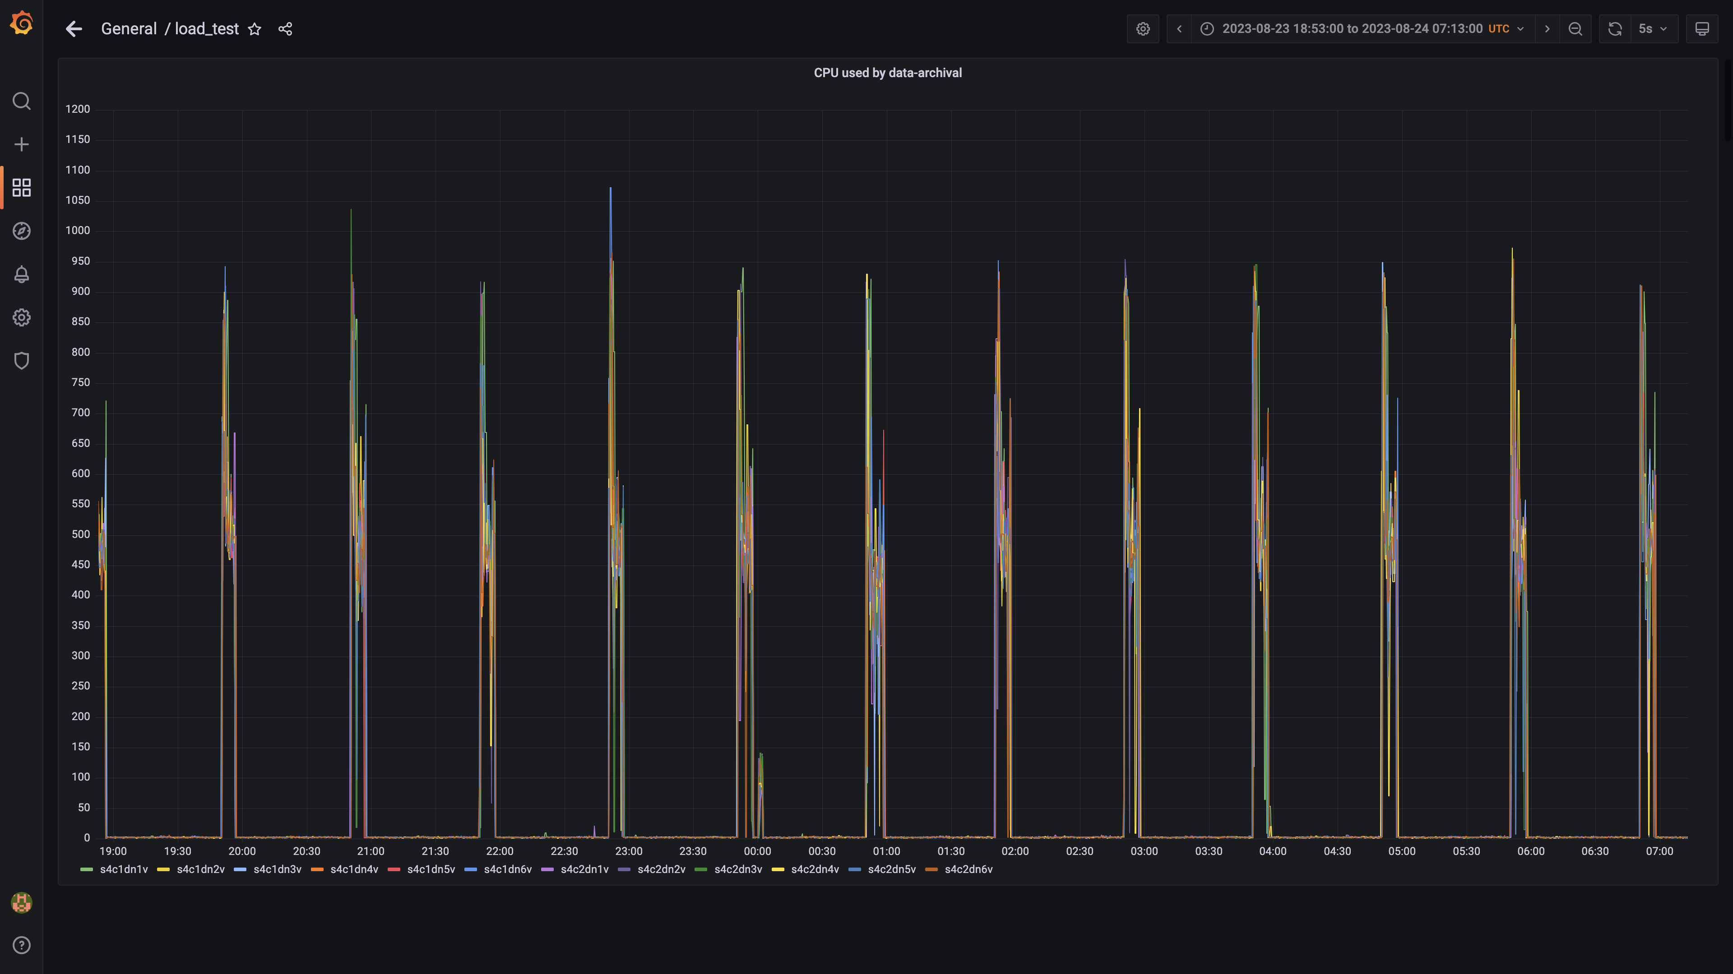

### Cpu consumed by osqueryingestion

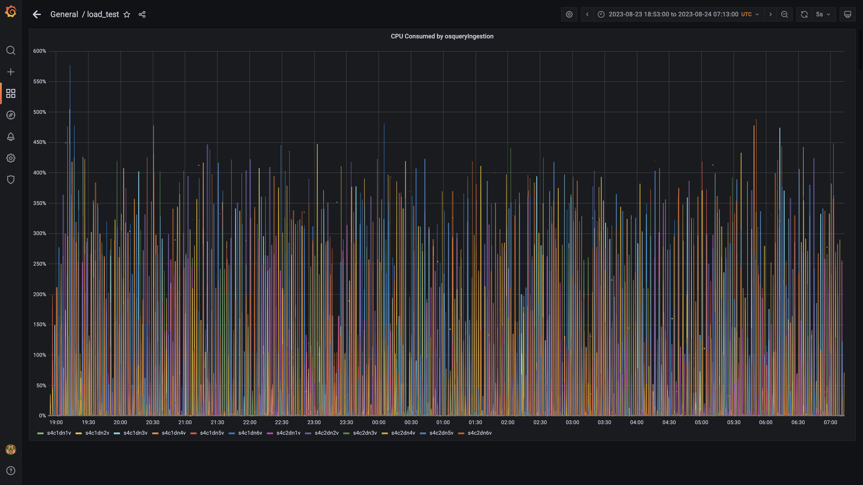

### Cpu consumed by logger

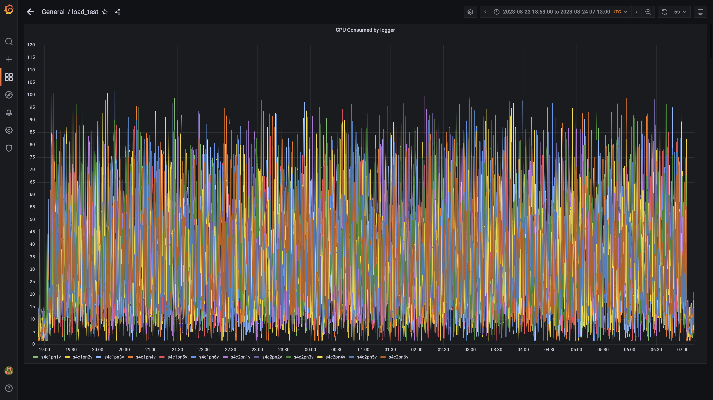

### Cpu consumed by trino

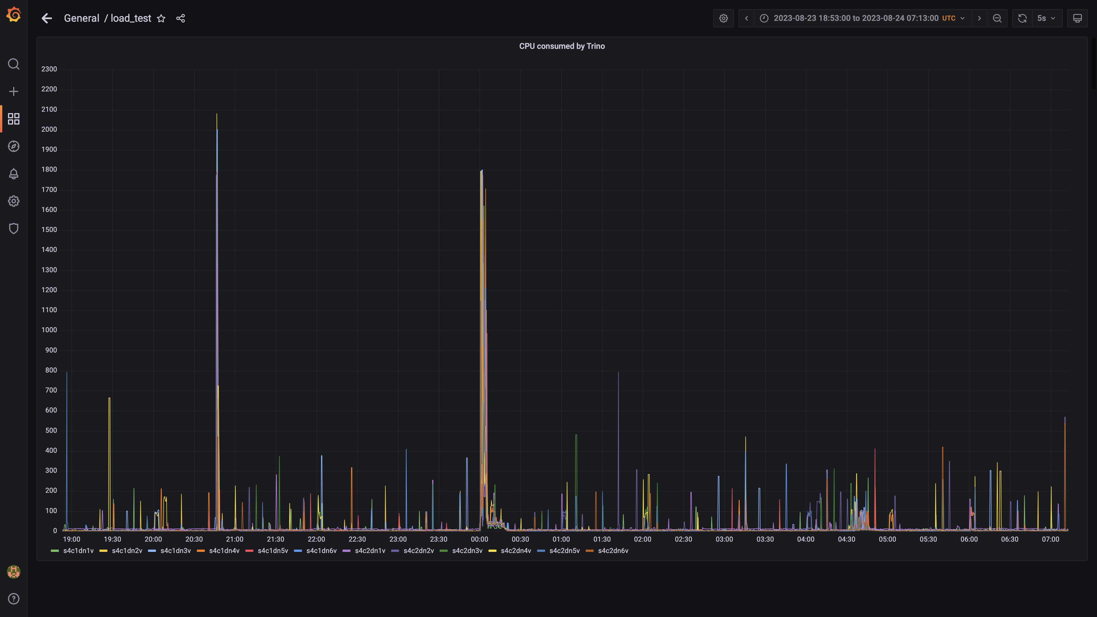

### Debezium cpu usage

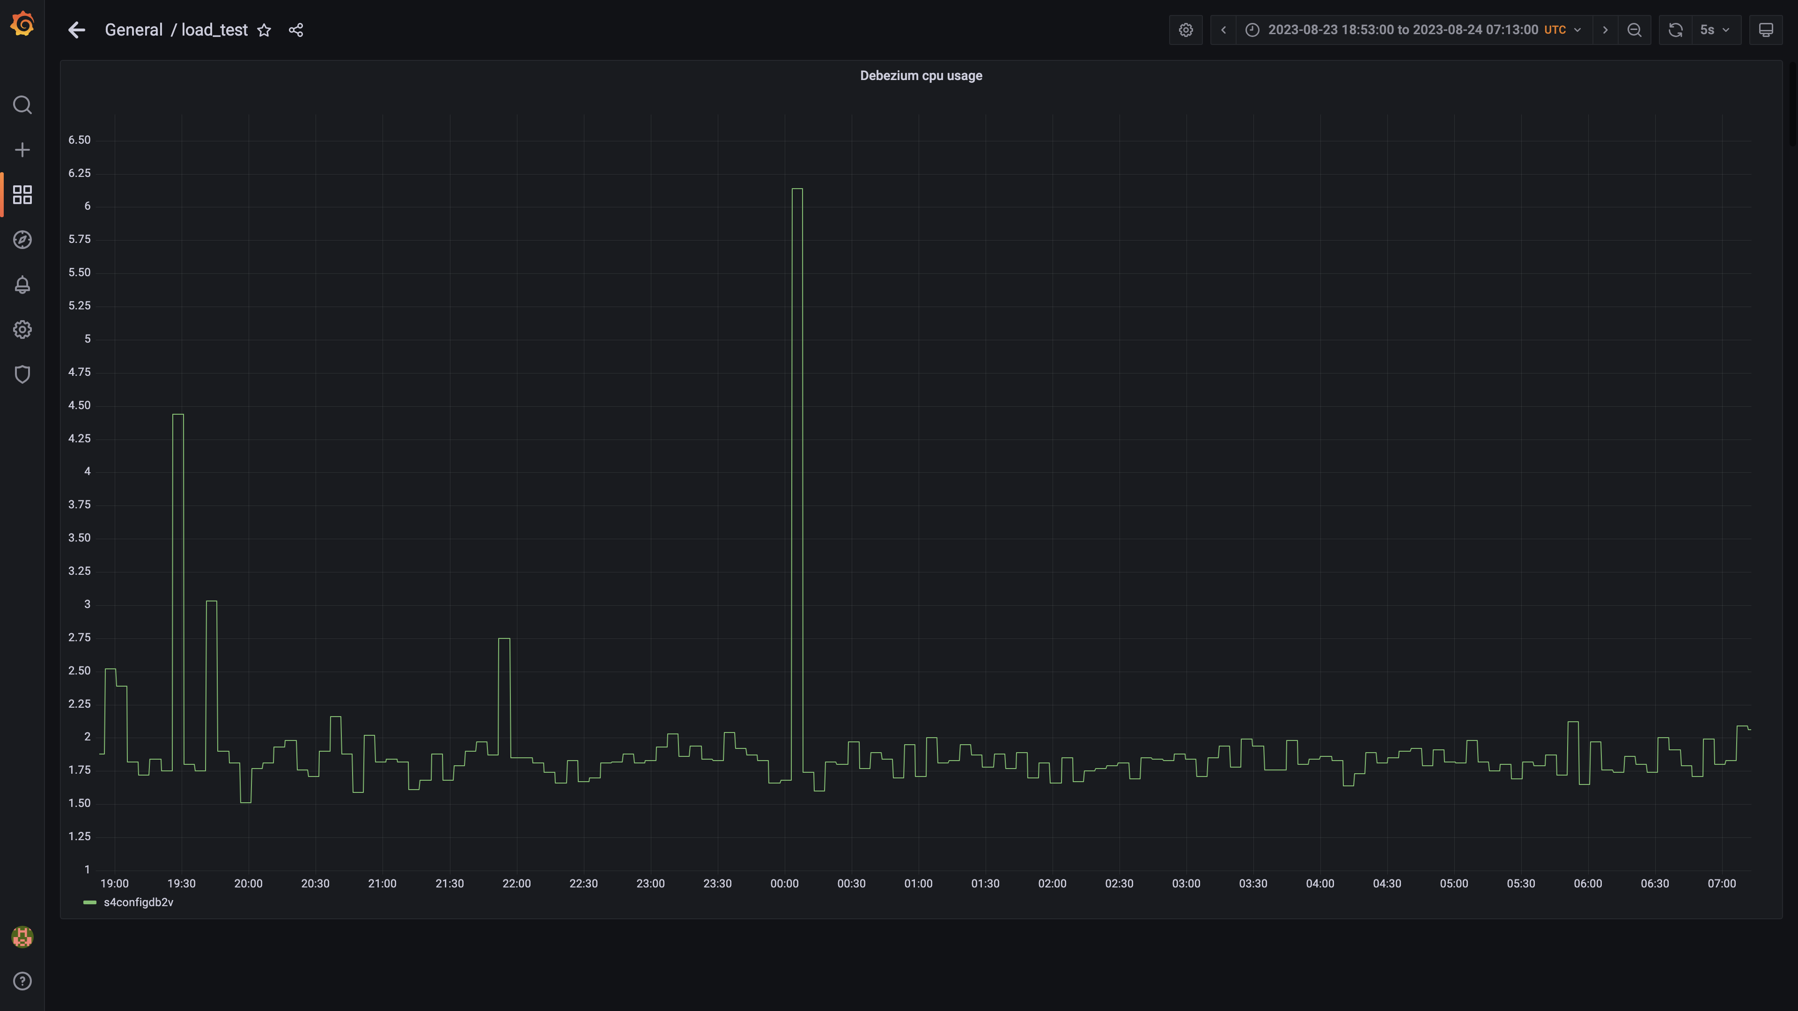

### Cpu consumed by orc-compaction:

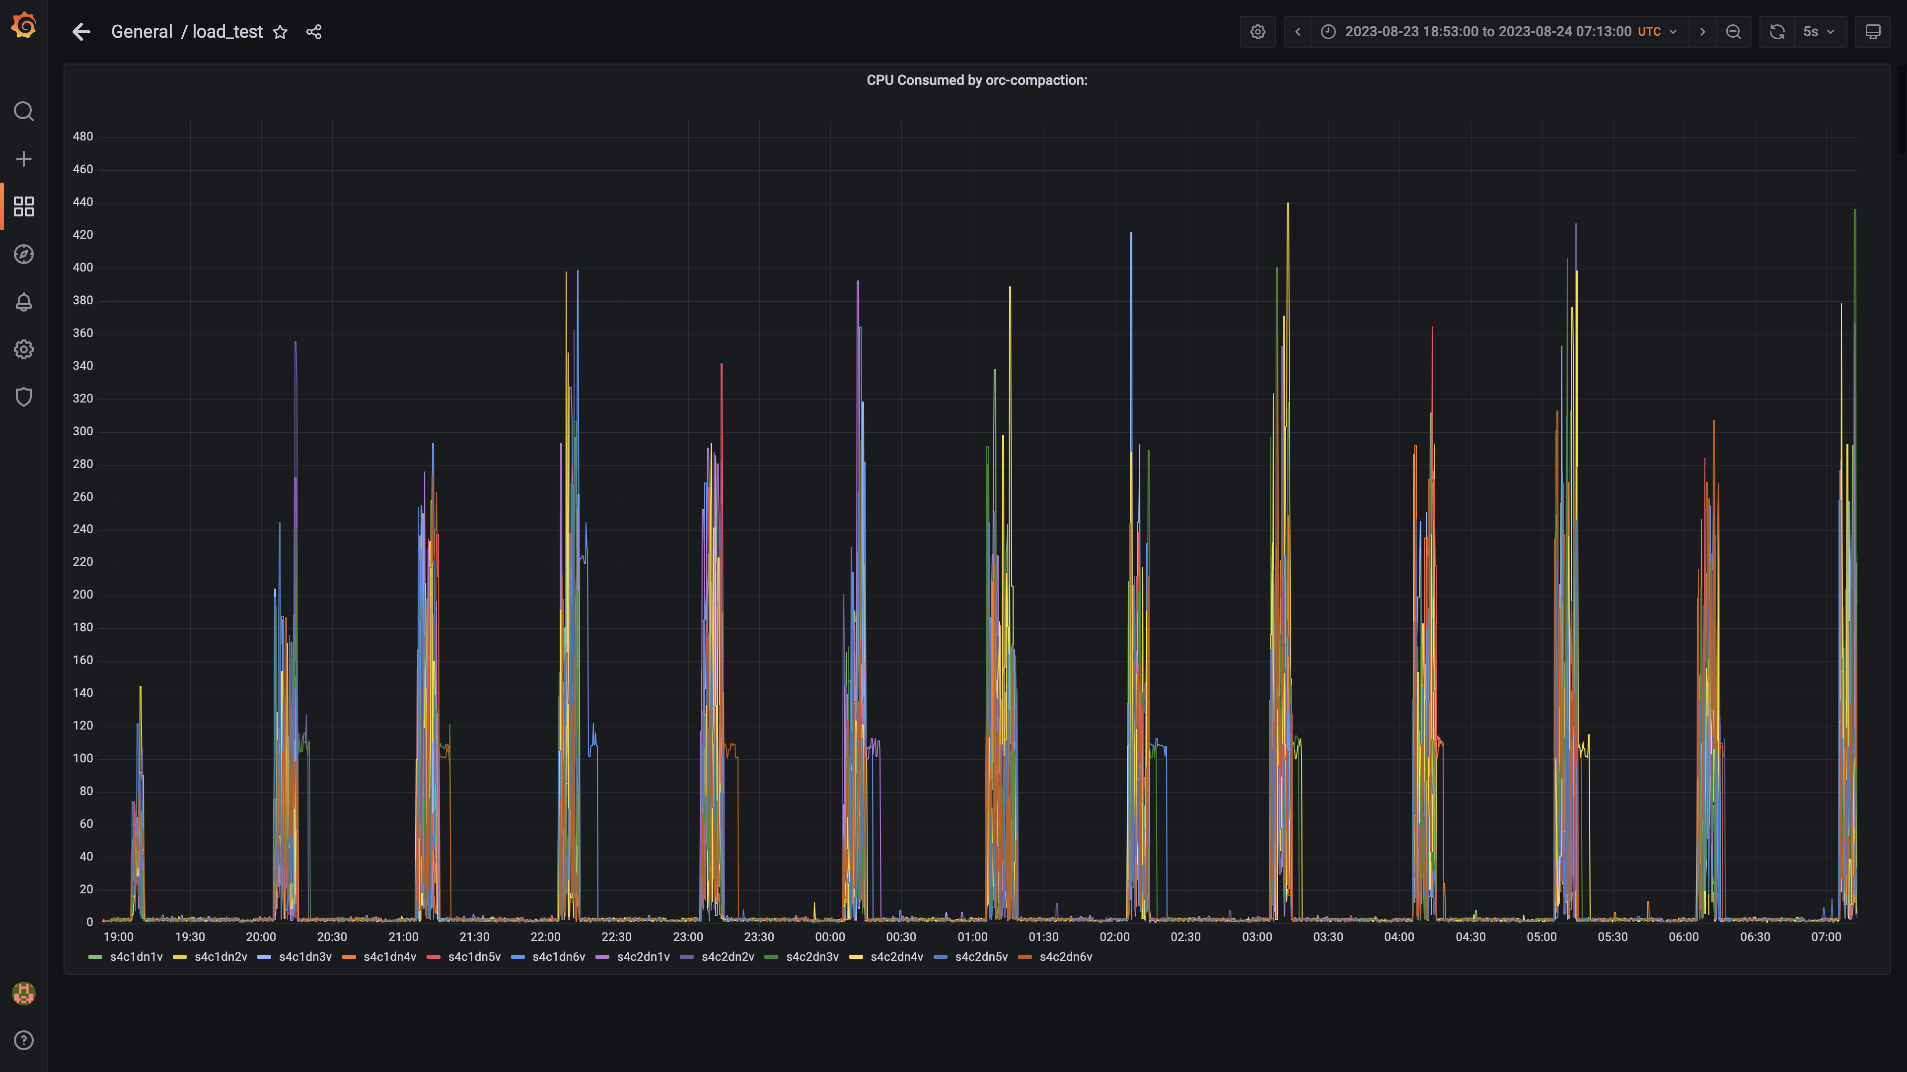

### Cpu consumed by spark-worker

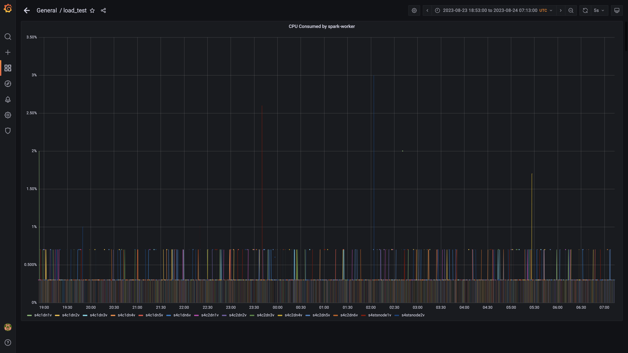

### Cpu consumed by ruleengine

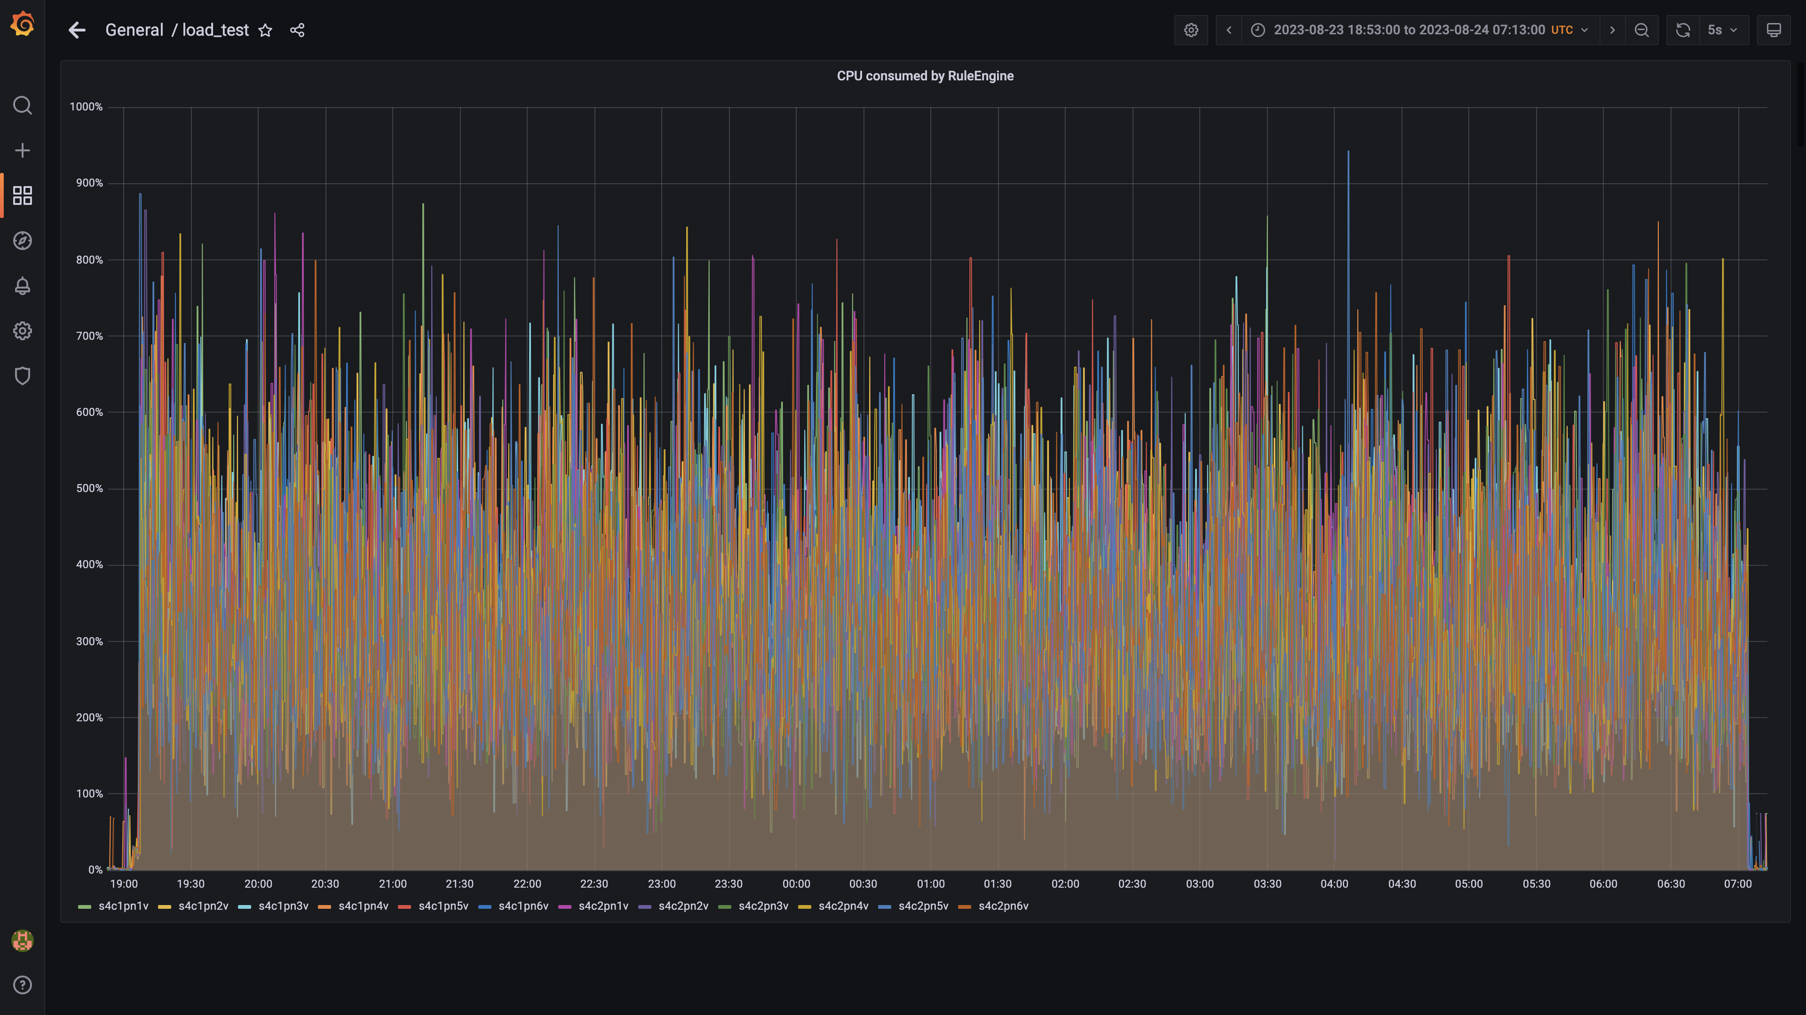

### Cpu consumed by airflow

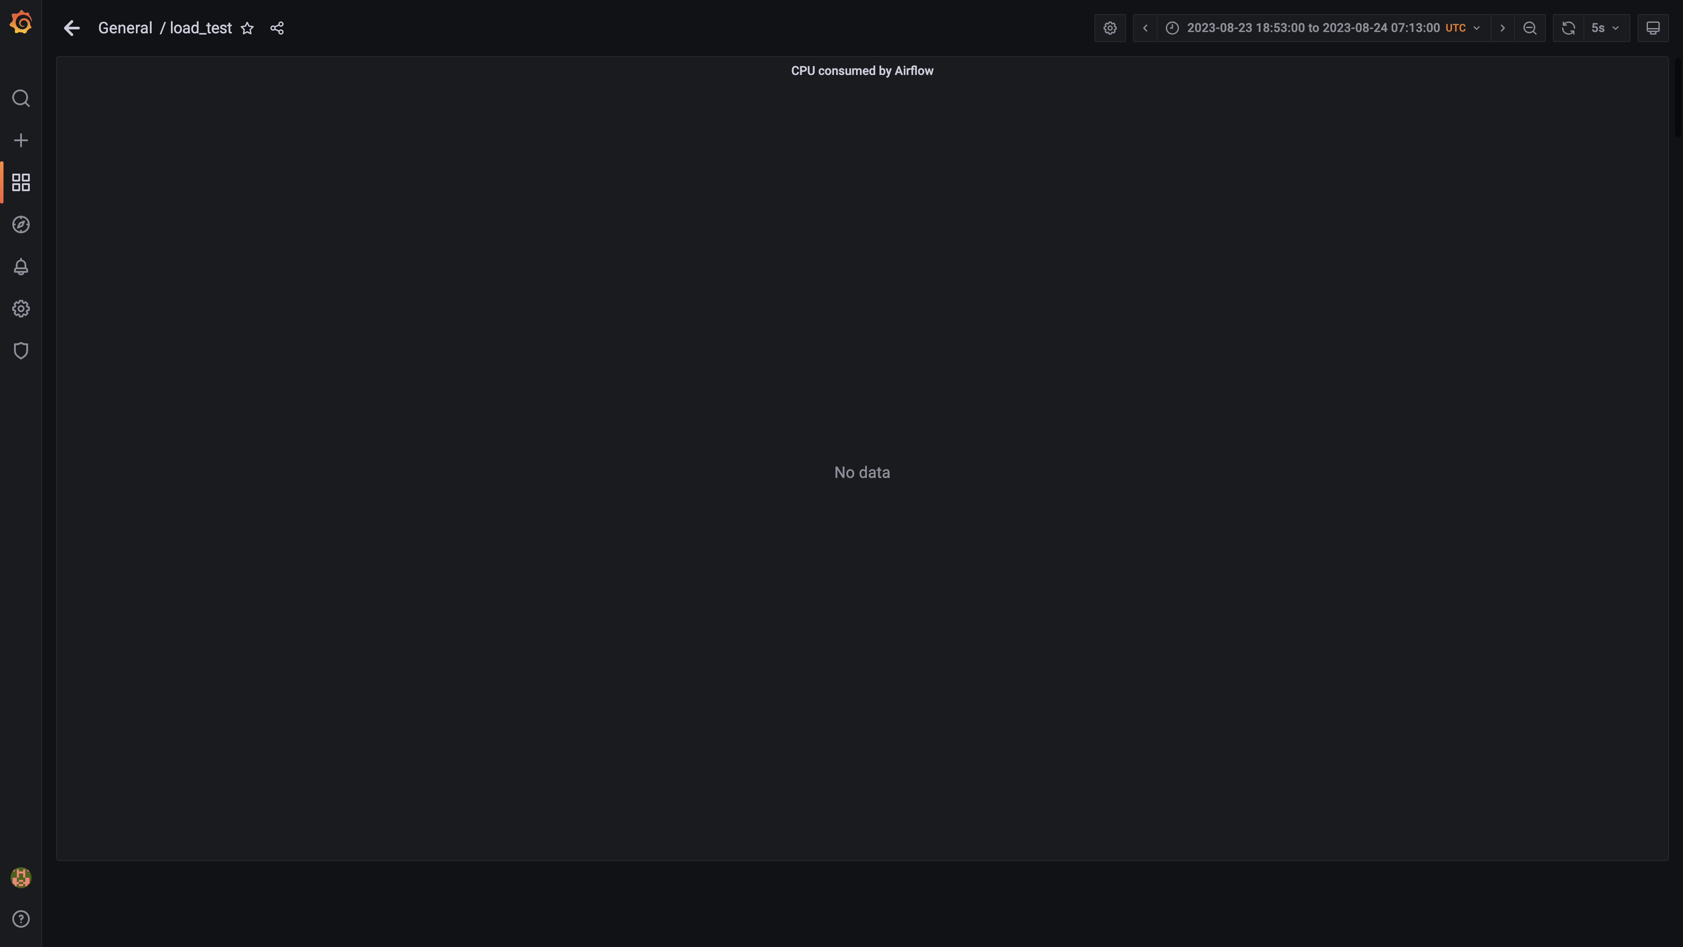

### Cpu consumed by redis server

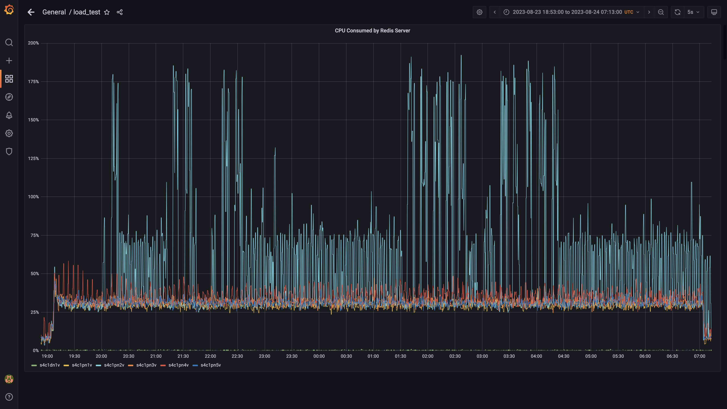

### Cpu consumed by spark-master

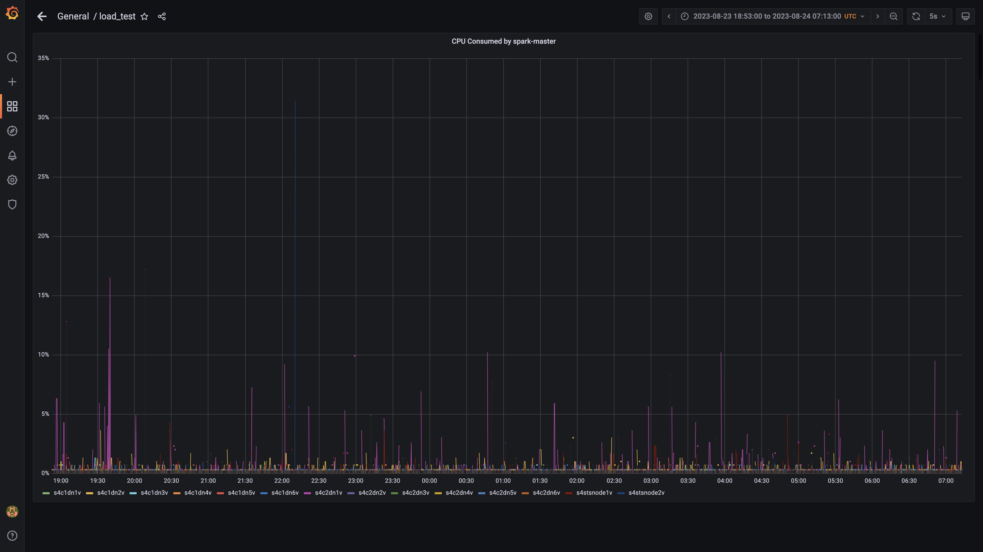

### Kafka lag for cloudconnectoringestion

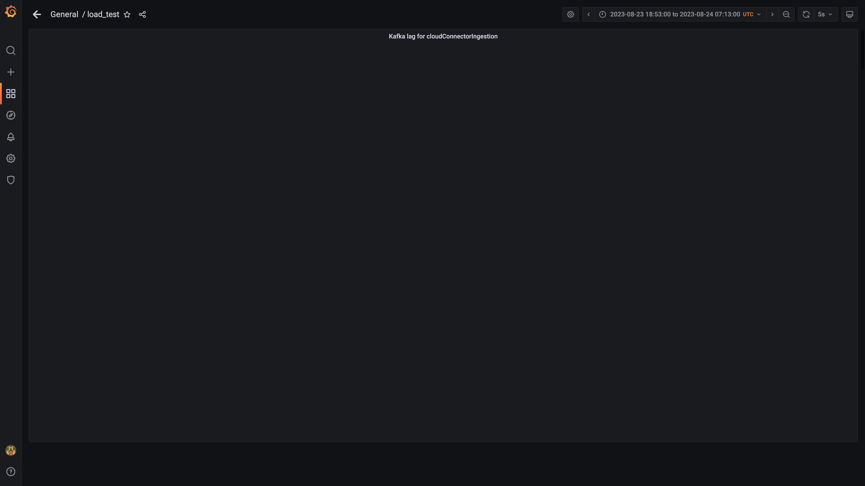

### Inject and drain rate for cloudconnectorsingestion

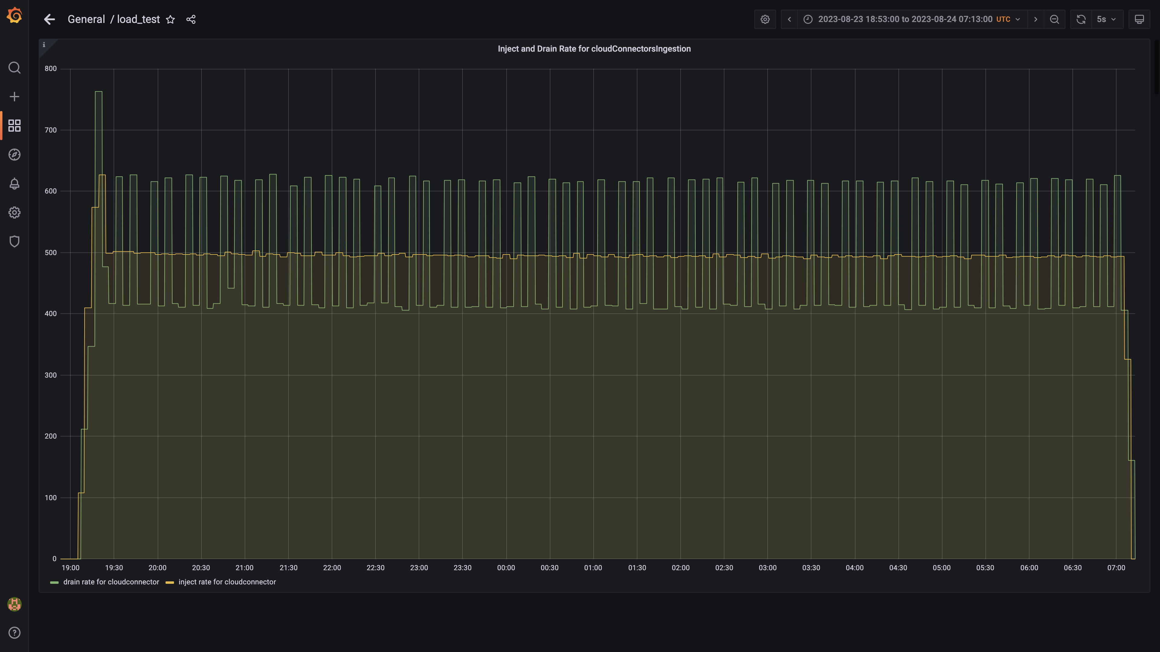

### Kafka lag for cloudqueryinventorygroup

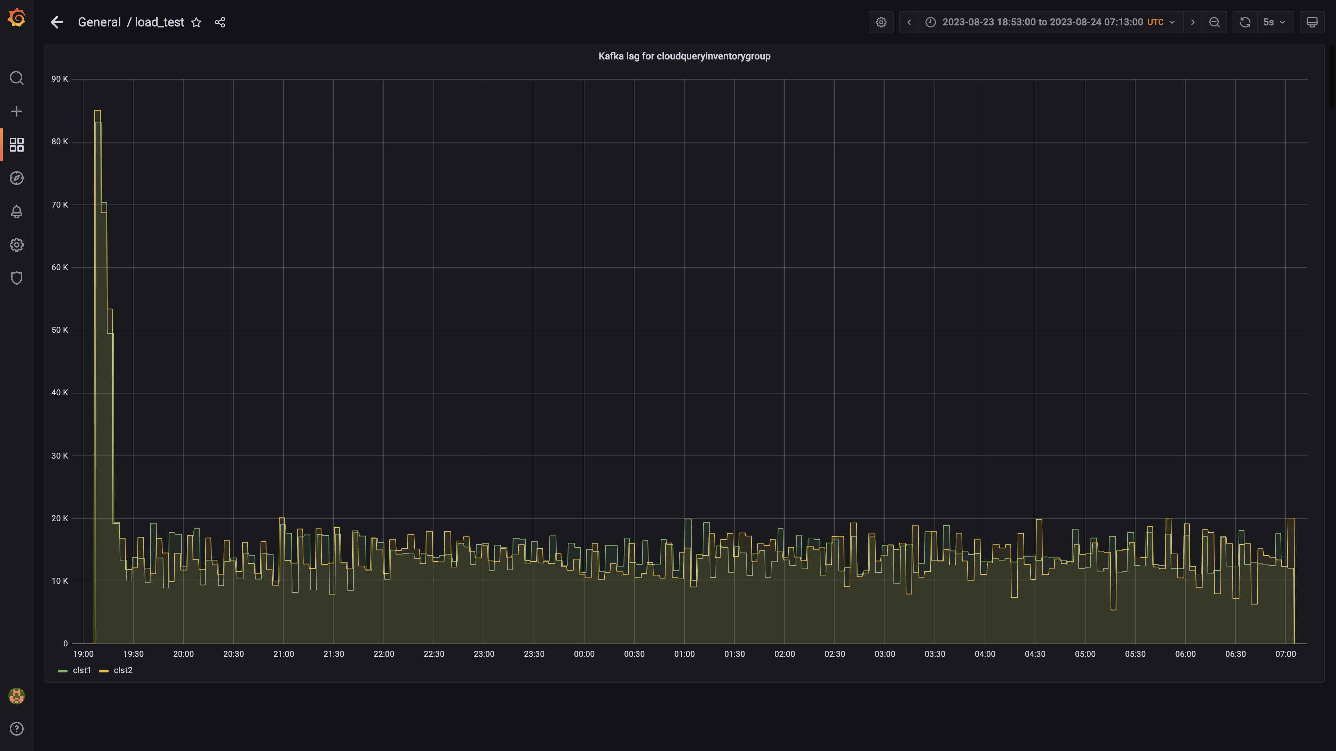

### Kafka lag for cloudtraileventsgroup

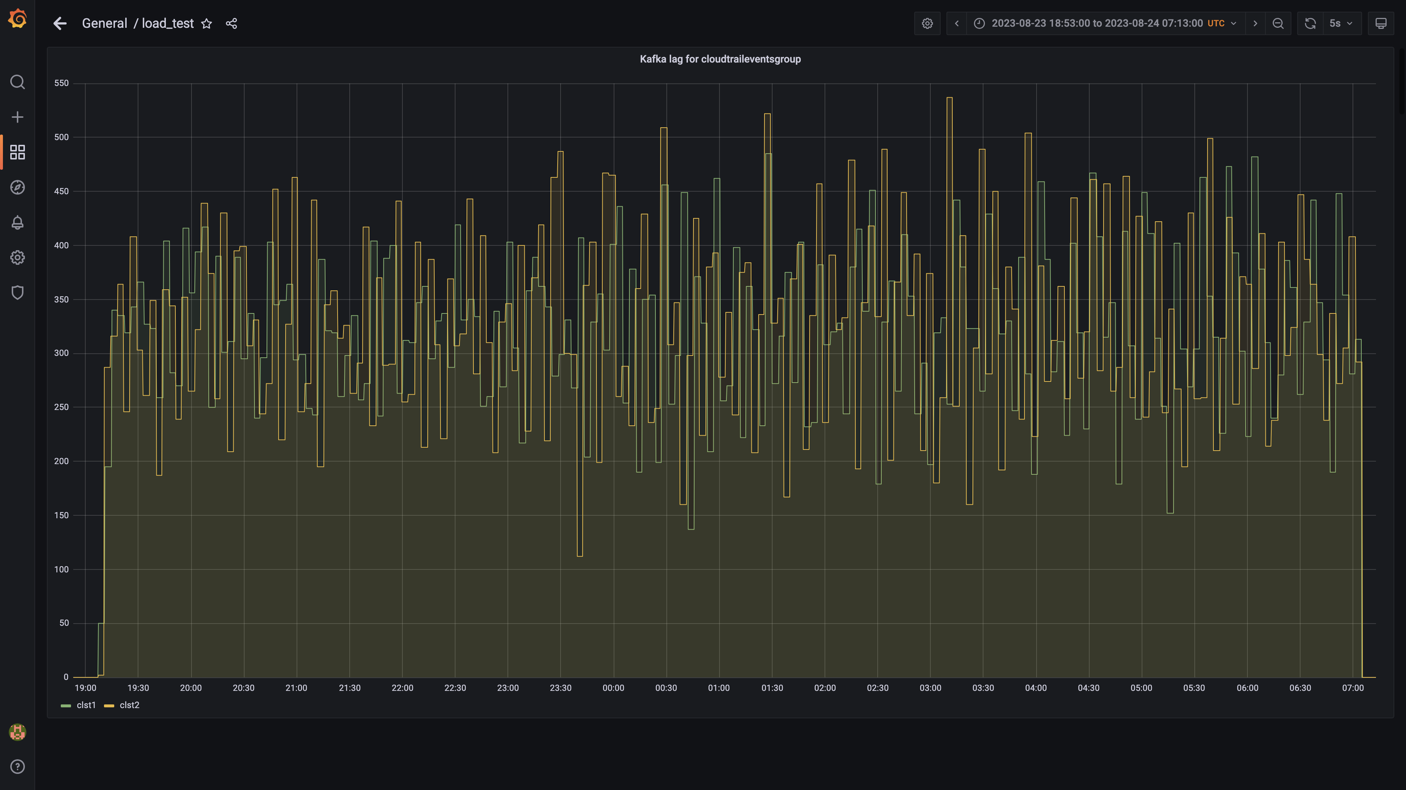

### Kafka lag for cloudqueryeventsgroup

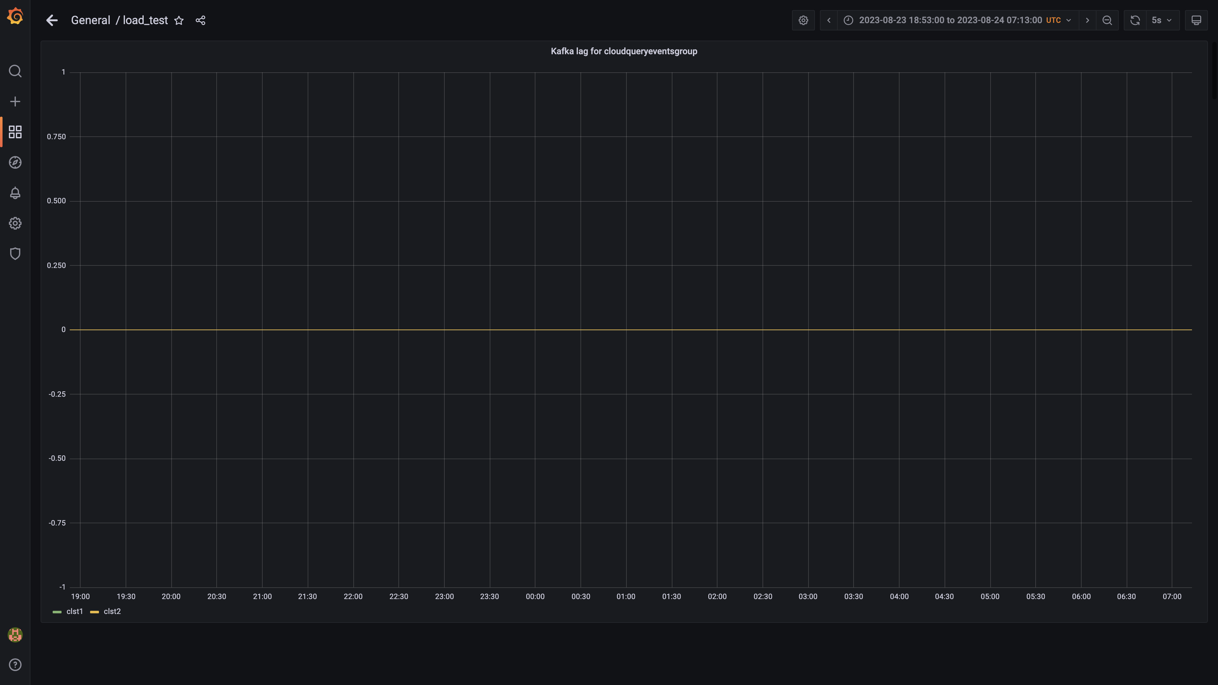

### Kafka lag for ruleenginecc group

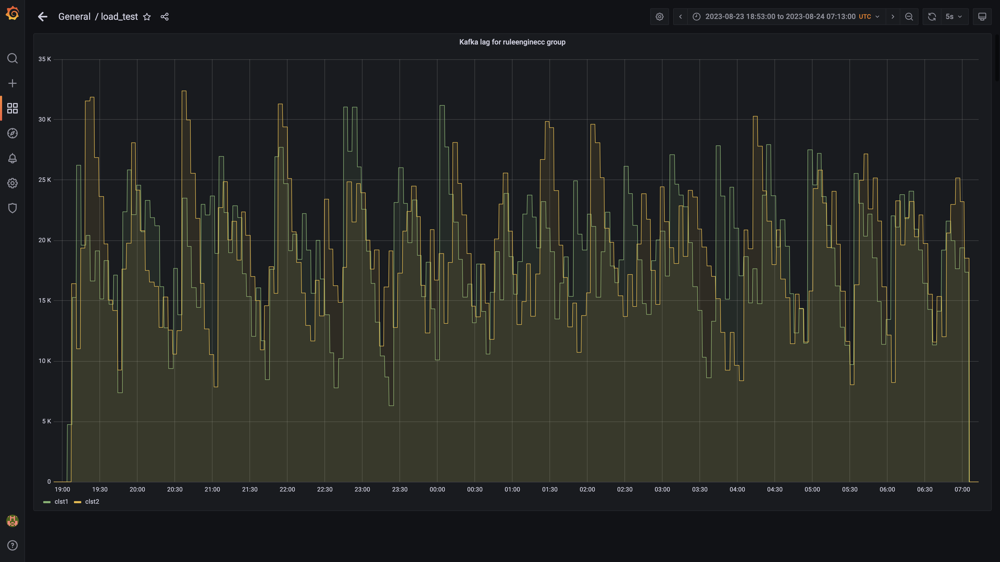

### Kafka lag for cloudcompliancemanager

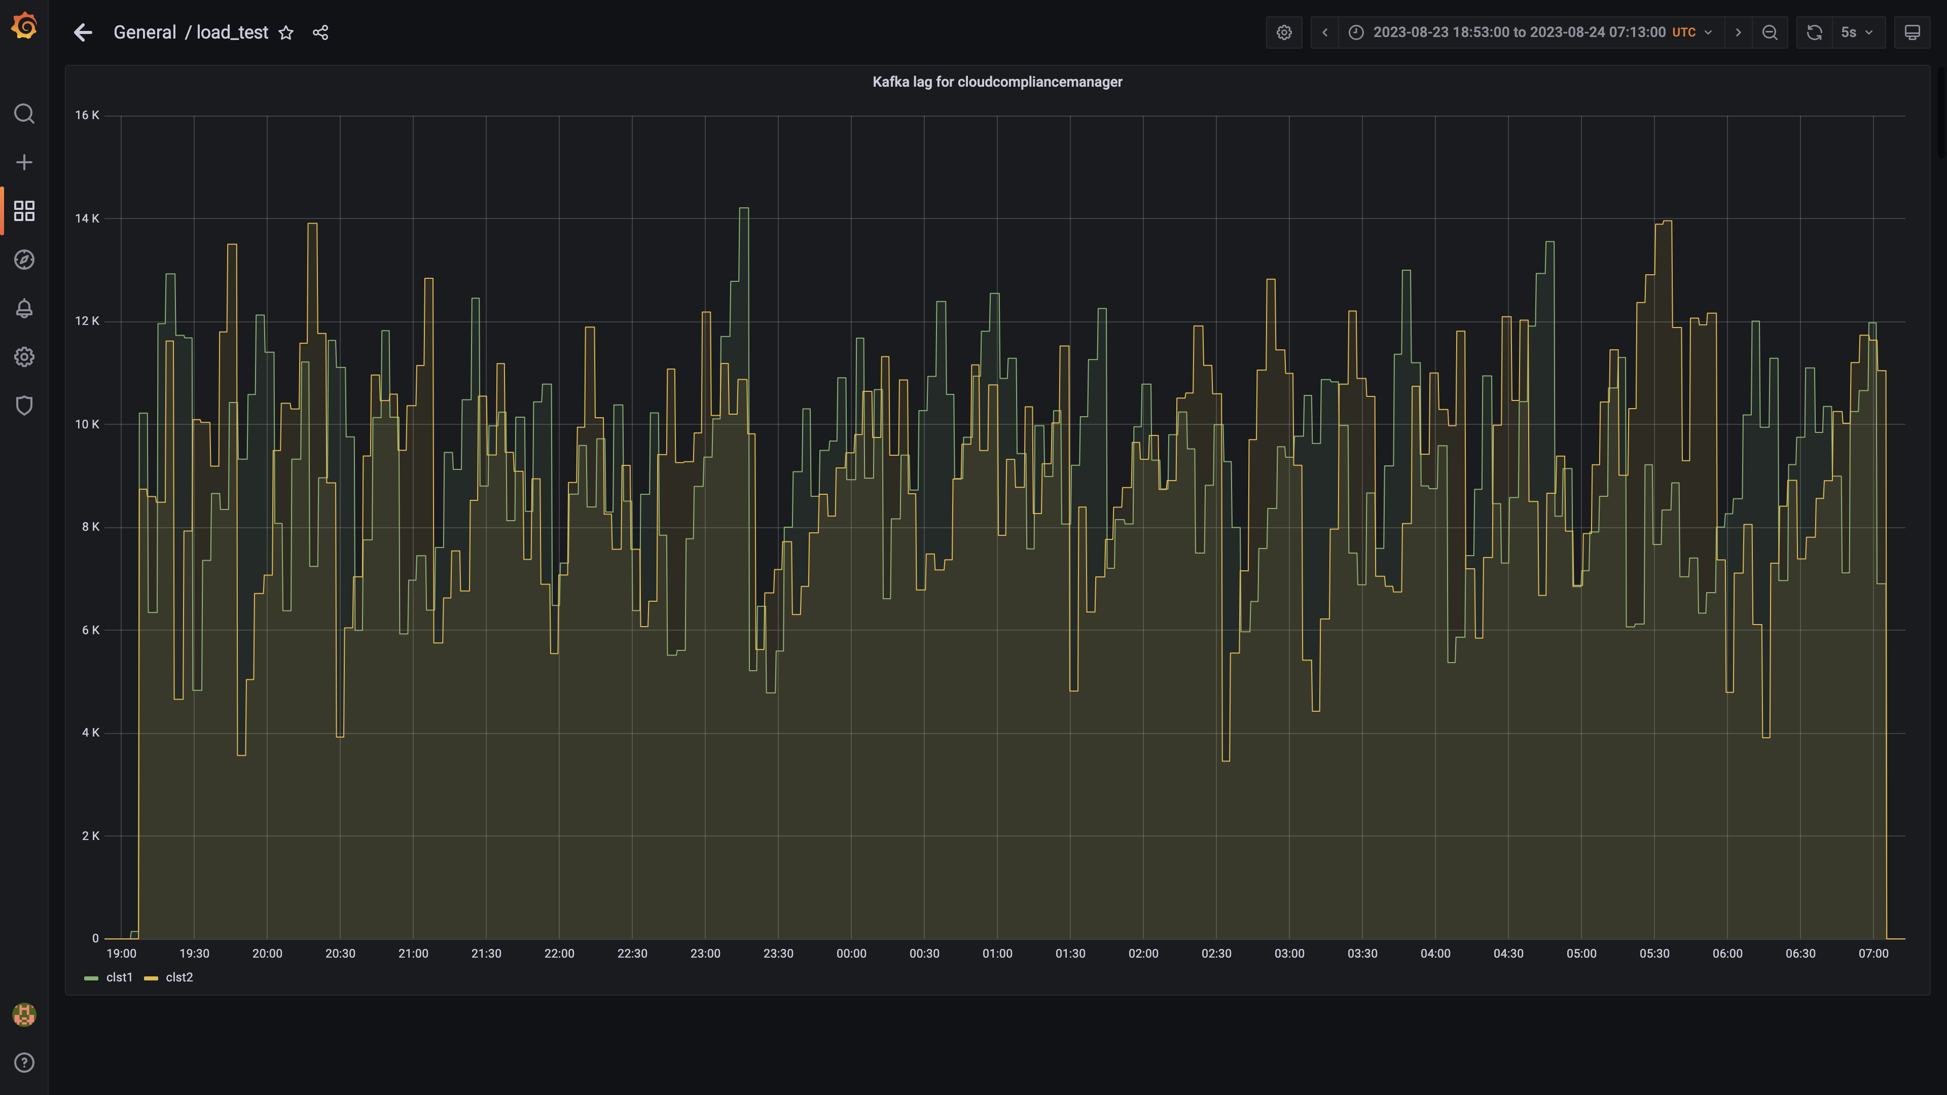

### Kafka lag for db-events

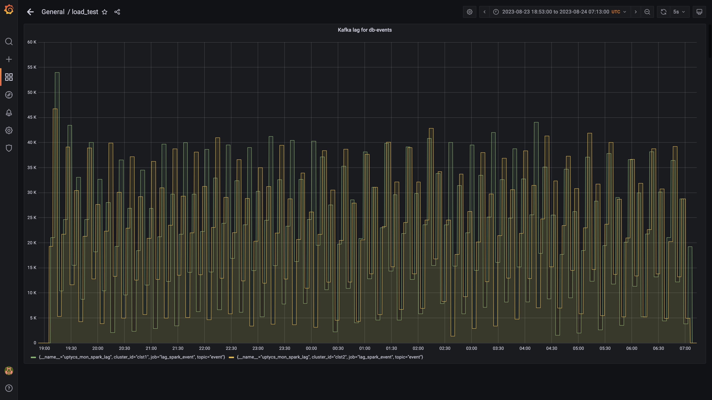

### Spark lag for eventsdbingestion

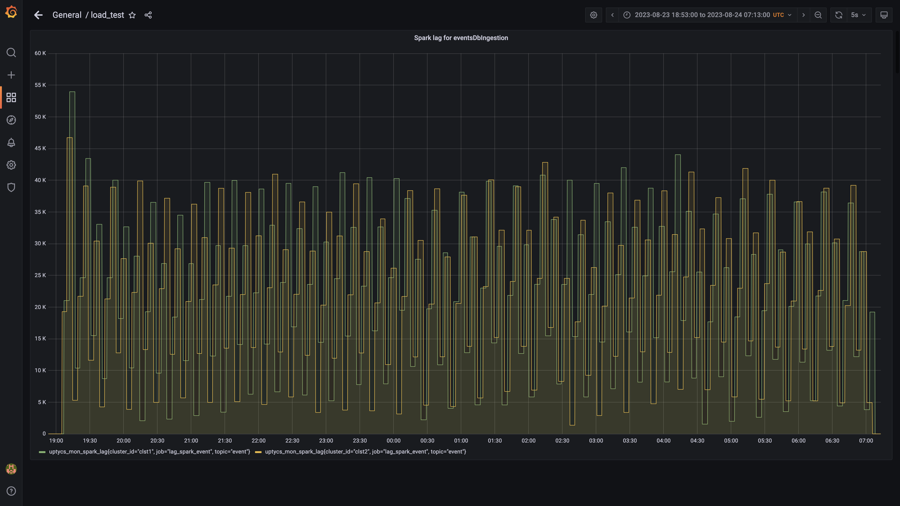

### Debezium replication lag

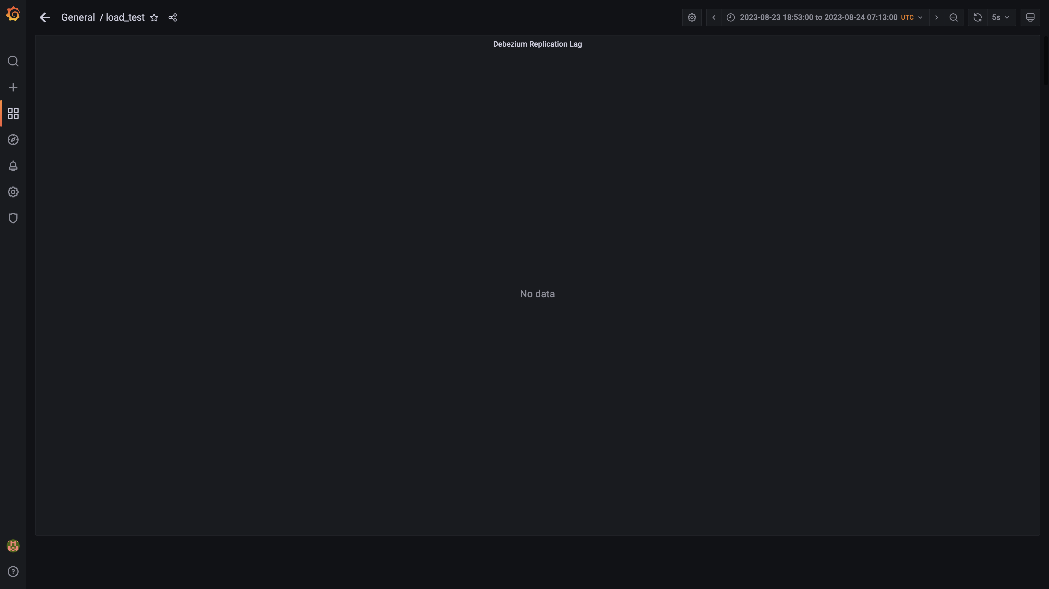

### Overall container memory and cpu usage

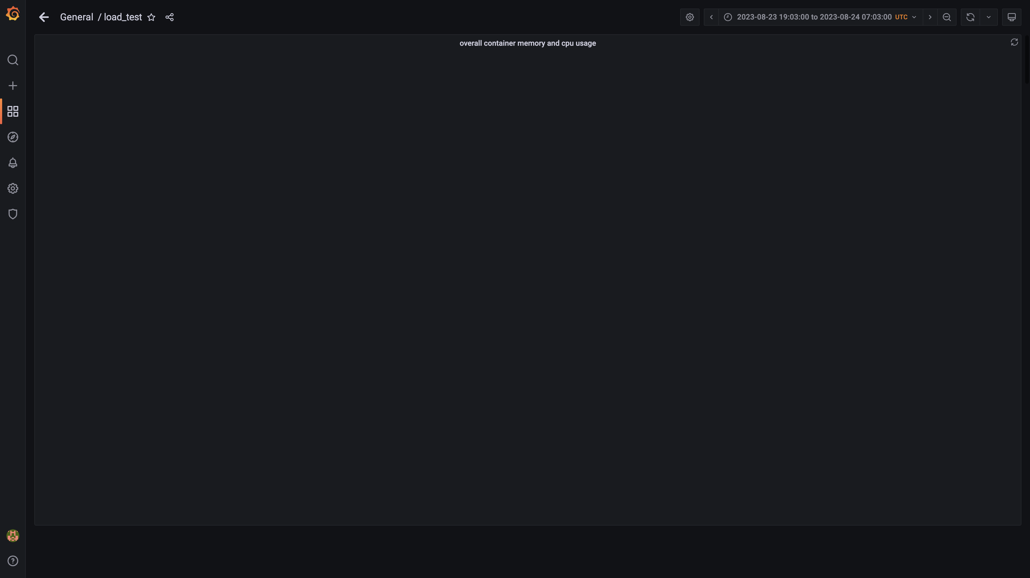

### Cpu and memory usages

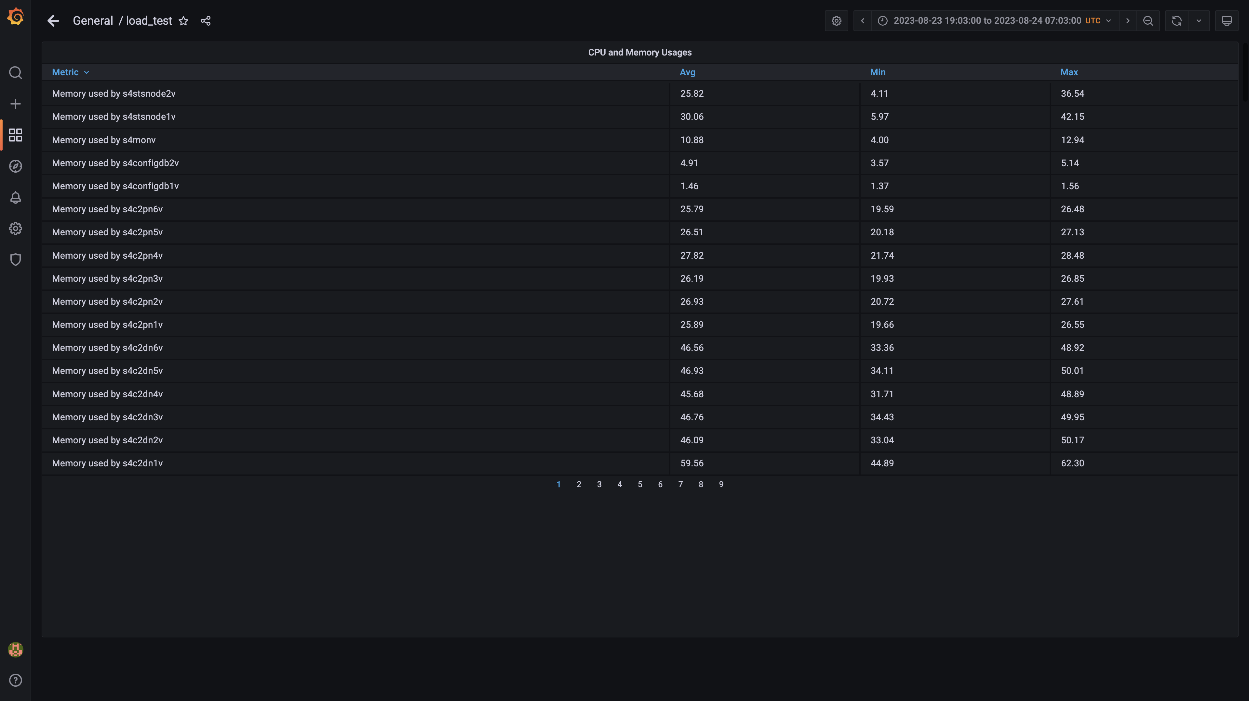

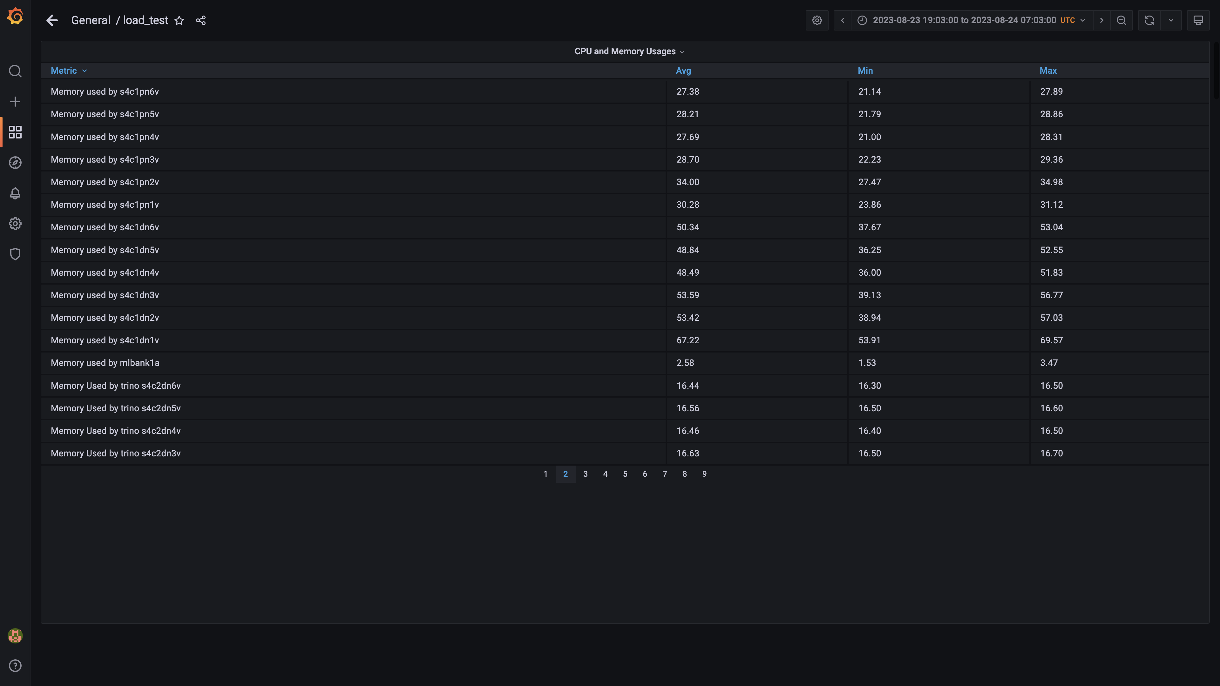

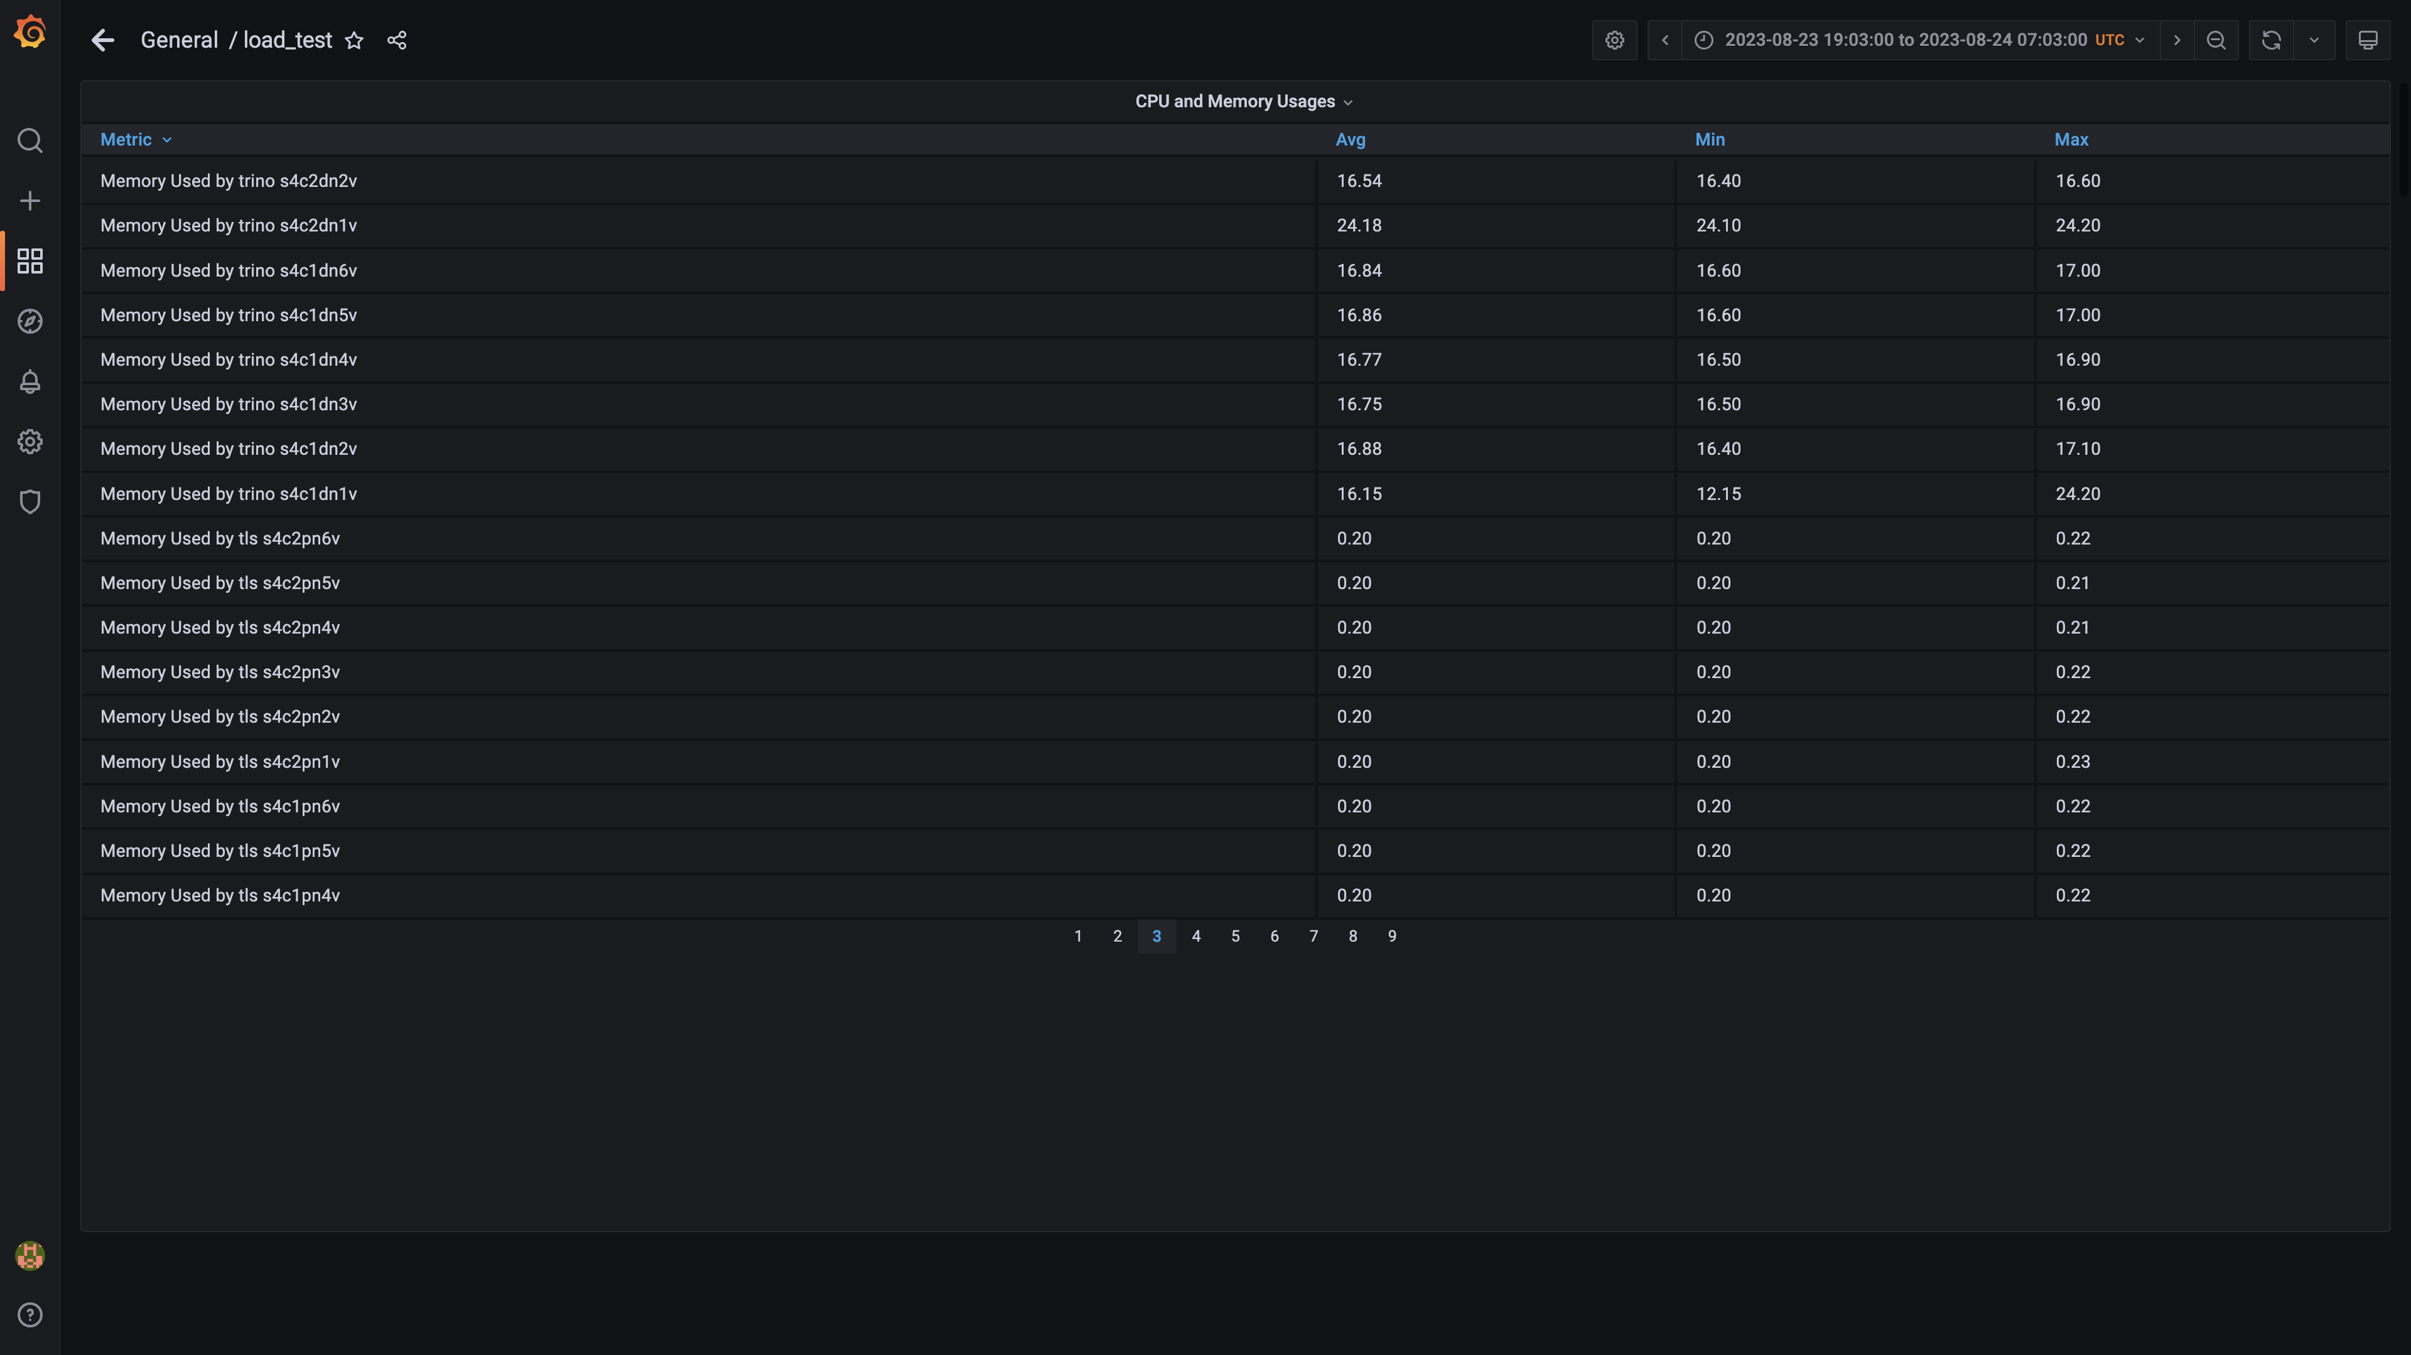

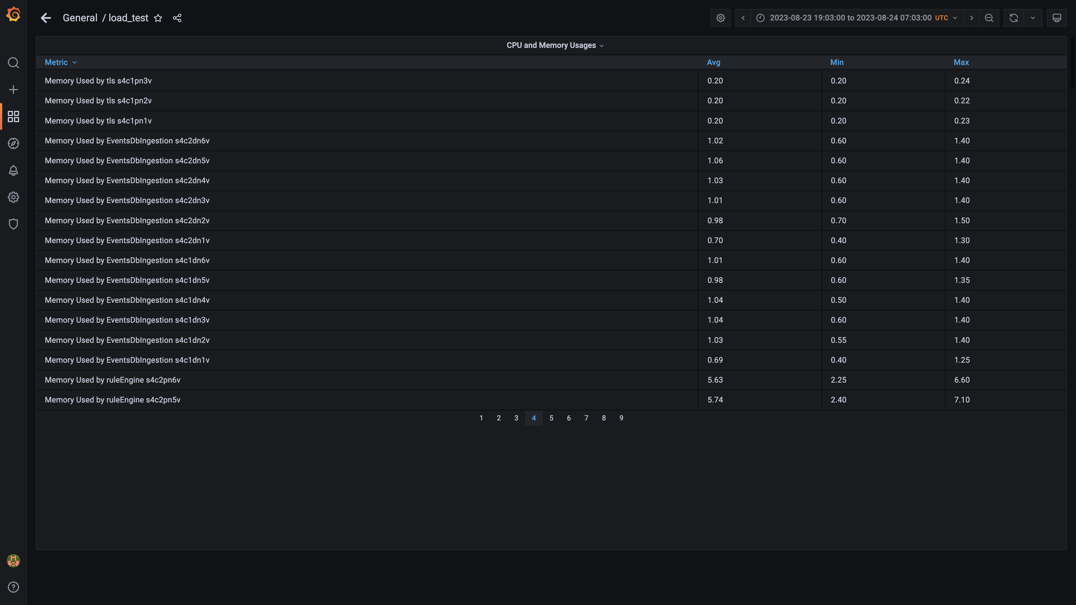

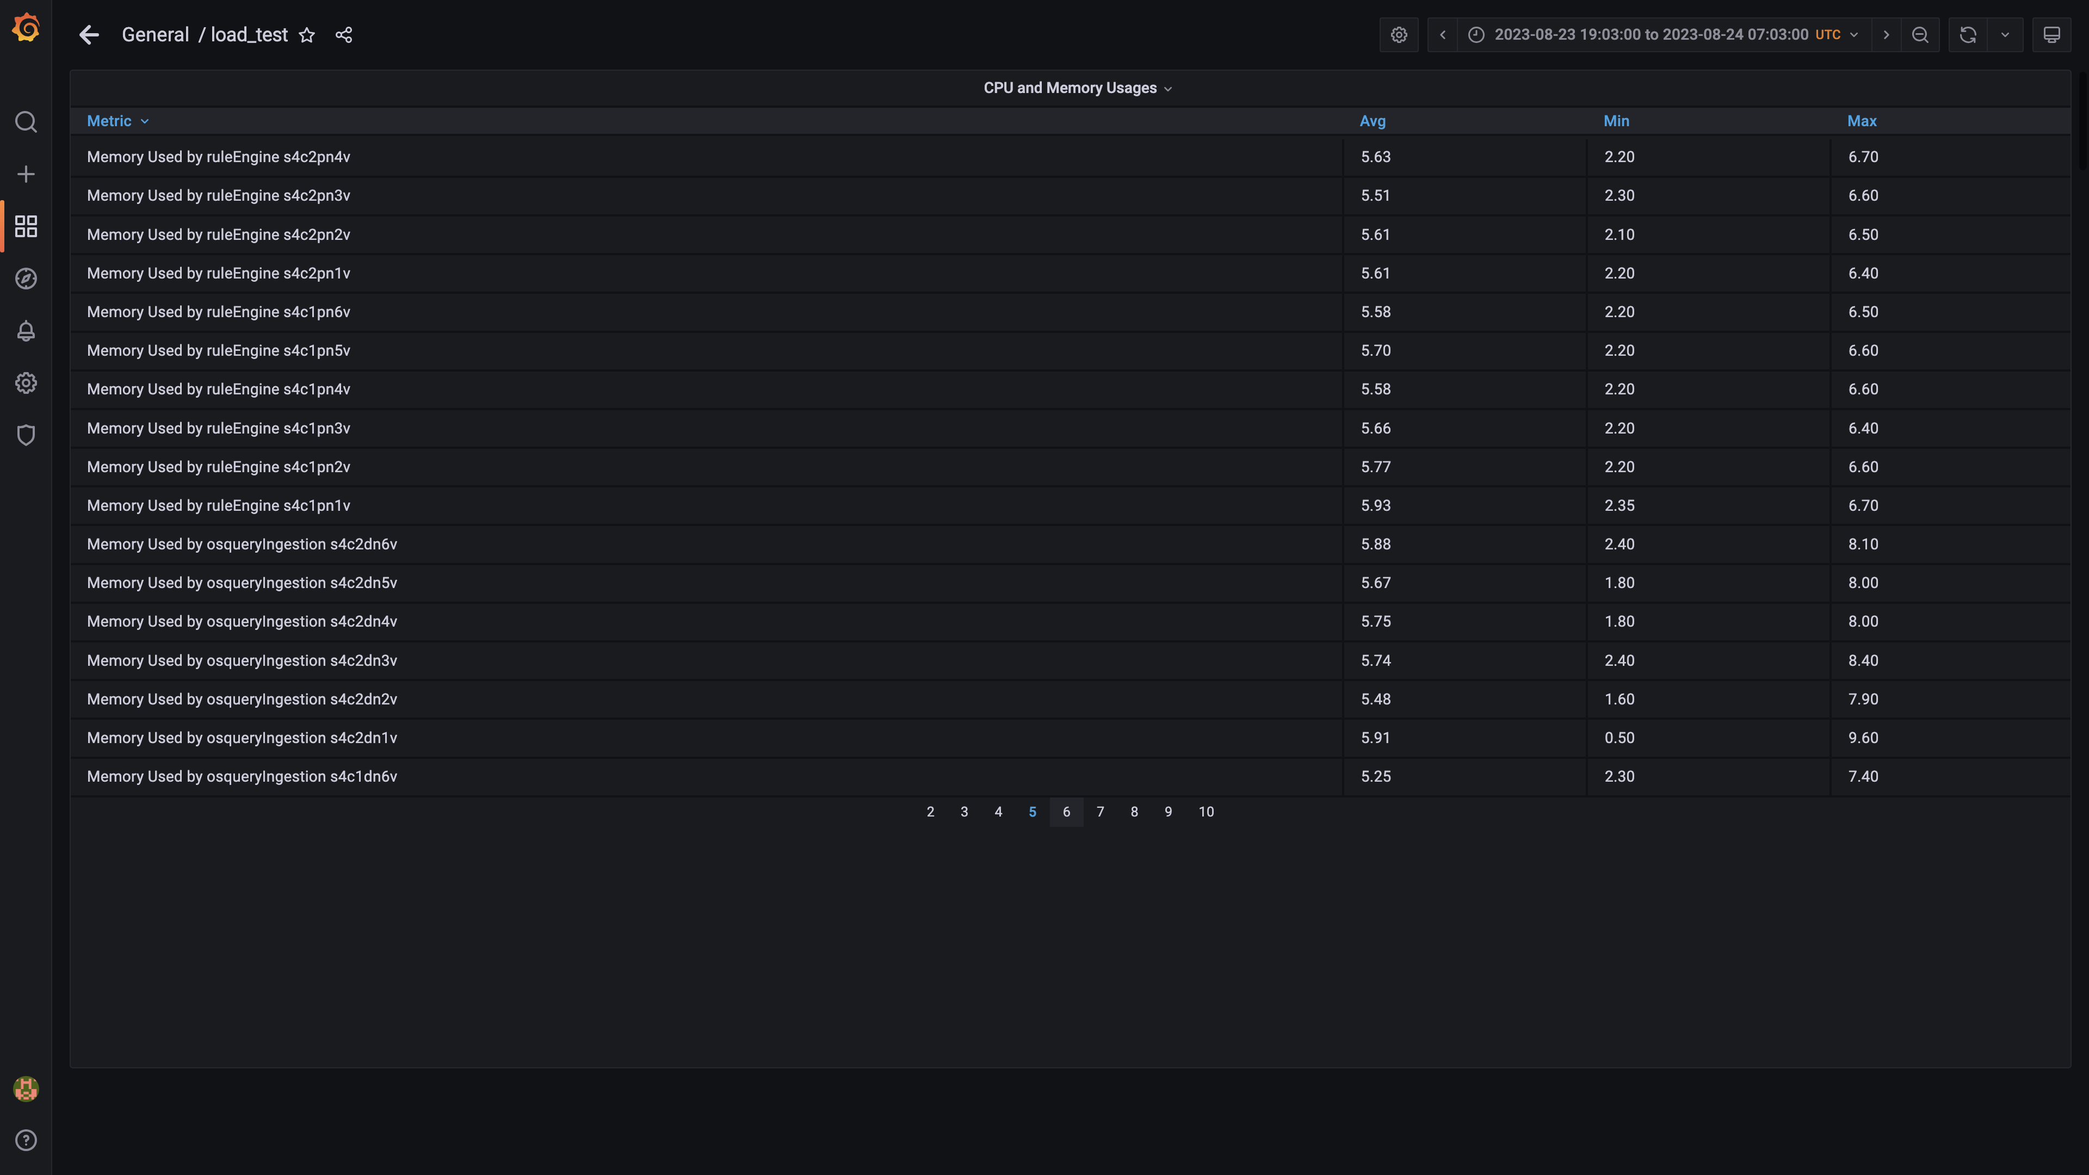

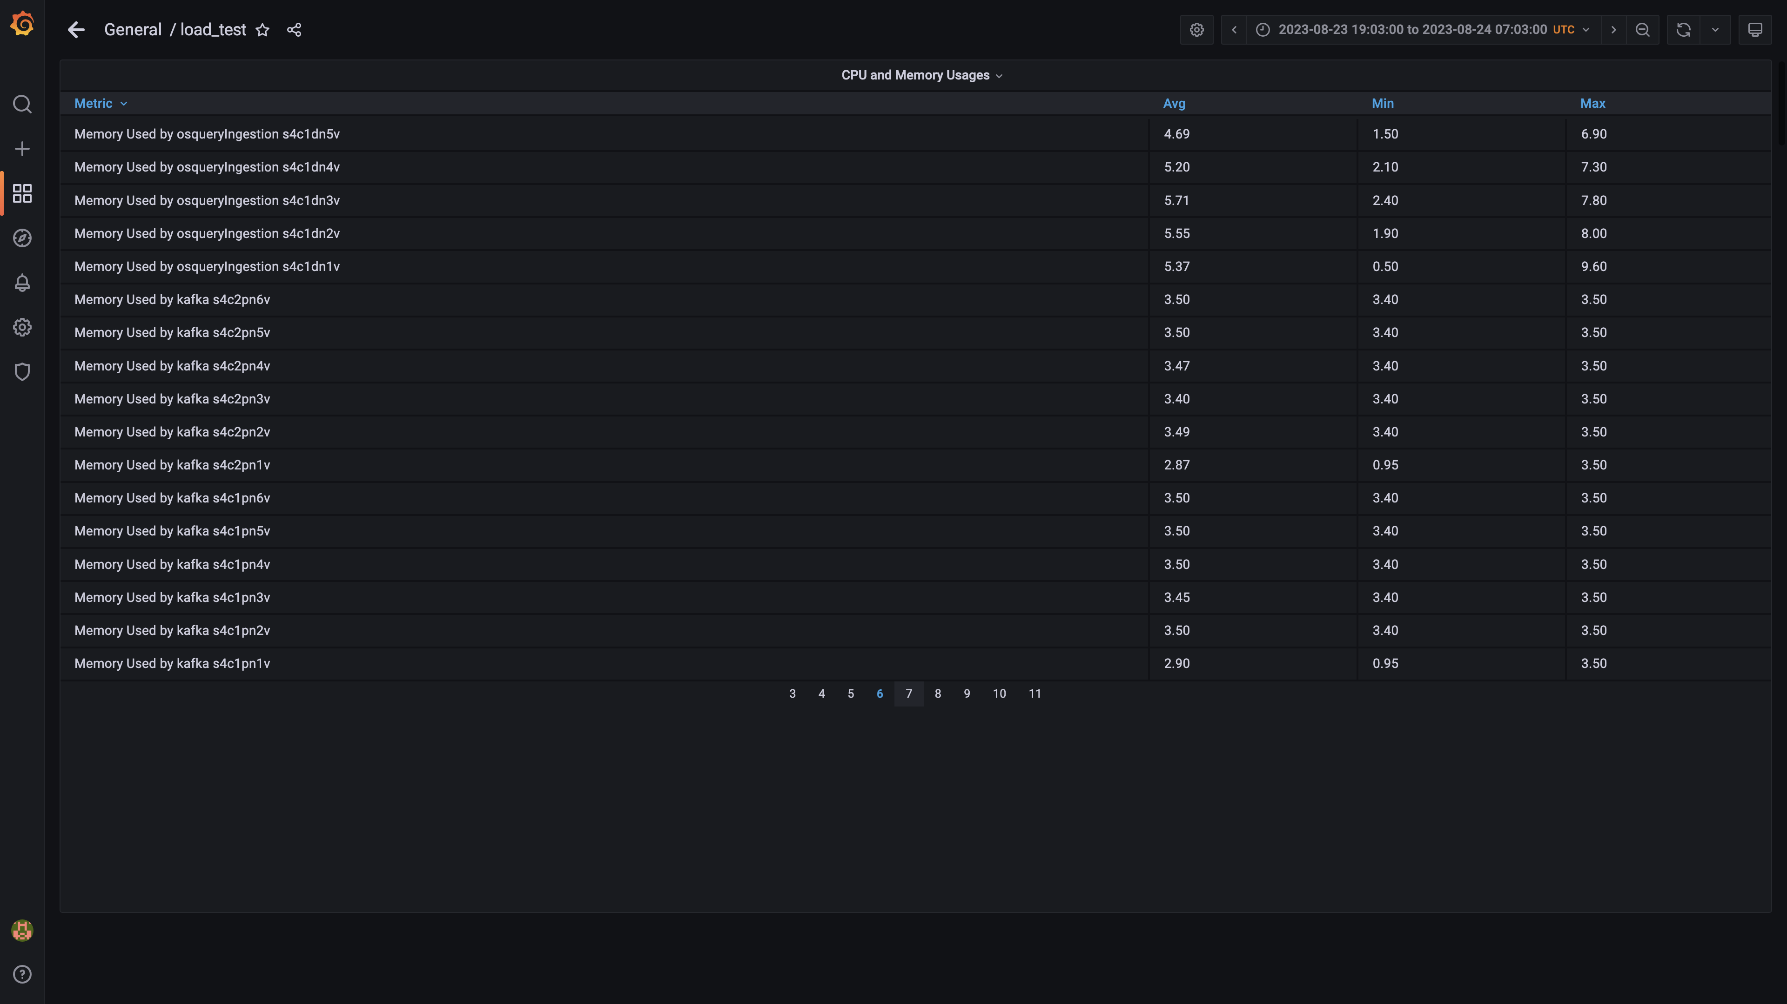

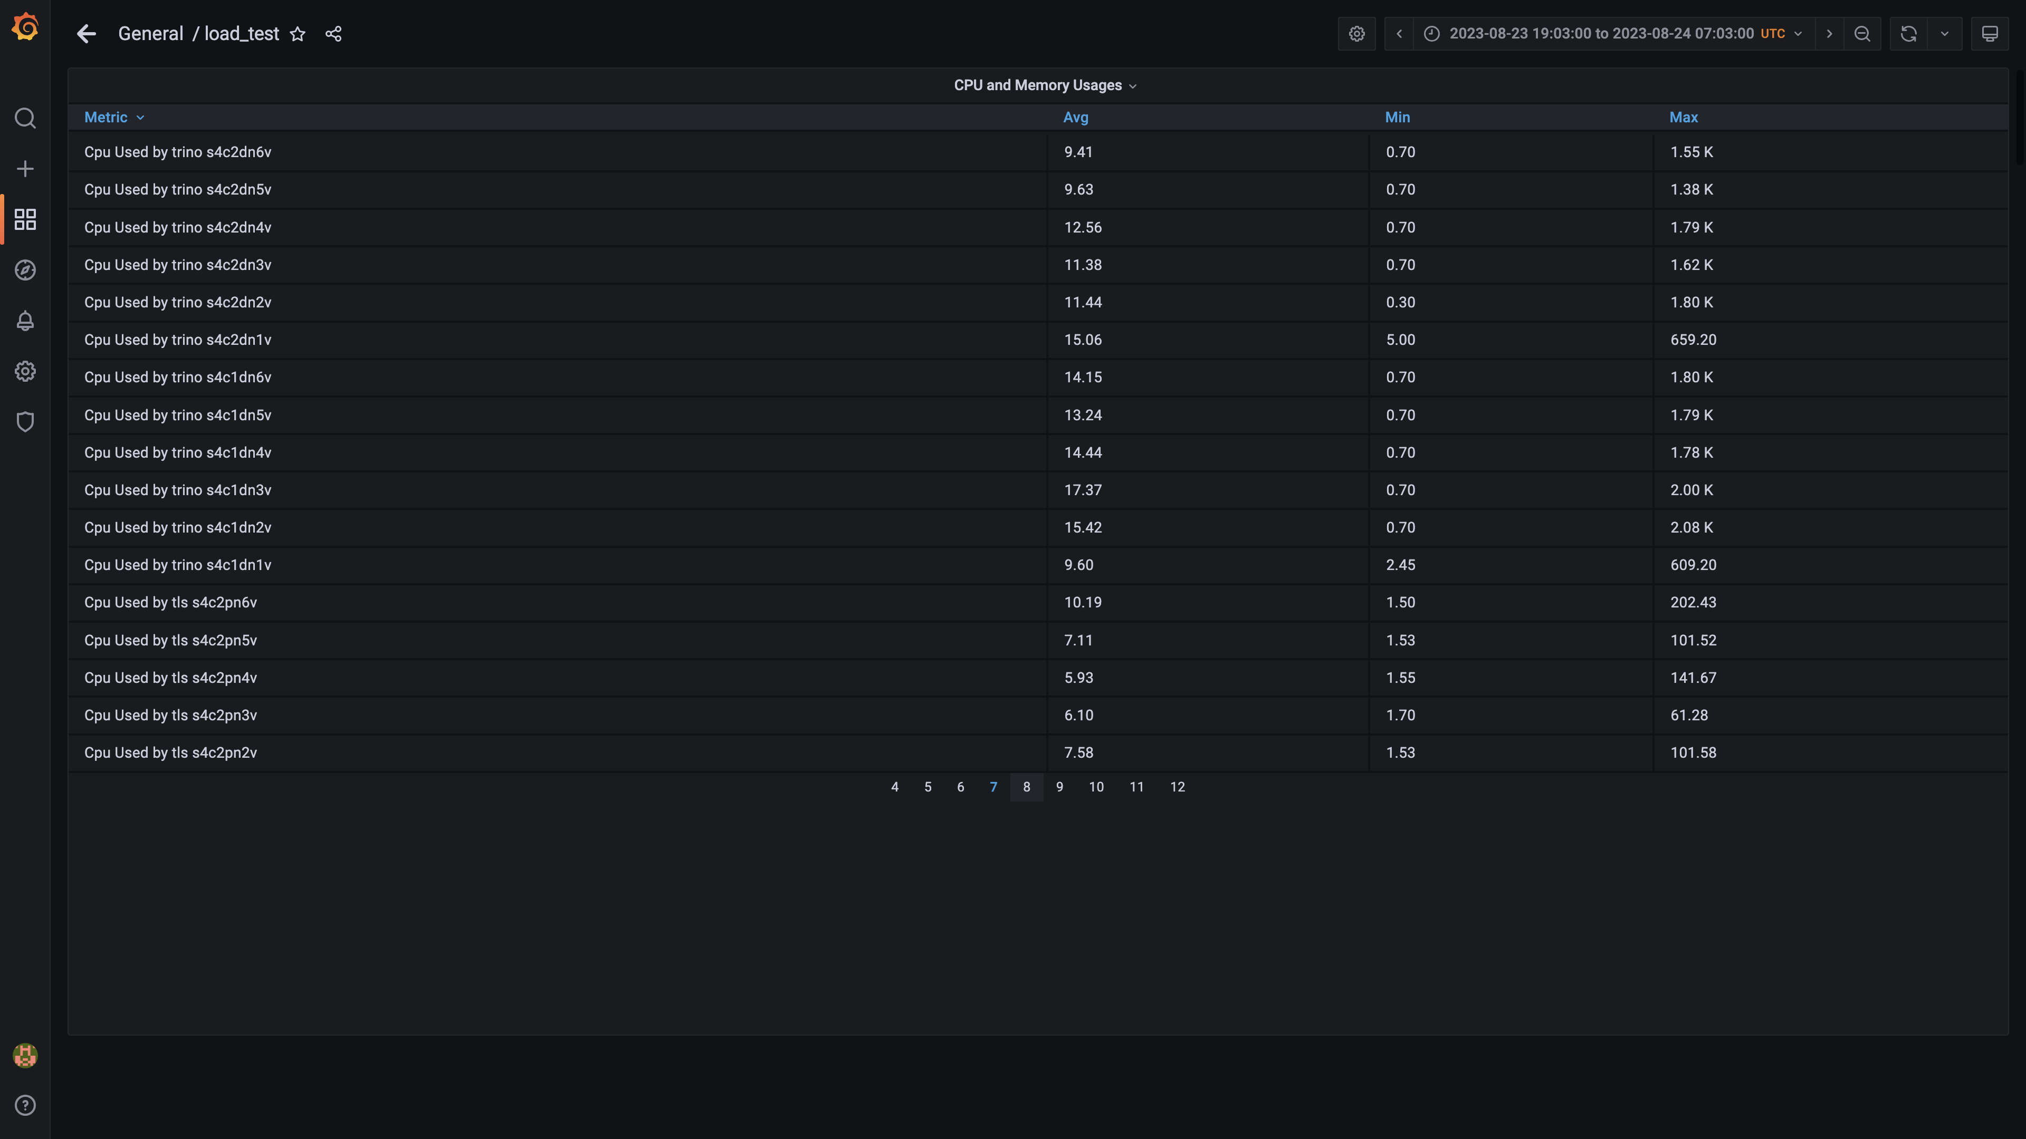

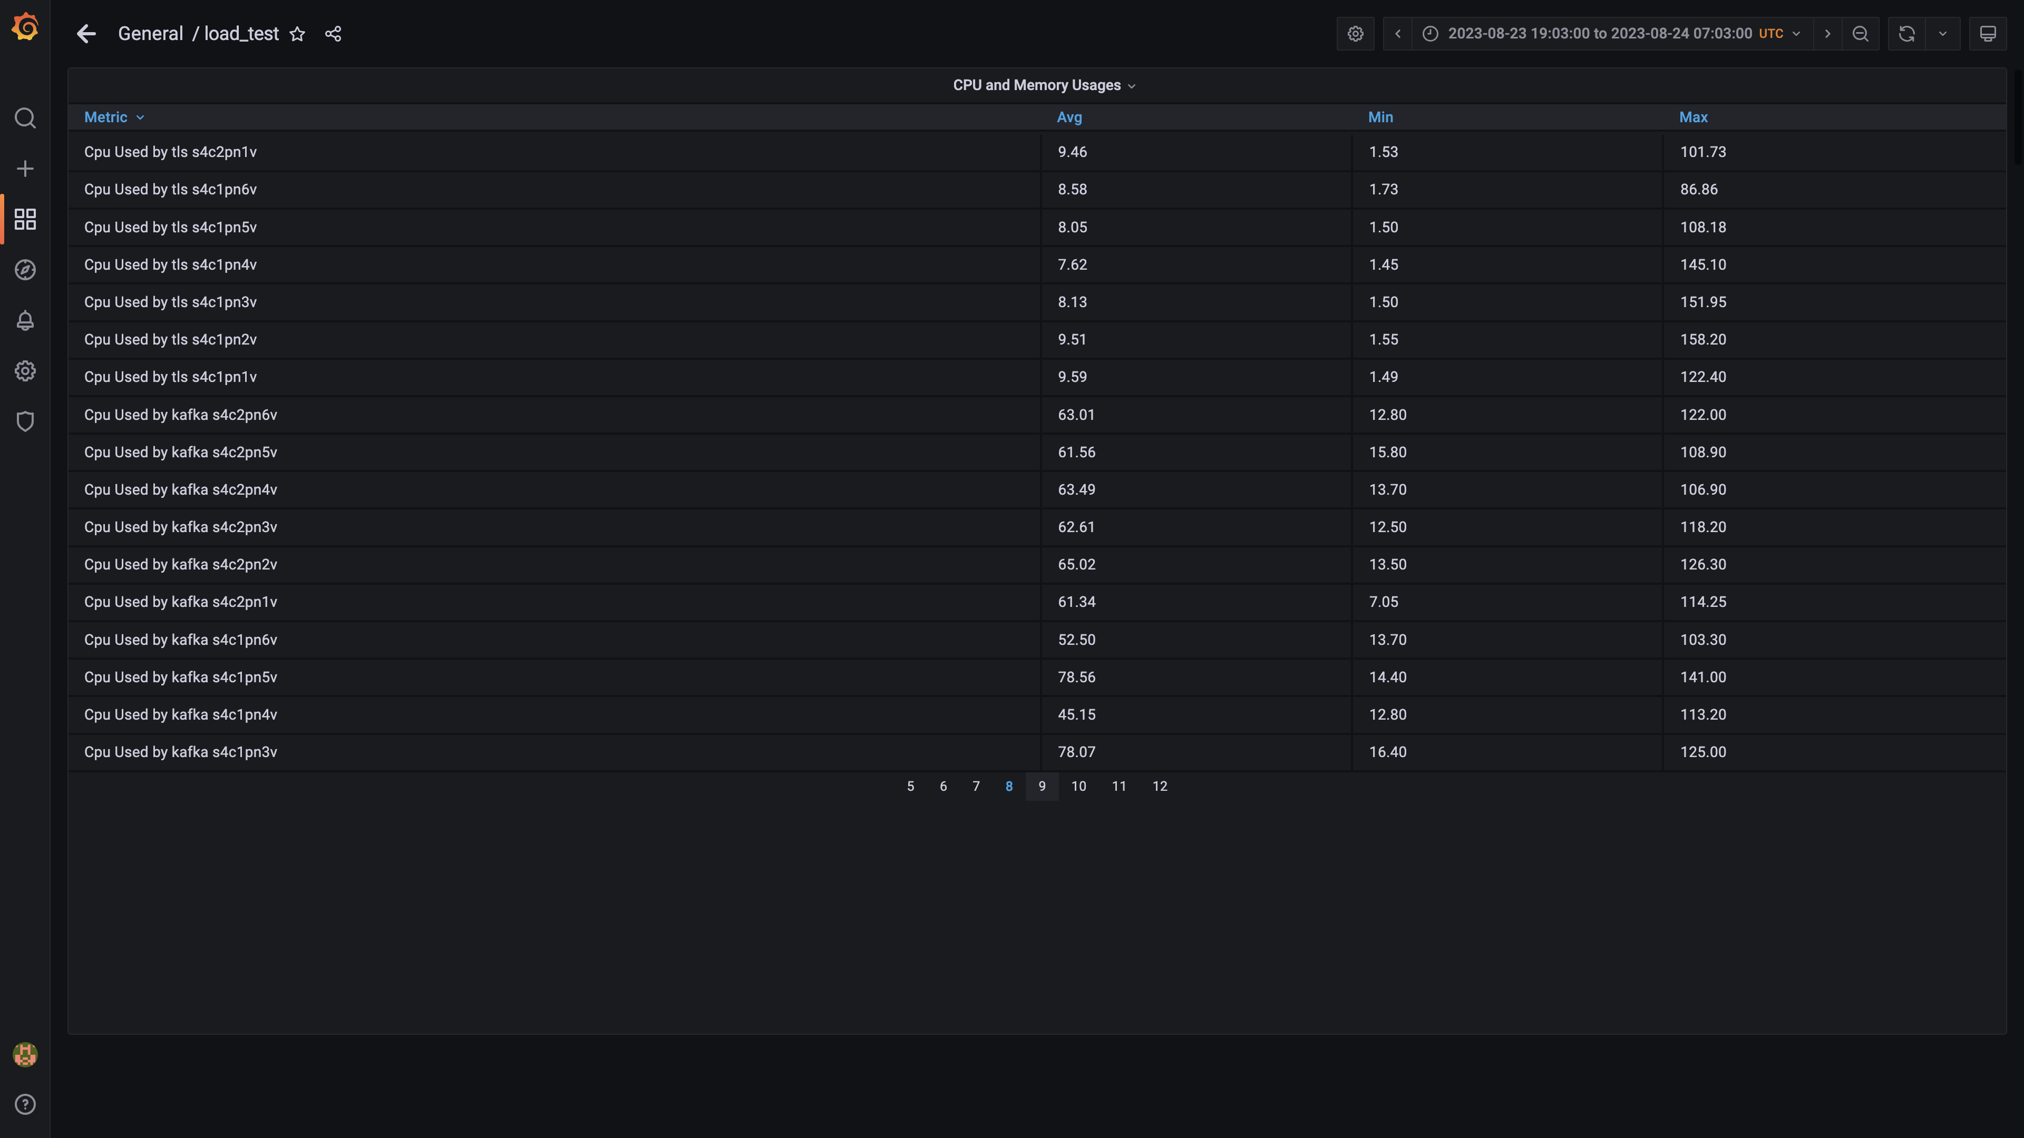

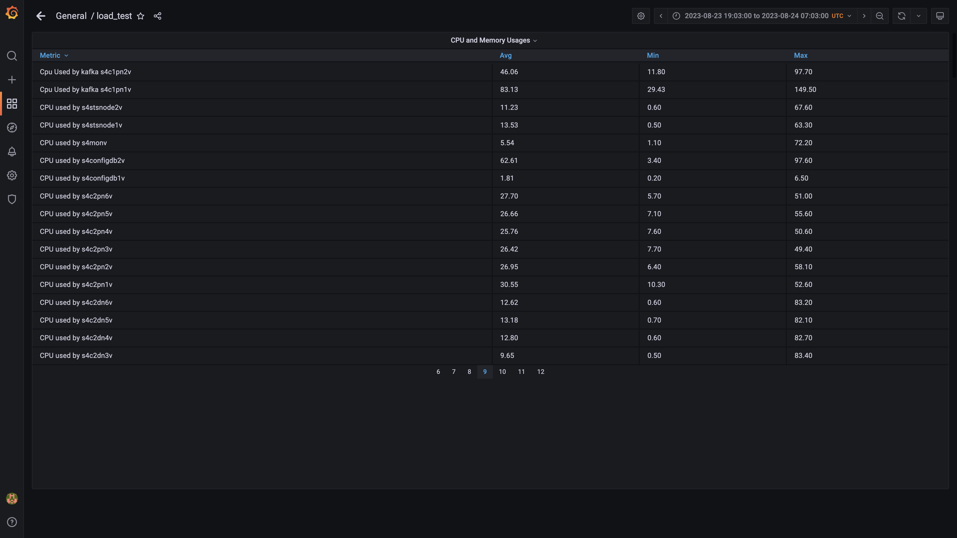

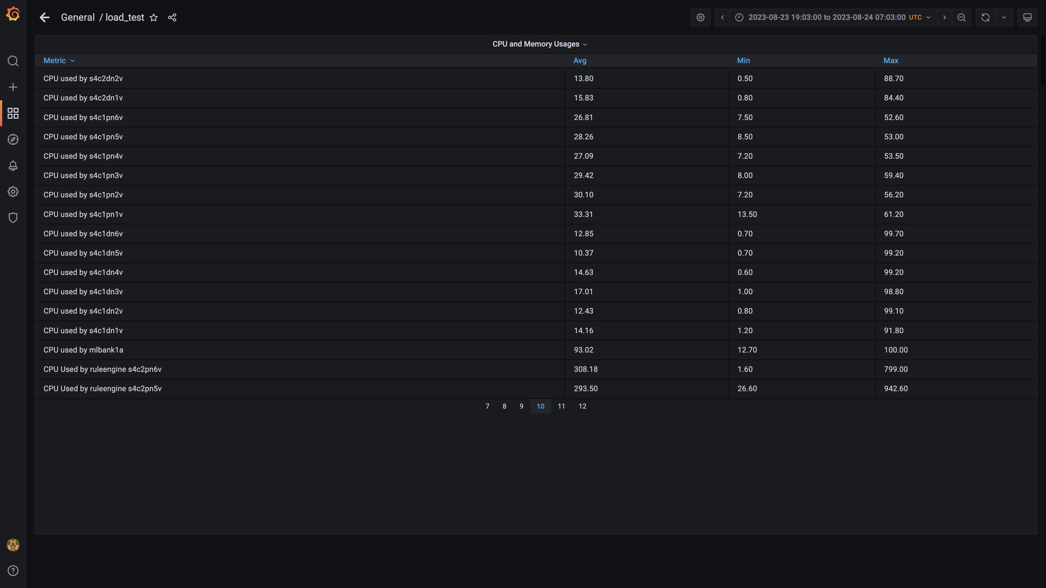

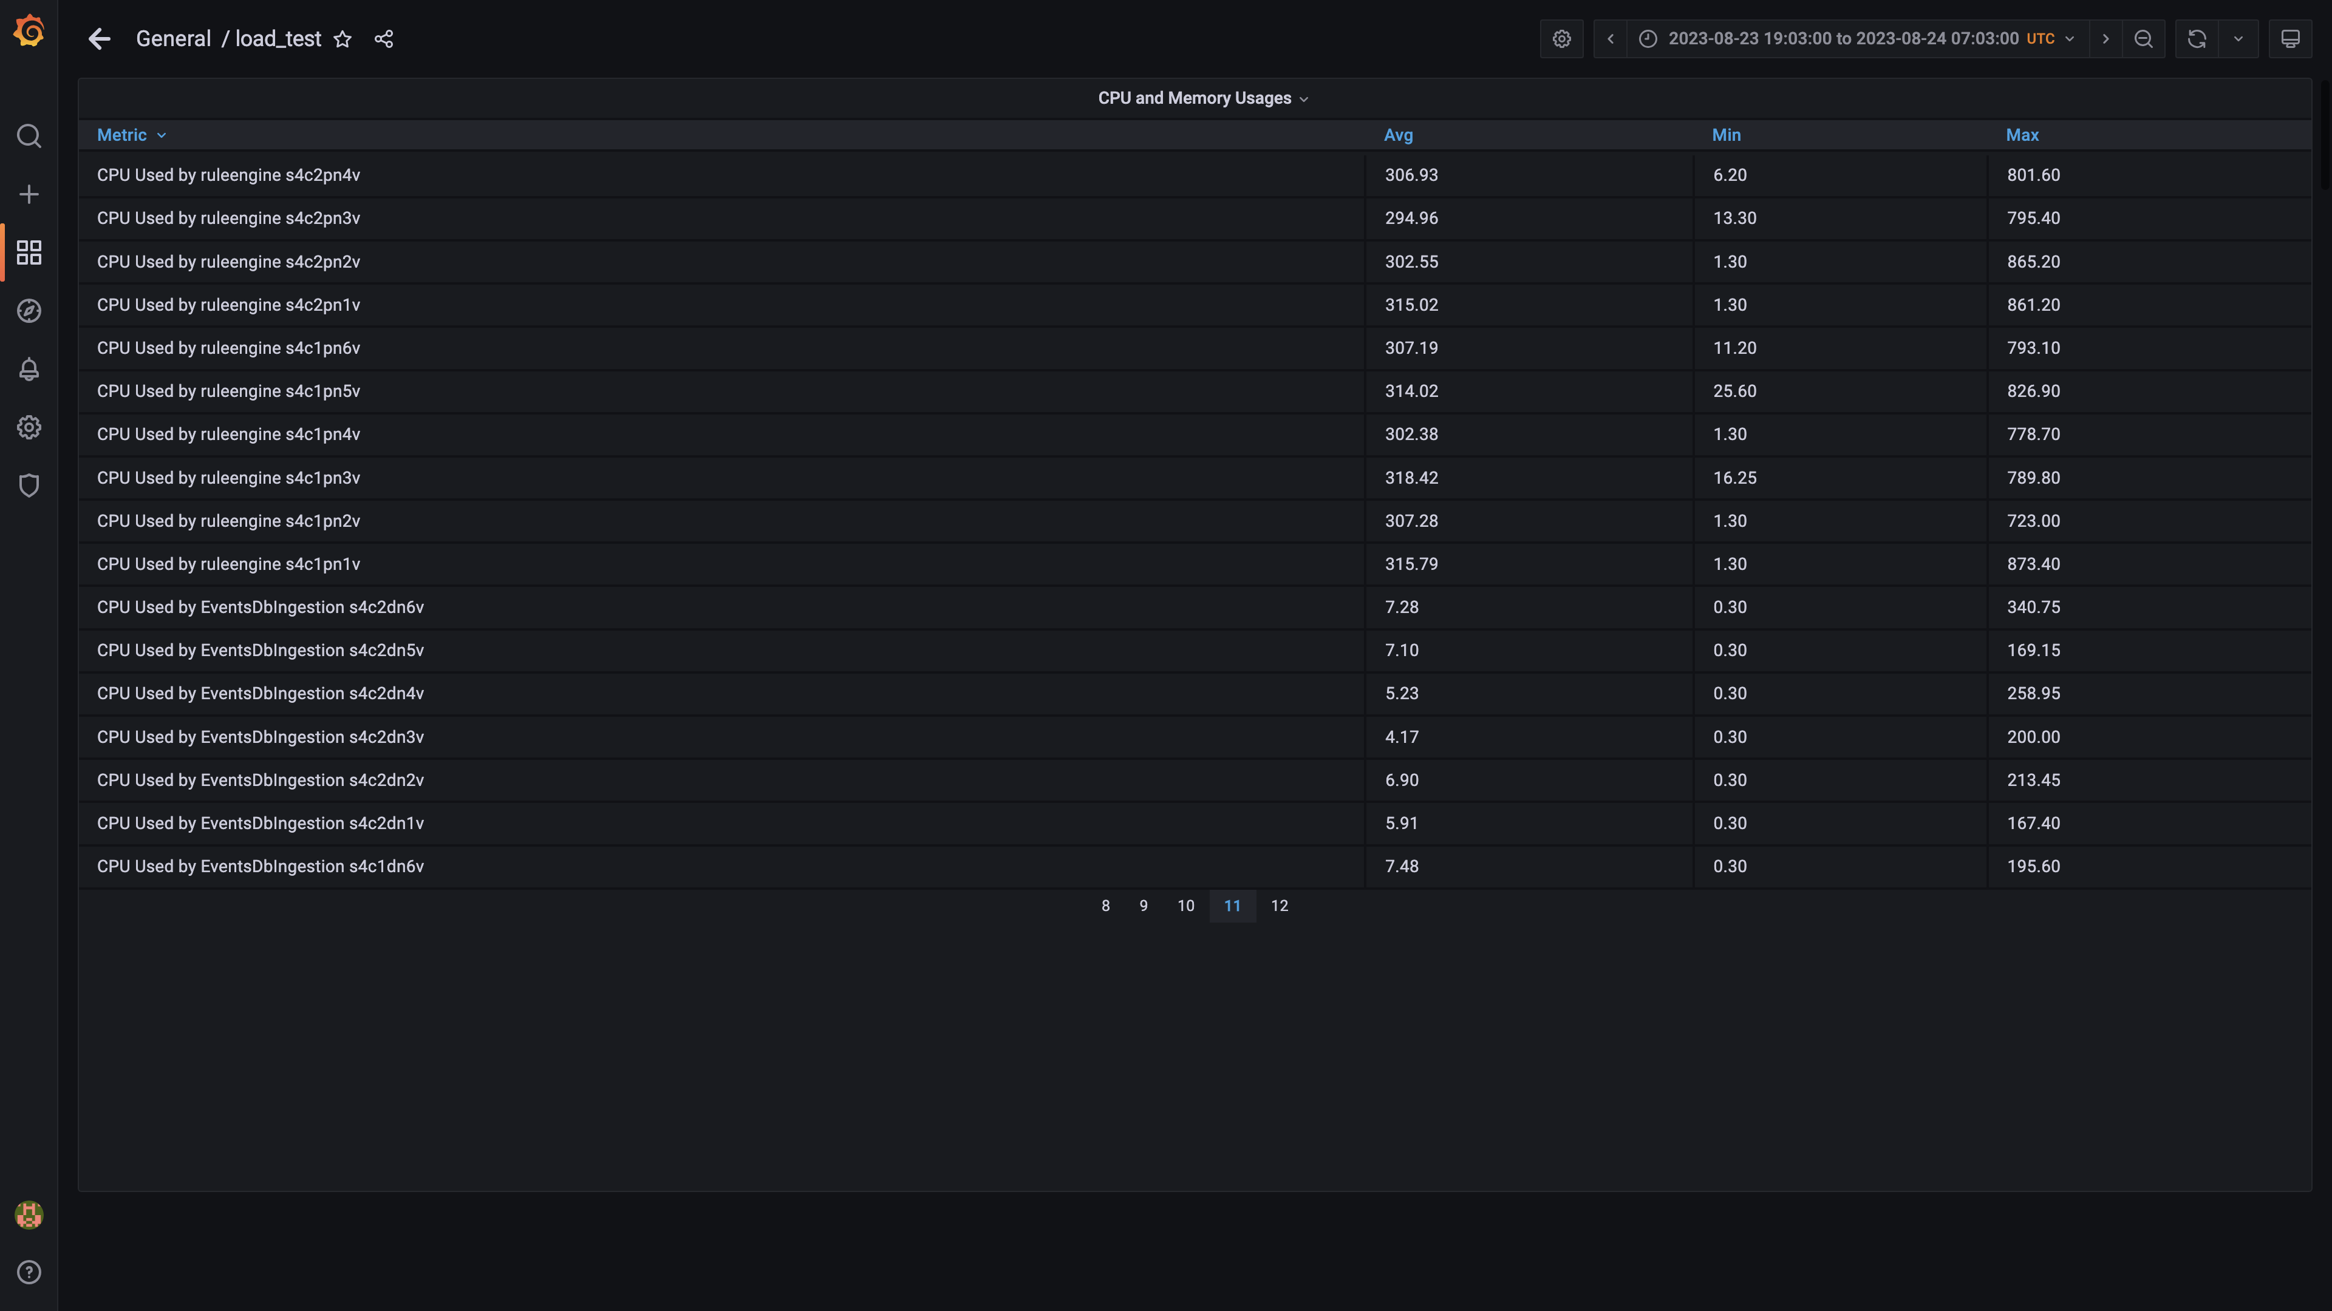

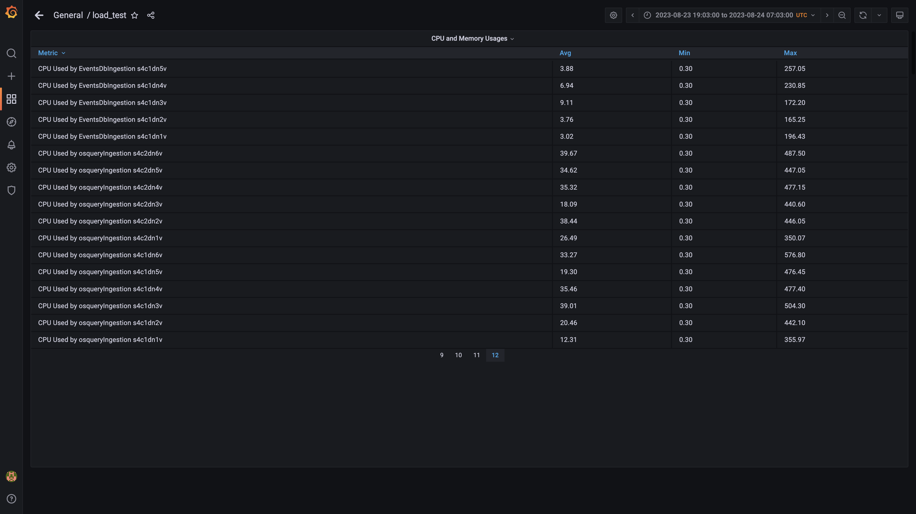

### Overall memory and cpu usages

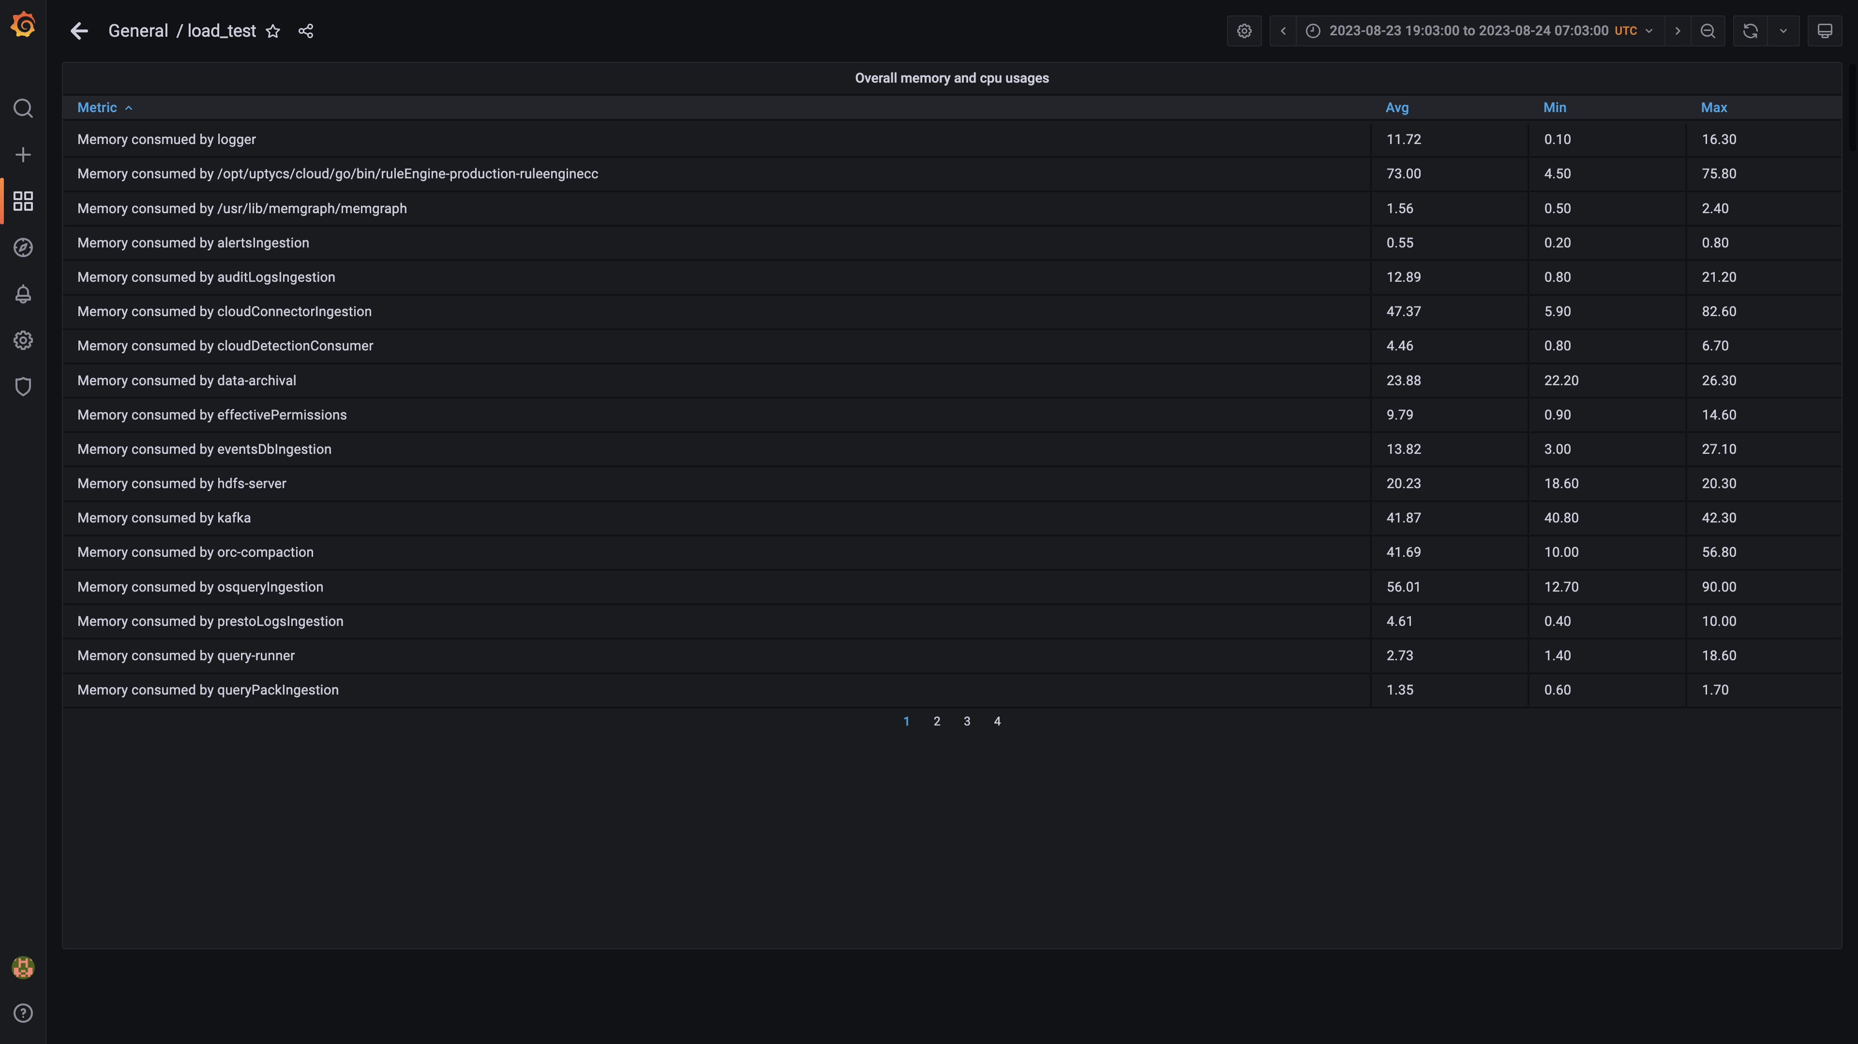

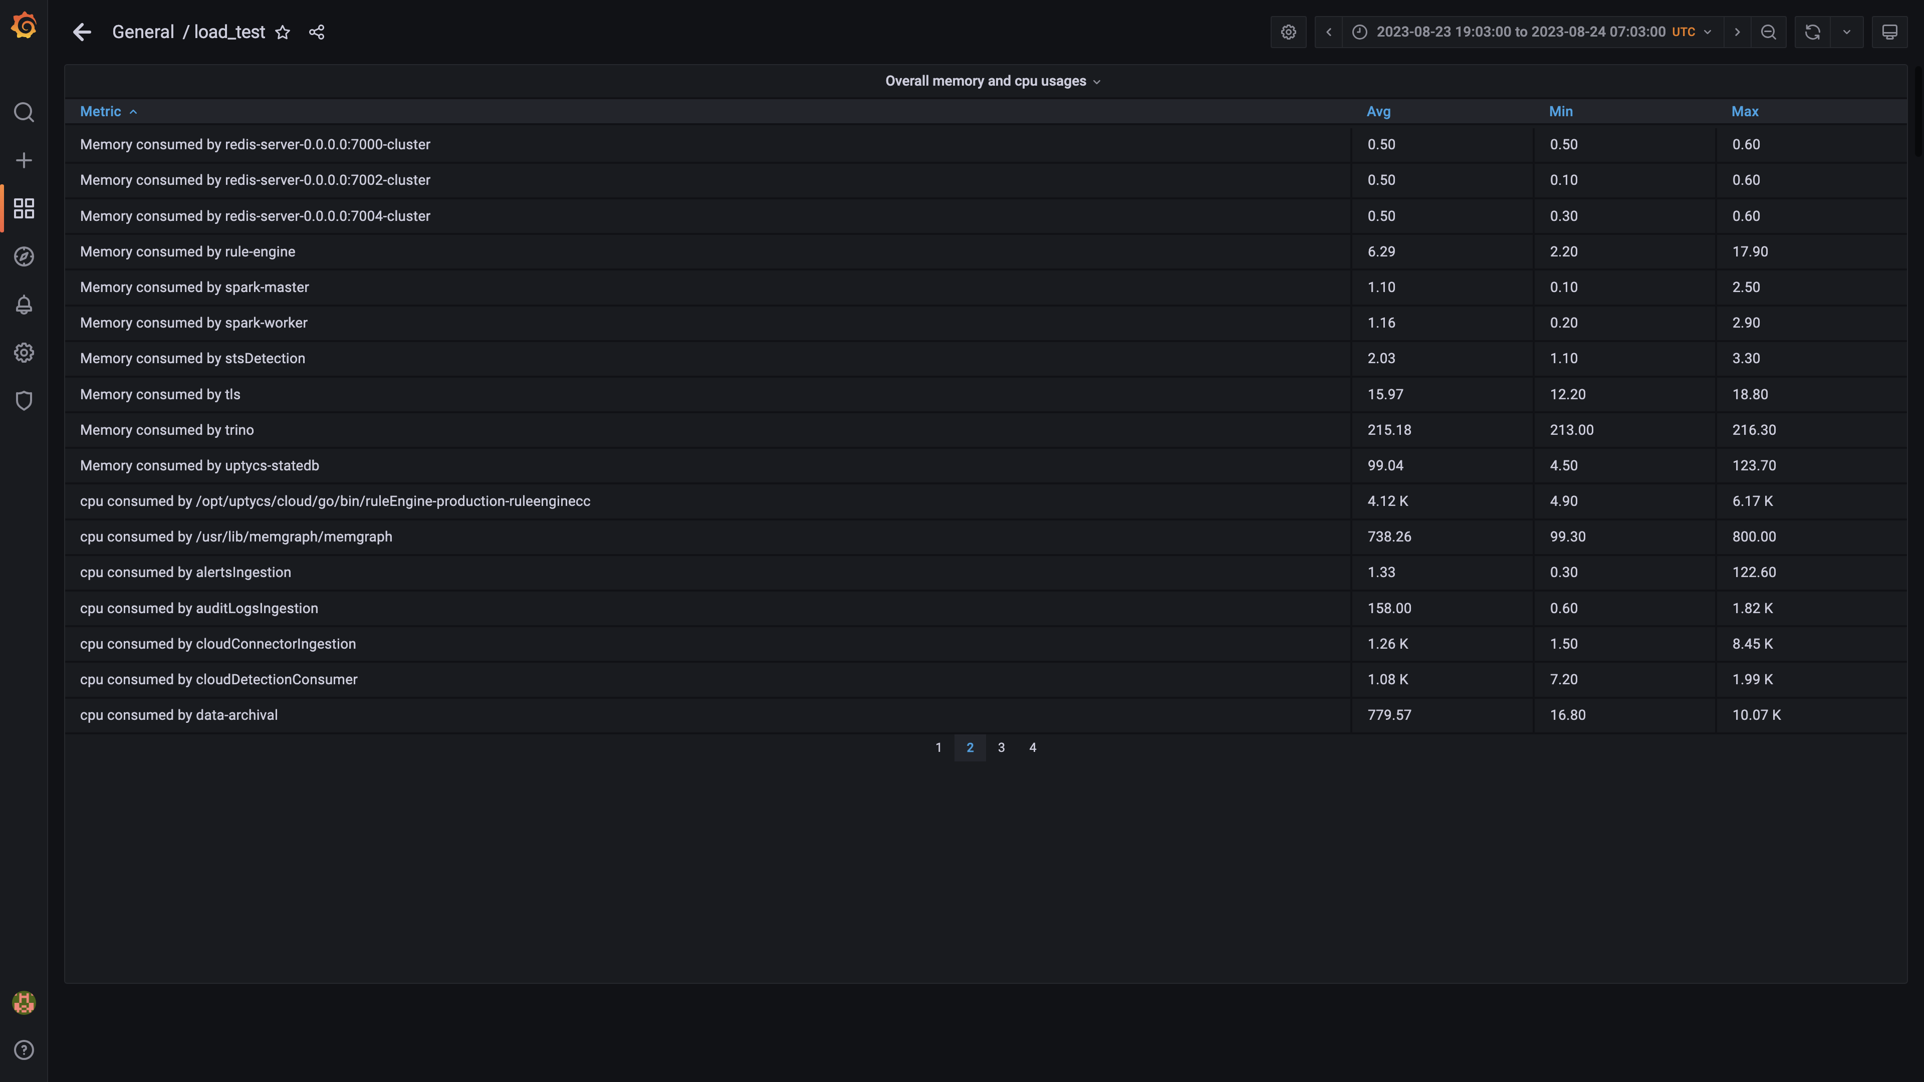

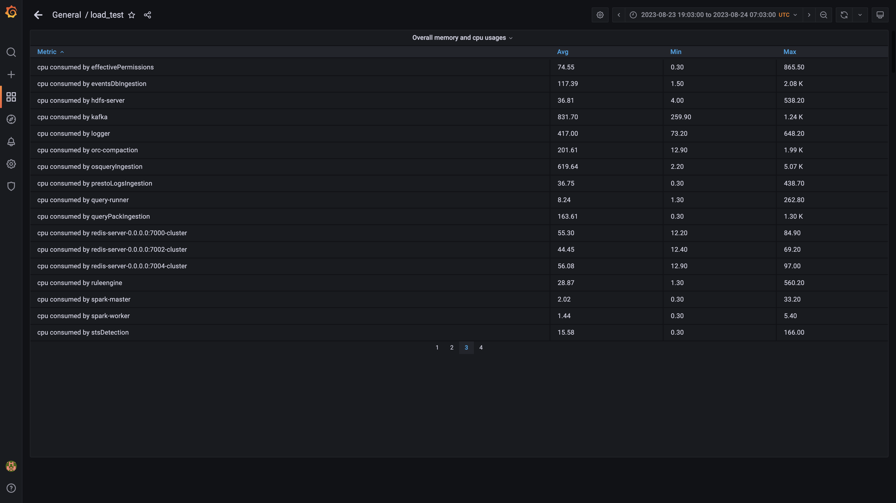

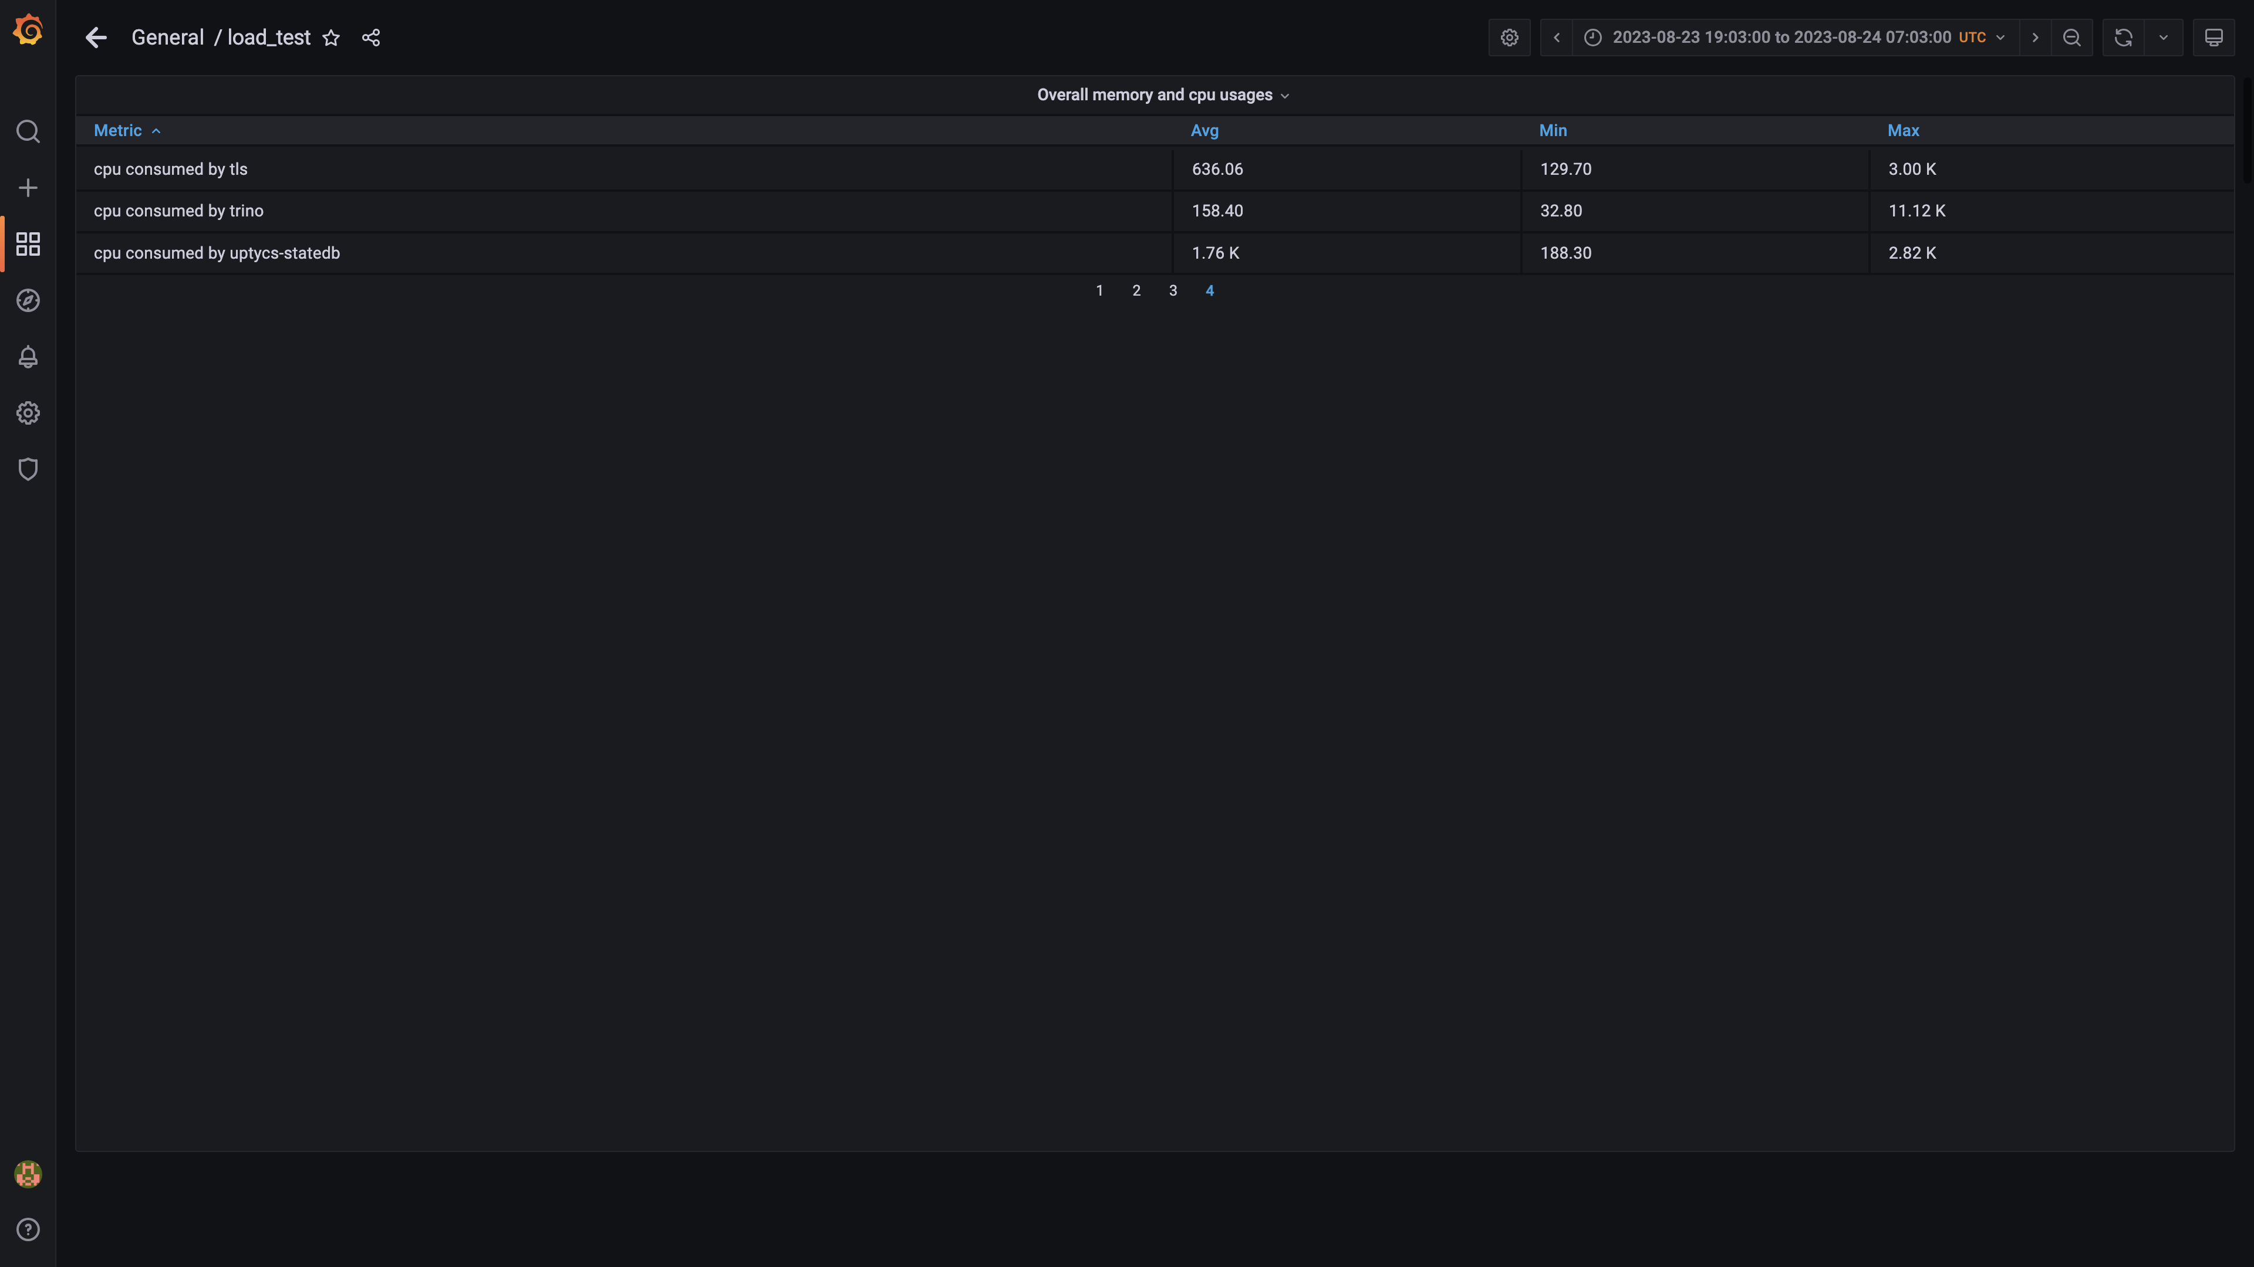

### Statedb errors

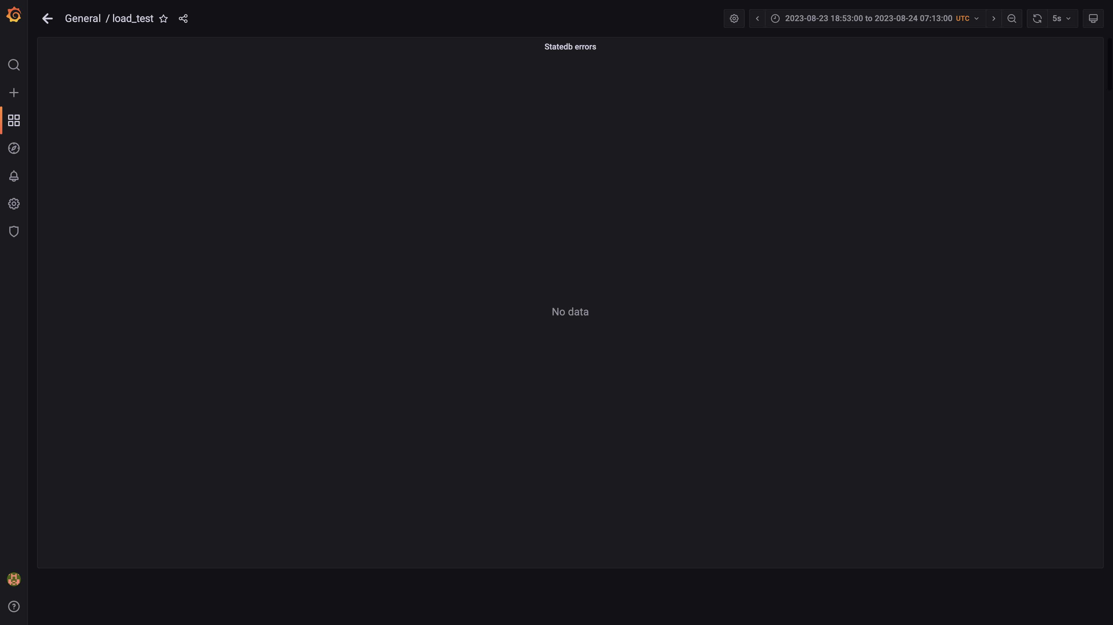

### Kafka disk used percentage

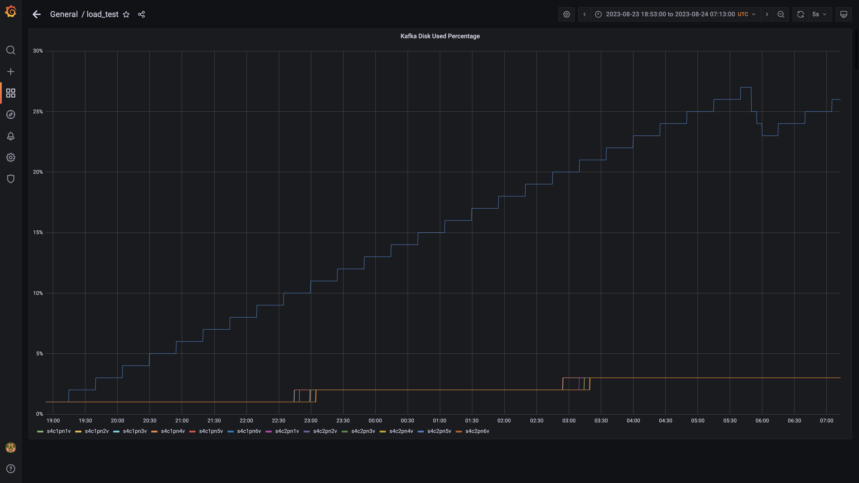

### Top 10 redis client connections by app

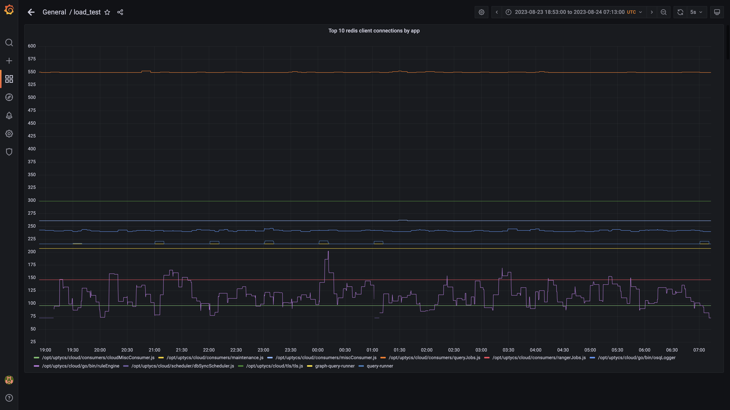

### Compaction status

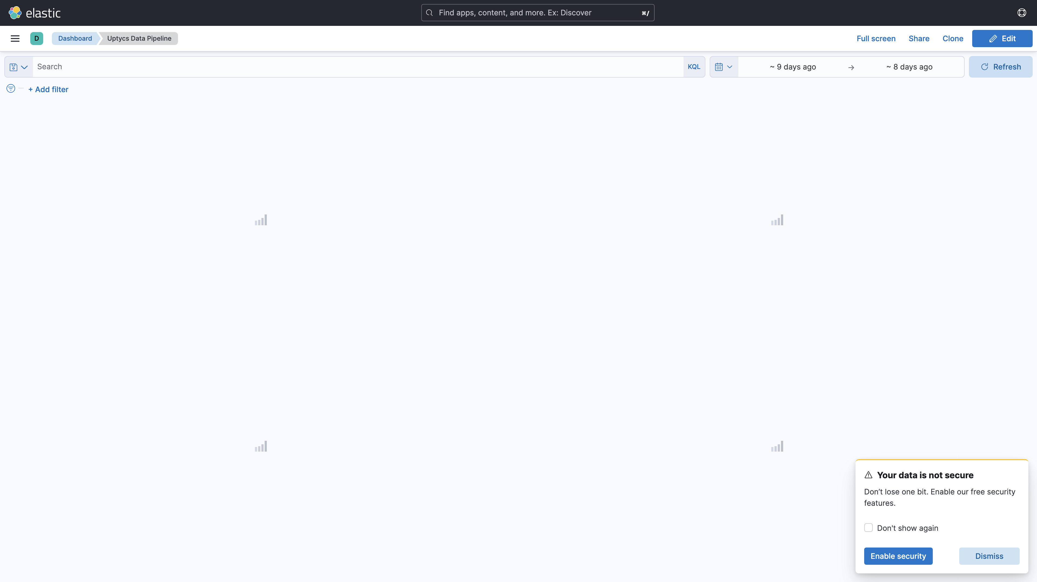

## Average Resource Utilization

### Comparision of Average Memory utilization

|  |  |  |  |  |
| --- | --- | --- | --- | --- |
| Metric | - | 138005 | Absolute(%) | Relative(%) |
| Memory used by mlbank1a | - | 2.58% | - | - |
| Memory used by s4c1dn1 | - | 67.22% (168.73 GB) | - | - |
| Memory used by s4c1dn2 | - | 53.42% (134.09 GB) | - | - |
| Memory used by s4c1dn3 | - | 53.59% (134.50 GB) | - | - |
| Memory used by s4c1dn4 | - | 48.49% (121.70 GB) | - | - |
| Memory used by s4c1dn5 | - | 48.85% (122.61 GB) | - | - |
| Memory used by s4c1dn6 | - | 50.34% (126.36 GB) | - | - |
| Memory used by s4c1pn1 | - | 30.28% (56.93 GB) | - | - |
| Memory used by s4c1pn2 | - | 34.00% (63.92 GB) | - | - |
| Memory used by s4c1pn3 | - | 28.70% (53.95 GB) | - | - |
| Memory used by s4c1pn4 | - | 27.69% (52.06 GB) | - | - |
| Memory used by s4c1pn5 | - | 28.21% (53.04 GB) | - | - |
| Memory used by s4c1pn6 | - | 27.38% (51.47 GB) | - | - |
| Memory used by s4c2dn1 | - | 59.56% (149.49 GB) | - | - |
| Memory used by s4c2dn2 | - | 46.09% (115.69 GB) | - | - |
| Memory used by s4c2dn3 | - | 46.77% (117.38 GB) | - | - |
| Memory used by s4c2dn4 | - | 45.68% (114.66 GB) | - | - |
| Memory used by s4c2dn5 | - | 46.93% (117.80 GB) | - | - |
| Memory used by s4c2dn6 | - | 46.57% (116.88 GB) | - | - |
| Memory used by s4c2pn1 | - | 25.89% (48.68 GB) | - | - |
| Memory used by s4c2pn2 | - | 26.93% (50.64 GB) | - | - |
| Memory used by s4c2pn3 | - | 26.19% (49.23 GB) | - | - |
| Memory used by s4c2pn4 | - | 27.82% (52.31 GB) | - | - |
| Memory used by s4c2pn5 | - | 26.51% (49.83 GB) | - | - |
| Memory used by s4c2pn6 | - | 25.80% (48.50 GB) | - | - |
| Memory used by s4configdb1 | - | 1.46% (2.74 GB) | - | - |
| Memory used by s4configdb2 | - | 4.91% (9.22 GB) | - | - |
| Memory used by s4mon | - | 10.88% (8.49 GB) | - | - |
| Memory used by s4stsnode1 | - | 30.07% | - | - |
| Memory used by s4stsnode2 | - | 25.82% | - | - |
| Memory used by Rule Engine s4c1pn1 | - | 5.94% (11.16 GB) | - | - |
| Memory used by Rule Engine s4c1pn2 | - | 5.77% (10.85 GB) | - | - |
| Memory used by Rule Engine s4c1pn3 | - | 5.66% (10.64 GB) | - | - |
| Memory used by Rule Engine s4c1pn4 | - | 5.57% (10.47 GB) | - | - |
| Memory used by Rule Engine s4c1pn5 | - | 5.70% (10.71 GB) | - | - |
| Memory used by Rule Engine s4c1pn6 | - | 5.57% (10.48 GB) | - | - |
| Memory used by Rule Engine s4c2pn1 | - | 5.62% (10.56 GB) | - | - |
| Memory used by Rule Engine s4c2pn2 | - | 5.59% (10.52 GB) | - | - |
| Memory used by Rule Engine s4c2pn3 | - | 5.50% (10.34 GB) | - | - |
| Memory used by Rule Engine s4c2pn4 | - | 5.65% (10.62 GB) | - | - |
| Memory used by Rule Engine s4c2pn5 | - | 5.74% (10.78 GB) | - | - |
| Memory used by Rule Engine s4c2pn6 | - | 5.62% (10.56 GB) | - | - |
| Memory used by Osquery Ingestion s4c1dn1 | - | 5.54% (13.90 GB) | - | - |
| Memory used by Osquery Ingestion s4c1dn2 | - | 5.68% (14.26 GB) | - | - |
| Memory used by Osquery Ingestion s4c1dn3 | - | 5.61% (14.08 GB) | - | - |
| Memory used by Osquery Ingestion s4c1dn4 | - | 5.09% (12.78 GB) | - | - |
| Memory used by Osquery Ingestion s4c1dn5 | - | 4.81% (12.07 GB) | - | - |
| Memory used by Osquery Ingestion s4c1dn6 | - | 5.27% (13.23 GB) | - | - |
| Memory used by Osquery Ingestion s4c2dn1 | - | 5.81% (14.60 GB) | - | - |
| Memory used by Osquery Ingestion s4c2dn2 | - | 5.43% (13.62 GB) | - | - |
| Memory used by Osquery Ingestion s4c2dn3 | - | 5.87% (14.74 GB) | - | - |
| Memory used by Osquery Ingestion s4c2dn4 | - | 5.73% (14.37 GB) | - | - |
| Memory used by Osquery Ingestion s4c2dn5 | - | 5.62% (14.10 GB) | - | - |
| Memory used by Osquery Ingestion s4c2dn6 | - | 5.83% (14.63 GB) | - | - |
| Memory used by Kafka s4c1pn1 | - | 2.90% (5.45 GB) | - | - |
| Memory used by Kafka s4c1pn2 | - | 3.50% (6.57 GB) | - | - |
| Memory used by Kafka s4c1pn3 | - | 3.45% (6.49 GB) | - | - |
| Memory used by Kafka s4c1pn4 | - | 3.50% (6.57 GB) | - | - |
| Memory used by Kafka s4c1pn5 | - | 3.50% (6.58 GB) | - | - |
| Memory used by Kafka s4c1pn6 | - | 3.50% (6.58 GB) | - | - |
| Memory used by Kafka s4c2pn1 | - | 2.88% (5.41 GB) | - | - |
| Memory used by Kafka s4c2pn2 | - | 3.49% (6.57 GB) | - | - |
| Memory used by Kafka s4c2pn3 | - | 3.40% (6.39 GB) | - | - |
| Memory used by Kafka s4c2pn4 | - | 3.47% (6.52 GB) | - | - |
| Memory used by Kafka s4c2pn5 | - | 3.50% (6.58 GB) | - | - |
| Memory used by Kafka s4c2pn6 | - | 3.50% (6.57 GB) | - | - |
| Memory used by Trino s4c1dn1 | - | 16.23% (40.74 GB) | - | - |
| Memory used by Trino s4c1dn2 | - | 16.88% (42.38 GB) | - | - |
| Memory used by Trino s4c1dn3 | - | 16.75% (42.03 GB) | - | - |
| Memory used by Trino s4c1dn4 | - | 16.77% (42.09 GB) | - | - |
| Memory used by Trino s4c1dn5 | - | 16.86% (42.33 GB) | - | - |
| Memory used by Trino s4c1dn6 | - | 16.84% (42.27 GB) | - | - |
| Memory used by Trino s4c2dn1 | - | 24.18% (60.70 GB) | - | - |
| Memory used by Trino s4c2dn2 | - | 16.54% (41.53 GB) | - | - |
| Memory used by Trino s4c2dn3 | - | 16.63% (41.75 GB) | - | - |
| Memory used by Trino s4c2dn4 | - | 16.46% (41.31 GB) | - | - |
| Memory used by Trino s4c2dn5 | - | 16.56% (41.56 GB) | - | - |
| Memory used by Trino s4c2dn6 | - | 16.44% (41.27 GB) | - | - |
| Memory used by Tls s4c1pn1 | - | 0.20% (0.38 GB) | - | - |
| Memory used by Tls s4c1pn2 | - | 0.20% (0.38 GB) | - | - |
| Memory used by Tls s4c1pn3 | - | 0.20% (0.38 GB) | - | - |
| Memory used by Tls s4c1pn4 | - | 0.20% (0.38 GB) | - | - |
| Memory used by Tls s4c1pn5 | - | 0.20% (0.38 GB) | - | - |
| Memory used by Tls s4c1pn6 | - | 0.20% (0.38 GB) | - | - |
| Memory used by Tls s4c2pn1 | - | 0.20% (0.38 GB) | - | - |
| Memory used by Tls s4c2pn2 | - | 0.20% (0.38 GB) | - | - |
| Memory used by Tls s4c2pn3 | - | 0.20% (0.38 GB) | - | - |
| Memory used by Tls s4c2pn4 | - | 0.20% (0.38 GB) | - | - |
| Memory used by Tls s4c2pn5 | - | 0.20% (0.38 GB) | - | - |
| Memory used by Tls s4c2pn6 | - | 0.20% (0.38 GB) | - | - |
| Memory used by EventsDbIngestion s4c1dn1 | - | 0.69% (1.72 GB) | - | - |
| Memory used by EventsDbIngestion s4c1dn2 | - | 1.03% (2.58 GB) | - | - |
| Memory used by EventsDbIngestion s4c1dn3 | - | 1.04% (2.61 GB) | - | - |
| Memory used by EventsDbIngestion s4c1dn4 | - | 1.04% (2.62 GB) | - | - |
| Memory used by EventsDbIngestion s4c1dn5 | - | 0.98% (2.47 GB) | - | - |
| Memory used by EventsDbIngestion s4c1dn6 | - | 1.02% (2.55 GB) | - | - |
| Memory used by EventsDbIngestion s4c2dn1 | - | 0.69% (1.74 GB) | - | - |
| Memory used by EventsDbIngestion s4c2dn2 | - | 0.98% (2.47 GB) | - | - |
| Memory used by EventsDbIngestion s4c2dn3 | - | 1.01% (2.53 GB) | - | - |
| Memory used by EventsDbIngestion s4c2dn4 | - | 1.03% (2.59 GB) | - | - |
| Memory used by EventsDbIngestion s4c2dn5 | - | 1.06% (2.66 GB) | - | - |
| Memory used by EventsDbIngestion s4c2dn6 | - | 1.02% (2.56 GB) | - | - |
| Memory used by Logger s4c1pn1 | - | 0.85% (1.59 GB) | - | - |
| Memory used by Logger s4c1pn2 | - | 0.67% (1.25 GB) | - | - |
| Memory used by Logger s4c1pn3 | - | 0.73% (1.37 GB) | - | - |
| Memory used by Logger s4c1pn4 | - | 0.80% (1.50 GB) | - | - |
| Memory used by Logger s4c1pn5 | - | 0.81% (1.53 GB) | - | - |
| Memory used by Logger s4c1pn6 | - | 1.21% (2.28 GB) | - | - |
| Memory used by Logger s4c2pn1 | - | 0.93% (1.74 GB) | - | - |
| Memory used by Logger s4c2pn2 | - | 1.20% (2.25 GB) | - | - |
| Memory used by Logger s4c2pn3 | - | 1.16% (2.19 GB) | - | - |
| Memory used by Logger s4c2pn4 | - | 1.26% (2.37 GB) | - | - |
| Memory used by Logger s4c2pn5 | - | 1.05% (1.97 GB) | - | - |
| Memory used by Logger s4c2pn6 | - | 1.10% (2.08 GB) | - | - |

### Comparision of Average CPU utilization

|  |  |  |  |  |
| --- | --- | --- | --- | --- |
| Metric | - | 138005 | Absolute(%) | Relative(%) |
| CPU used by mlbank1a | - | 93.03% | - | - |
| CPU used by s4c1dn1 | - | 16.79% (5.37 cores) | - | - |
| CPU used by s4c1dn2 | - | 14.35% (4.59 cores) | - | - |
| CPU used by s4c1dn3 | - | 14.91% (4.77 cores) | - | - |
| CPU used by s4c1dn4 | - | 12.28% (3.93 cores) | - | - |
| CPU used by s4c1dn5 | - | 12.59% (4.03 cores) | - | - |
| CPU used by s4c1dn6 | - | 13.50% (4.32 cores) | - | - |
| CPU used by s4c1pn1 | - | 33.36% (10.68 cores) | - | - |
| CPU used by s4c1pn2 | - | 30.15% (9.65 cores) | - | - |
| CPU used by s4c1pn3 | - | 29.45% (9.42 cores) | - | - |
| CPU used by s4c1pn4 | - | 27.11% (8.68 cores) | - | - |
| CPU used by s4c1pn5 | - | 28.23% (9.03 cores) | - | - |
| CPU used by s4c1pn6 | - | 26.81% (8.58 cores) | - | - |
| CPU used by s4c2dn1 | - | 15.09% (4.83 cores) | - | - |
| CPU used by s4c2dn2 | - | 13.48% (4.31 cores) | - | - |
| CPU used by s4c2dn3 | - | 11.58% (3.71 cores) | - | - |
| CPU used by s4c2dn4 | - | 12.06% (3.86 cores) | - | - |
| CPU used by s4c2dn5 | - | 12.10% (3.87 cores) | - | - |
| CPU used by s4c2dn6 | - | 12.43% (3.98 cores) | - | - |
| CPU used by s4c2pn1 | - | 30.51% (9.76 cores) | - | - |
| CPU used by s4c2pn2 | - | 26.94% (8.62 cores) | - | - |
| CPU used by s4c2pn3 | - | 26.41% (8.45 cores) | - | - |
| CPU used by s4c2pn4 | - | 25.76% (8.24 cores) | - | - |
| CPU used by s4c2pn5 | - | 26.64% (8.52 cores) | - | - |
| CPU used by s4c2pn6 | - | 27.75% (8.88 cores) | - | - |
| CPU used by s4configdb1 | - | 1.80% (0.58 cores) | - | - |
| CPU used by s4configdb2 | - | 62.74% (20.08 cores) | - | - |
| CPU used by s4mon | - | 5.54% (0.89 cores) | - | - |
| CPU used by s4stsnode1 | - | 13.49% | - | - |
| CPU used by s4stsnode2 | - | 11.37% | - | - |
| CPU used by Rule Engine s4c1pn1 | - | 316.94% (3.17 cores) | - | - |
| CPU used by Rule Engine s4c1pn2 | - | 306.54% (3.07 cores) | - | - |
| CPU used by Rule Engine s4c1pn3 | - | 319.72% (3.20 cores) | - | - |
| CPU used by Rule Engine s4c1pn4 | - | 301.09% (3.01 cores) | - | - |
| CPU used by Rule Engine s4c1pn5 | - | 313.73% (3.14 cores) | - | - |
| CPU used by Rule Engine s4c1pn6 | - | 306.07% (3.06 cores) | - | - |
| CPU used by Rule Engine s4c2pn1 | - | 316.39% (3.16 cores) | - | - |
| CPU used by Rule Engine s4c2pn2 | - | 302.48% (3.02 cores) | - | - |
| CPU used by Rule Engine s4c2pn3 | - | 294.86% (2.95 cores) | - | - |
| CPU used by Rule Engine s4c2pn4 | - | 307.32% (3.07 cores) | - | - |
| CPU used by Rule Engine s4c2pn5 | - | 291.71% (2.92 cores) | - | - |
| CPU used by Rule Engine s4c2pn6 | - | 306.39% (3.06 cores) | - | - |
| CPU used by Osquery Ingestion s4c1dn1 | - | 17.70% (0.18 cores) | - | - |
| CPU used by Osquery Ingestion s4c1dn2 | - | 28.30% (0.28 cores) | - | - |
| CPU used by Osquery Ingestion s4c1dn3 | - | 32.31% (0.32 cores) | - | - |
| CPU used by Osquery Ingestion s4c1dn4 | - | 27.30% (0.27 cores) | - | - |
| CPU used by Osquery Ingestion s4c1dn5 | - | 27.71% (0.28 cores) | - | - |
| CPU used by Osquery Ingestion s4c1dn6 | - | 36.66% (0.37 cores) | - | - |
| CPU used by Osquery Ingestion s4c2dn1 | - | 22.90% (0.23 cores) | - | - |
| CPU used by Osquery Ingestion s4c2dn2 | - | 34.77% (0.35 cores) | - | - |
| CPU used by Osquery Ingestion s4c2dn3 | - | 25.92% (0.26 cores) | - | - |
| CPU used by Osquery Ingestion s4c2dn4 | - | 32.16% (0.32 cores) | - | - |
| CPU used by Osquery Ingestion s4c2dn5 | - | 30.12% (0.30 cores) | - | - |
| CPU used by Osquery Ingestion s4c2dn6 | - | 37.94% (0.38 cores) | - | - |
| CPU used by Kafka s4c1pn1 | - | 83.14% (0.83 cores) | - | - |
| CPU used by Kafka s4c1pn2 | - | 46.07% (0.46 cores) | - | - |
| CPU used by Kafka s4c1pn3 | - | 78.06% (0.78 cores) | - | - |
| CPU used by Kafka s4c1pn4 | - | 45.17% (0.45 cores) | - | - |
| CPU used by Kafka s4c1pn5 | - | 78.59% (0.79 cores) | - | - |
| CPU used by Kafka s4c1pn6 | - | 52.52% (0.53 cores) | - | - |
| CPU used by Kafka s4c2pn1 | - | 61.34% (0.61 cores) | - | - |
| CPU used by Kafka s4c2pn2 | - | 65.19% (0.65 cores) | - | - |
| CPU used by Kafka s4c2pn3 | - | 62.70% (0.63 cores) | - | - |
| CPU used by Kafka s4c2pn4 | - | 63.50% (0.64 cores) | - | - |
| CPU used by Kafka s4c2pn5 | - | 61.66% (0.62 cores) | - | - |
| CPU used by Kafka s4c2pn6 | - | 63.01% (0.63 cores) | - | - |
| CPU used by Trino s4c1dn1 | - | 9.87% (0.10 cores) | - | - |
| CPU used by Trino s4c1dn2 | - | 16.21% (0.16 cores) | - | - |
| CPU used by Trino s4c1dn3 | - | 17.20% (0.17 cores) | - | - |
| CPU used by Trino s4c1dn4 | - | 13.99% (0.14 cores) | - | - |
| CPU used by Trino s4c1dn5 | - | 13.49% (0.13 cores) | - | - |
| CPU used by Trino s4c1dn6 | - | 13.63% (0.14 cores) | - | - |
| CPU used by Trino s4c2dn1 | - | 14.69% (0.15 cores) | - | - |
| CPU used by Trino s4c2dn2 | - | 11.45% (0.11 cores) | - | - |
| CPU used by Trino s4c2dn3 | - | 11.51% (0.12 cores) | - | - |
| CPU used by Trino s4c2dn4 | - | 12.90% (0.13 cores) | - | - |
| CPU used by Trino s4c2dn5 | - | 9.95% (0.10 cores) | - | - |
| CPU used by Trino s4c2dn6 | - | 9.40% (0.09 cores) | - | - |
| CPU used by Tls s4c1pn1 | - | 9.40% (0.09 cores) | - | - |
| CPU used by Tls s4c1pn2 | - | 9.51% (0.10 cores) | - | - |
| CPU used by Tls s4c1pn3 | - | 8.14% (0.08 cores) | - | - |
| CPU used by Tls s4c1pn4 | - | 7.67% (0.08 cores) | - | - |
| CPU used by Tls s4c1pn5 | - | 8.05% (0.08 cores) | - | - |
| CPU used by Tls s4c1pn6 | - | 8.61% (0.09 cores) | - | - |
| CPU used by Tls s4c2pn1 | - | 9.35% (0.09 cores) | - | - |
| CPU used by Tls s4c2pn2 | - | 7.63% (0.08 cores) | - | - |
| CPU used by Tls s4c2pn3 | - | 6.08% (0.06 cores) | - | - |
| CPU used by Tls s4c2pn4 | - | 6.02% (0.06 cores) | - | - |
| CPU used by Tls s4c2pn5 | - | 7.02% (0.07 cores) | - | - |
| CPU used by Tls s4c2pn6 | - | 10.14% (0.10 cores) | - | - |
| CPU used by EventsDbIngestion s4c1dn1 | - | 4.27% (0.04 cores) | - | - |
| CPU used by EventsDbIngestion s4c1dn2 | - | 5.45% (0.05 cores) | - | - |
| CPU used by EventsDbIngestion s4c1dn3 | - | 8.63% (0.09 cores) | - | - |
| CPU used by EventsDbIngestion s4c1dn4 | - | 5.29% (0.05 cores) | - | - |
| CPU used by EventsDbIngestion s4c1dn5 | - | 5.66% (0.06 cores) | - | - |
| CPU used by EventsDbIngestion s4c1dn6 | - | 5.97% (0.06 cores) | - | - |
| CPU used by EventsDbIngestion s4c2dn1 | - | 4.57% (0.05 cores) | - | - |
| CPU used by EventsDbIngestion s4c2dn2 | - | 5.38% (0.05 cores) | - | - |
| CPU used by EventsDbIngestion s4c2dn3 | - | 6.01% (0.06 cores) | - | - |
| CPU used by EventsDbIngestion s4c2dn4 | - | 6.59% (0.07 cores) | - | - |
| CPU used by EventsDbIngestion s4c2dn5 | - | 7.95% (0.08 cores) | - | - |
| CPU used by EventsDbIngestion s4c2dn6 | - | 5.65% (0.06 cores) | - | - |
| CPU used by Logger s4c1pn1 | - | 34.98% (0.35 cores) | - | - |
| CPU used by Logger s4c1pn2 | - | 31.65% (0.32 cores) | - | - |
| CPU used by Logger s4c1pn3 | - | 33.41% (0.33 cores) | - | - |
| CPU used by Logger s4c1pn4 | - | 31.88% (0.32 cores) | - | - |
| CPU used by Logger s4c1pn5 | - | 34.34% (0.34 cores) | - | - |
| CPU used by Logger s4c1pn6 | - | 37.50% (0.37 cores) | - | - |
| CPU used by Logger s4c2pn1 | - | 33.64% (0.34 cores) | - | - |
| CPU used by Logger s4c2pn2 | - | 35.92% (0.36 cores) | - | - |
| CPU used by Logger s4c2pn3 | - | 36.73% (0.37 cores) | - | - |
| CPU used by Logger s4c2pn4 | - | 36.42% (0.36 cores) | - | - |
| CPU used by Logger s4c2pn5 | - | 35.15% (0.35 cores) | - | - |
| CPU used by Logger s4c2pn6 | - | 36.62% (0.37 cores) | - | - |

## Overall Usages

### Comparision of Overall Memory utilization

|  |  |  |  |
| --- | --- | --- | --- |
| Metric | - | 138005 | Delta |
| Average Memory used by pnodes | - | 630.56 GB | - |
| Average Memory used by dnodes | - | 1539.90 GB | - |
| Average Memory used by pgnodes | - | 11.96 GB | - |

### Comparision of Overall CPU utilization

|  |  |  |  |
| --- | --- | --- | --- |
| Metric | - | 138005 | Delta |
| Average CPU used by pnodes | - | 108.52 cores | - |
| Average CPU used by dnodes | - | 51.57 cores | - |
| Average CPU used by pgnodes | - | 20.66 cores | - |